**Central Limit Theorem:**

Suppose you have to find the mean of the heights of person in United States. Now suppose there are 150 million people in united states. One way to find out is measure the height of the 150 million people and then add them and then divide by 150 million. This is very cumbersome as well as at a particular point of time there are person who can die and there is person who can be born. Here we should use CLT to find the average height of a person in United States. According to CLT, we should take sample of a population. We should take several samples. In a sample, there should be sample size (in this case the number of persons in a sample). This number should be constant for all the samples. Now, take the average of sample…similarly take average of all the samples. Plot it on a graph. You will find that the distribution is normally distributed. If the sample size (number of persons in a sample) is more, then we get more accurate result. The mean of the normal distribution is the mean of the population of united states. Sample size of 30 is sufficient to get result. As sample size increases, standard deviation gets reduced.

Formally, it states that if we sample from a population using a sufficiently large sample size, the mean of the samples (also known as the sample population) will be normally distributed (assuming true random sampling), the mean tending to the mean of the population and variance equal to the variance of the population divided by the size of the sampling. What’s especially important is that this will be true regardless of the distribution of the original population.

The distribution that we get is called sample distribution and the sample distribution approaches normal distribution as sample size increases

<https://www.khanacademy.org/math/statistics-probability/sampling-distributions-library/sample-means/v/sampling-distribution-of-the-sample-mean>

explanation of CLT

**Skewness and kurtosis:**

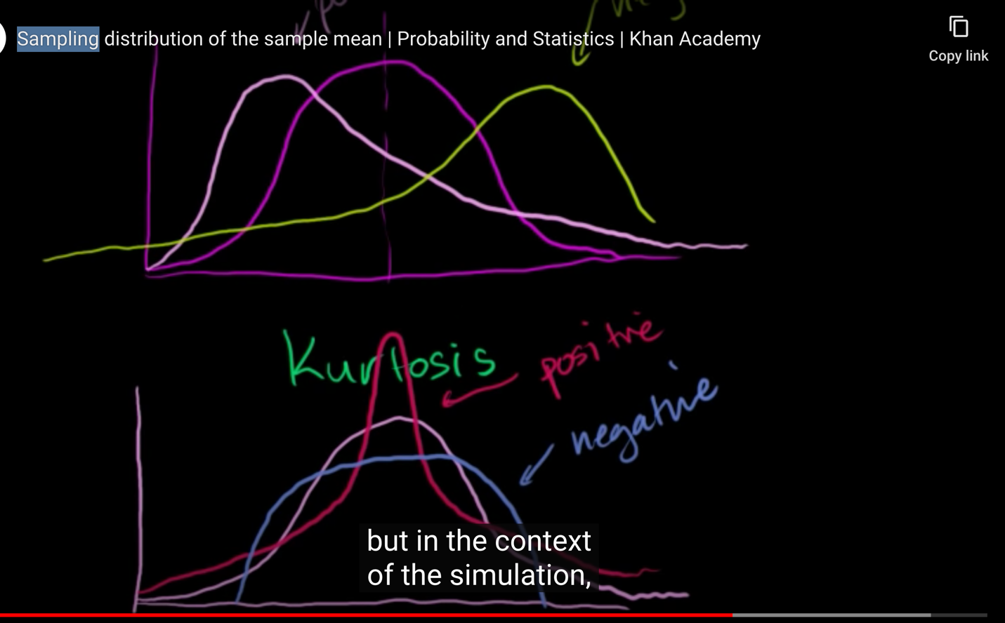

**Types of Sampling:**

**Sampling based on probability:**

1. **Simple random sampling:** Software randomly selects subjects from whole population
2. **Stratified sampling:** Subset. Take sample from each subset but it should be proportional. Red, yellow, blue
3. **Cluster sampling:** Red Yellow, blue.
4. **Multistage sampling:** A more complicated form of cluster sampling. In this the large population is divided into cluster. Second stage clusters are then broken based on secondary factors. Those clusters are then sampled and analyzed. More staging can be done after that
5. **Systematic sampling**: Excel 200 rows sample size 20. Every 10th row is the sample rec

**Sampling based on non-probability approach:** Data is sampled based on the judgement of an analyst

1. **Convenience sampling:** Datacollected from easily accessible and available grp
2. **Consecutive sampling:** Data is collected from every subject that meets the criteria until the predetermined sample size is met
3. **Purposive or judgmental sampling**
4. **Quota sampling:**  The researcher ensures equal representation within the sample

**Type1 and Type2 error:**

**Type1(False Positive) error:** Null hypothesis is true, but is rejected due to false testing

**Type2(False Negative) error:** Null hypothesis is false, but accepted as true

|  |  |  |
| --- | --- | --- |
| **Null hypothesis** | **Type 1 error or false positive** | **Type 2 error or false negative** |
| Medicine A cures disease B | (H0 **true**, but rejected as **false**)  Medicine A **cures** Disease B, but is **rejected as false** | H0 **false**, but accepted as **true**)  Medicine A **does not cure** Disease B, but is **accepted as true** |
| Cost Assessment | Lost opportunity cost for rejecting an effective drug that could cure Disease B | Unexpected side effects (maybe even death) for using a drug that is not effective |

|  |  |  |
| --- | --- | --- |
| **Null hypothesis** | **Type 1 error or false positive** | **Type 2 error or false negative** |
| Person is not guilty of the crime | Person is judged as **guilty** when the person actually **did not** commit the crime (convicting an innocent person) | Person is judged **not guilty** when they actually **did** commit the crime (letting a guilty person go free) |
| Cost Assessment | Social costs of sending an innocent person to prison and denying them their personal freedoms (which in our society, is considered an almost unbearable cost) | Risks of letting a guilty criminal roam the streets and committing future crimes |

So, Cost assessment has to be taken into consideration to check which error will cause severe impact.

**Linear Regression:**

1. Use least-squares to fit a line to the data
2. Calculate R2
3. Calculate a p-value for R2

Steps 1) Plot dependent and independent variable

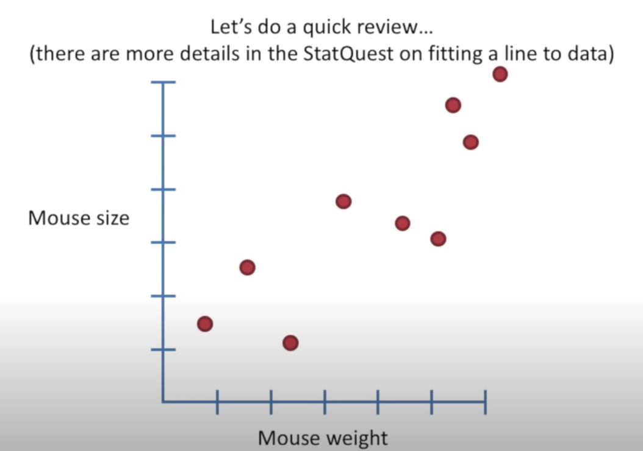

2) Draw a line 3) Calculate Residuals and add square of residuals

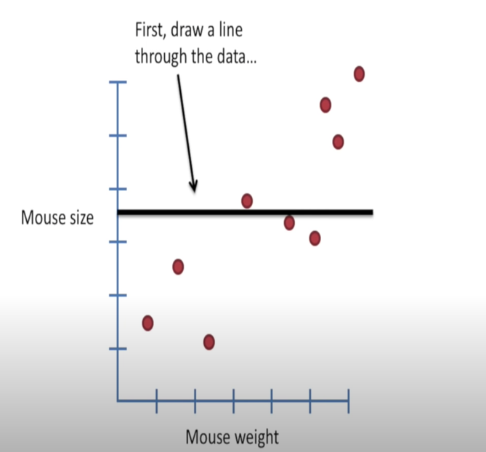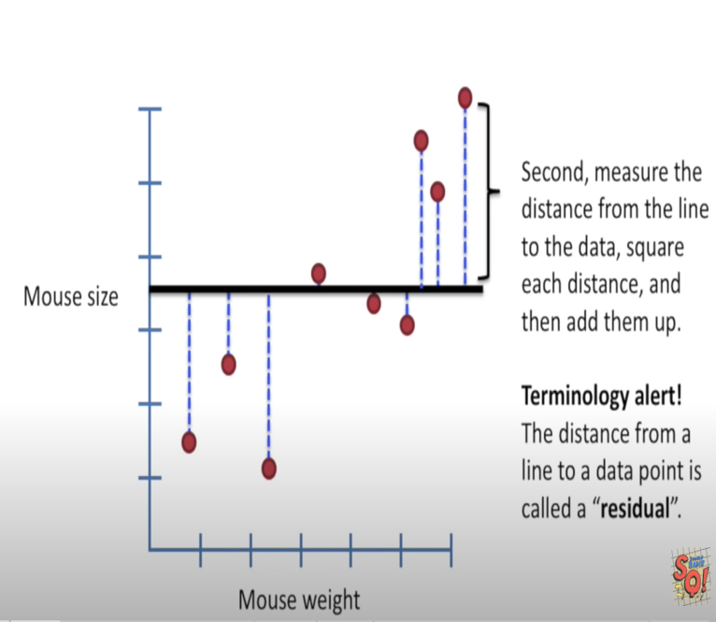

4) Rotate line and calculate residuals

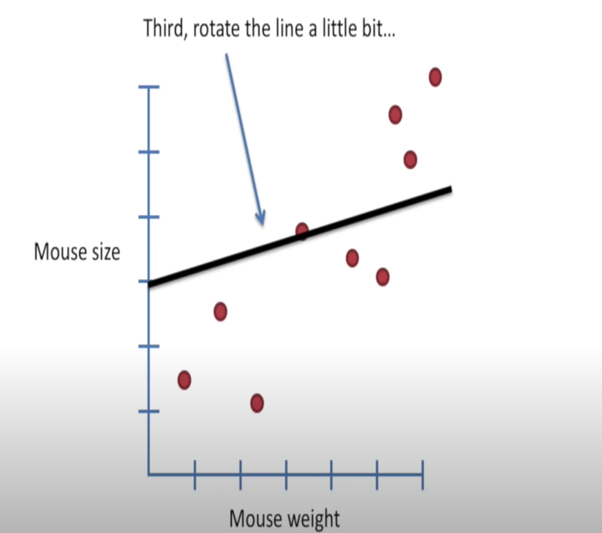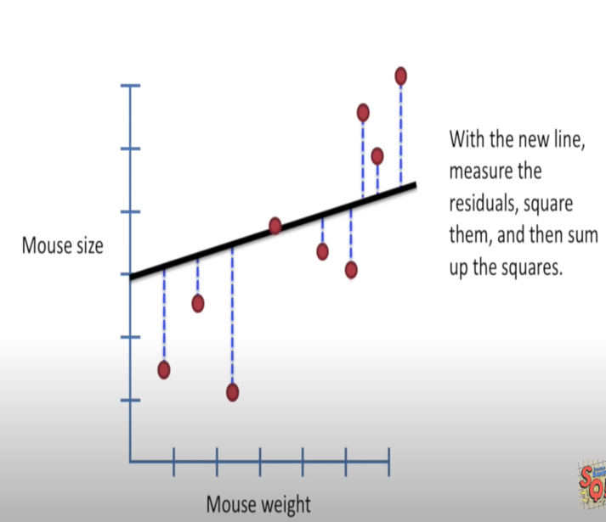

5) Rotate more and calculate residuals

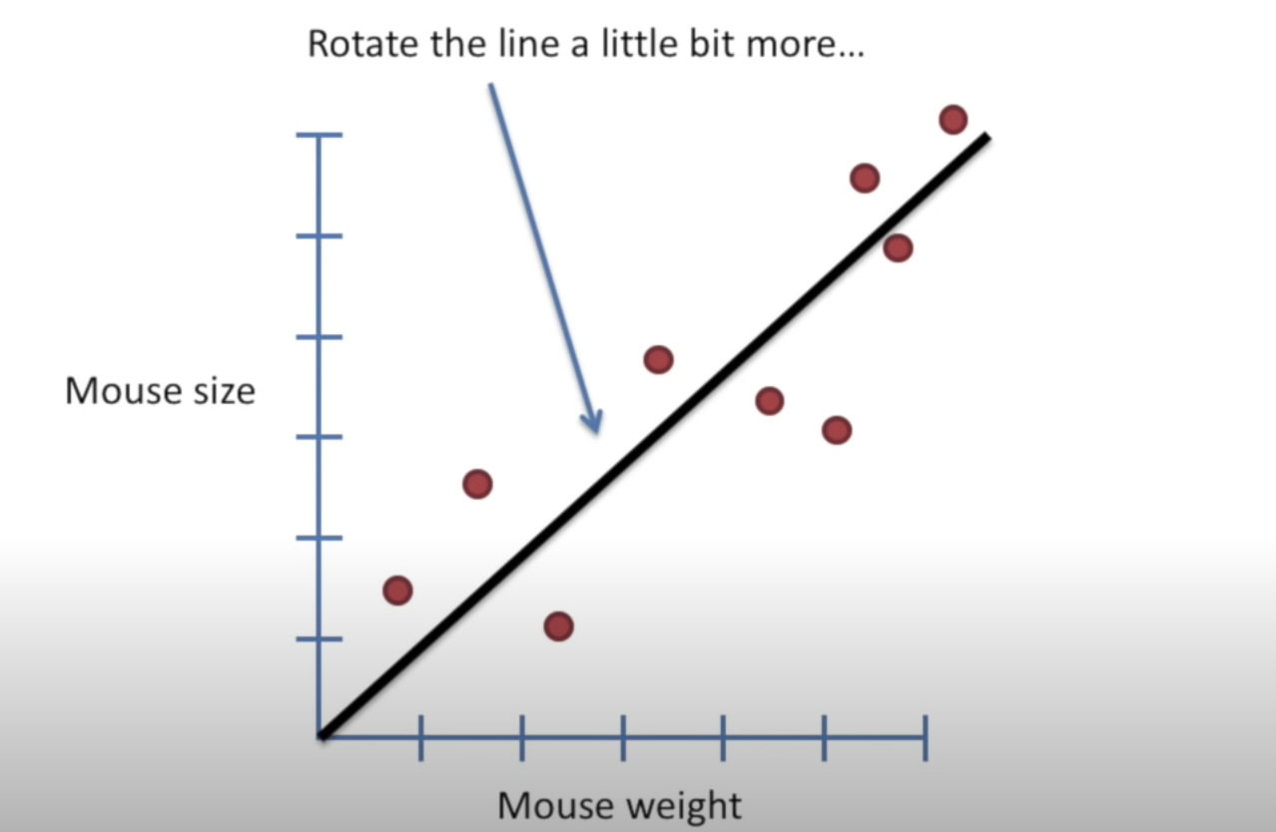

6) plot sum of residuals w.r.t rotation

7) find the rotation that has least sum of residuals

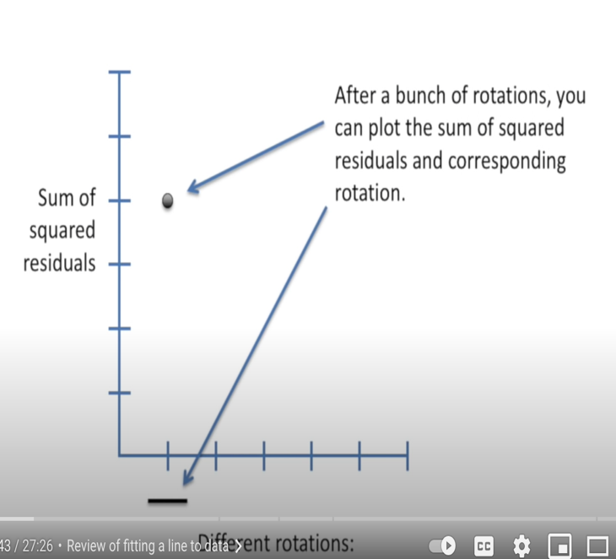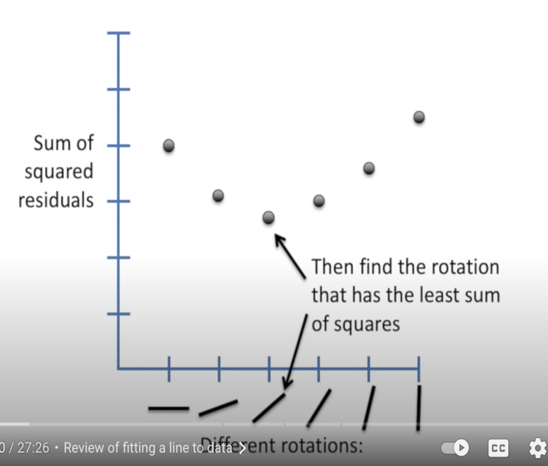

**R square(R2): R**-**squared** is a statistical measure of how close the data are to the fitted regression line

The **R2** represents how much variance of the data is explained by the model, the **R2**=0.90 means that 0.10 of the variances cannot explain by the model, the logical case when **R2**=1 the model completely fit and explained all variance.

R squared (R2) is a statistical measure that represents the proportion of the variance for a dependent variable that's explained by an independent variable or variables in a regression model.

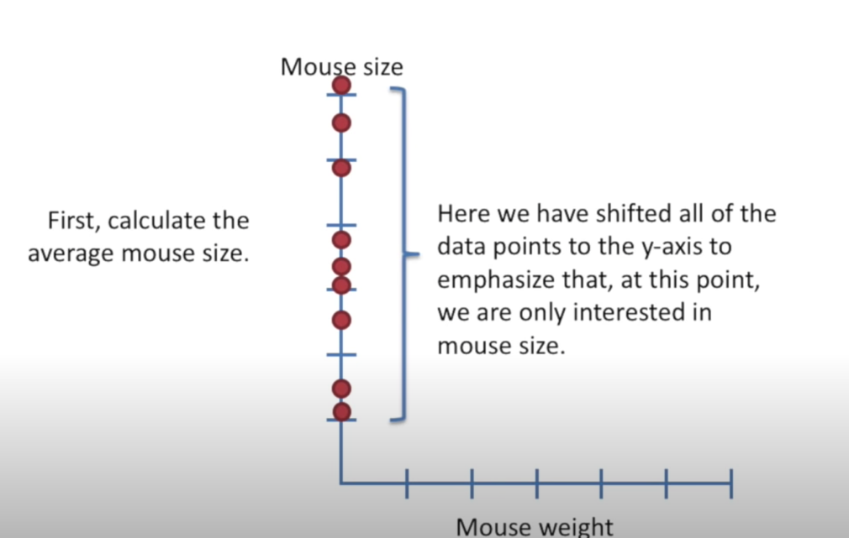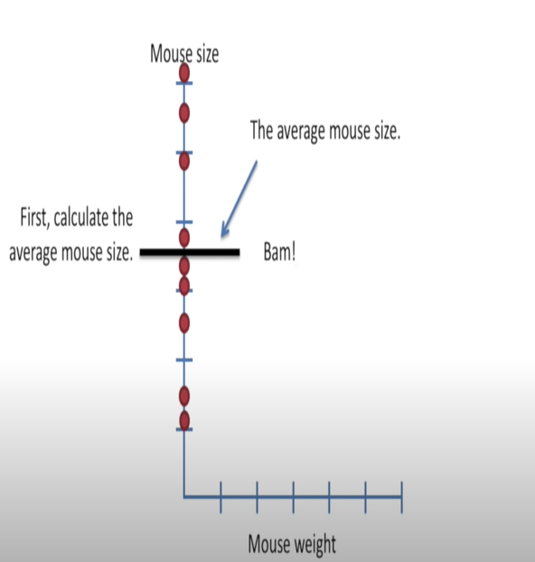

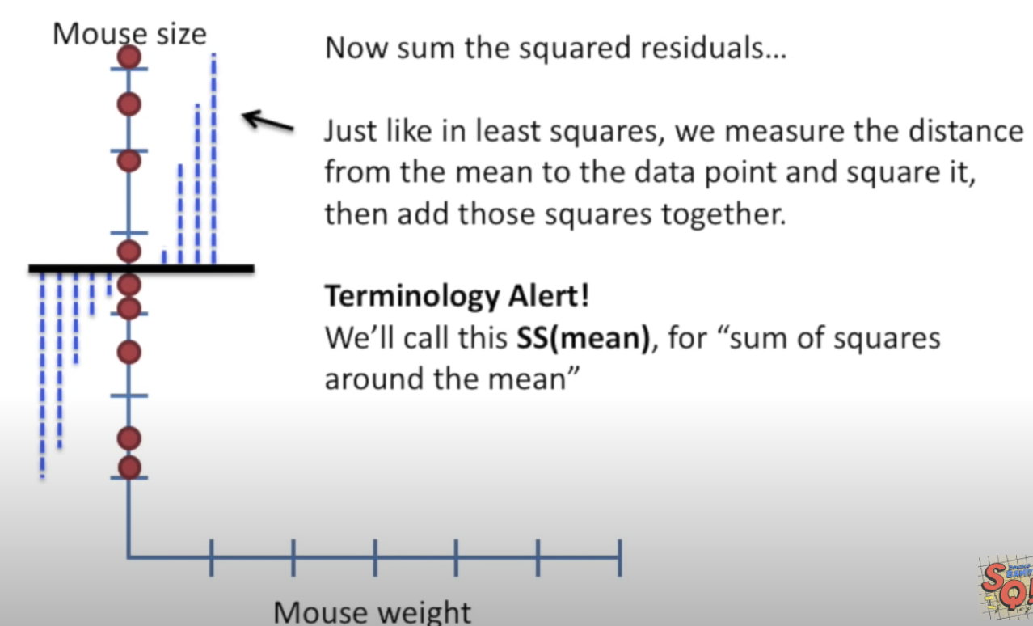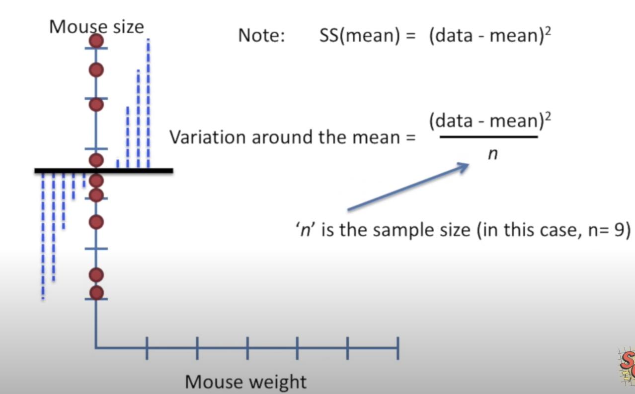

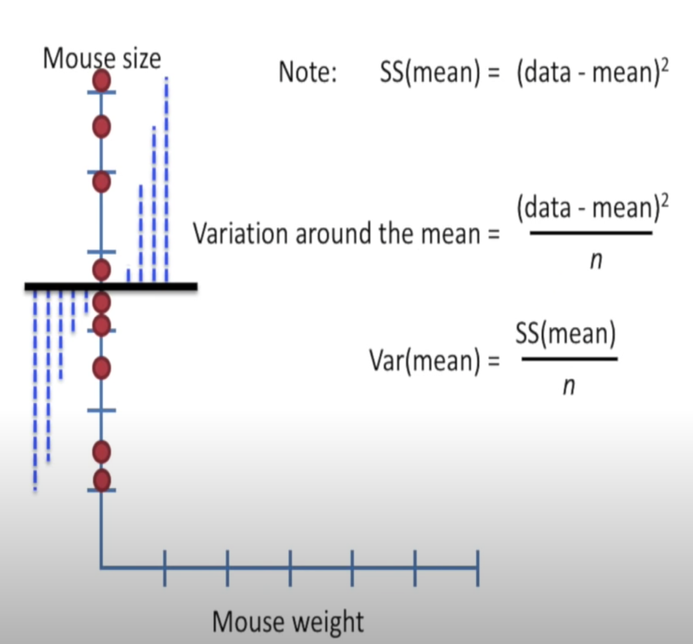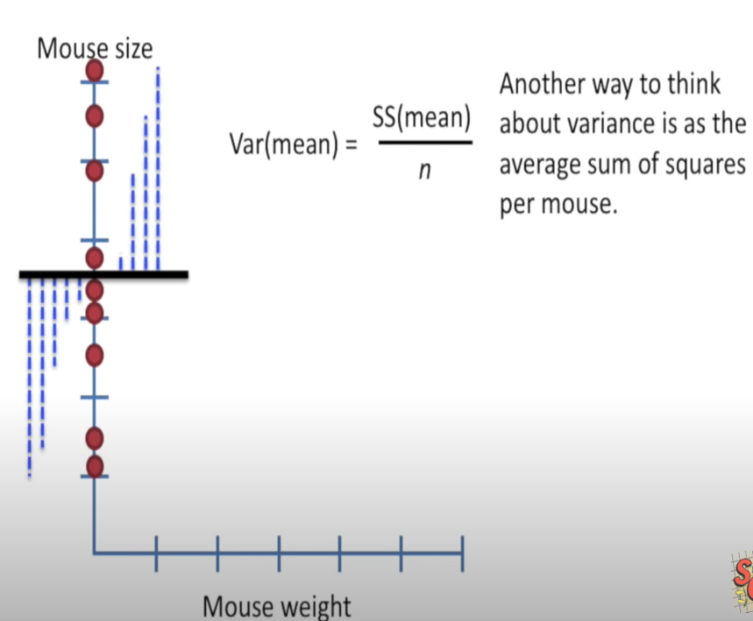

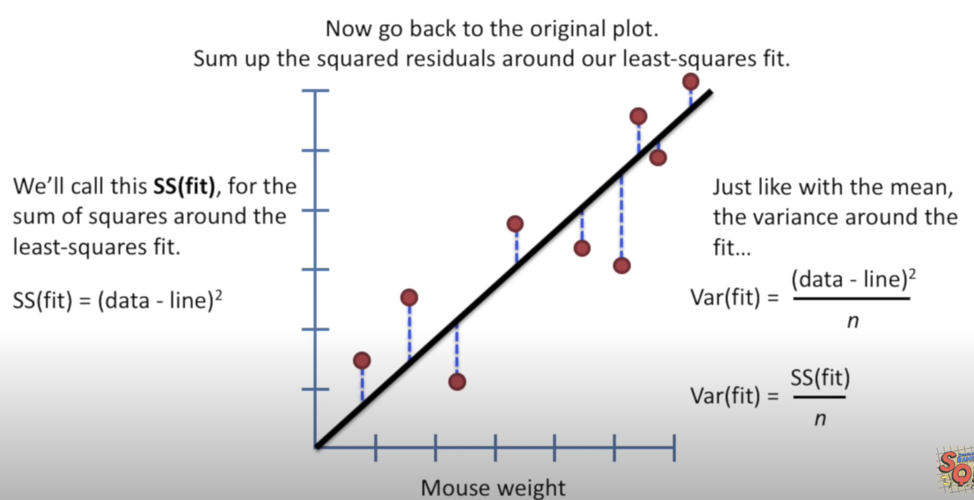

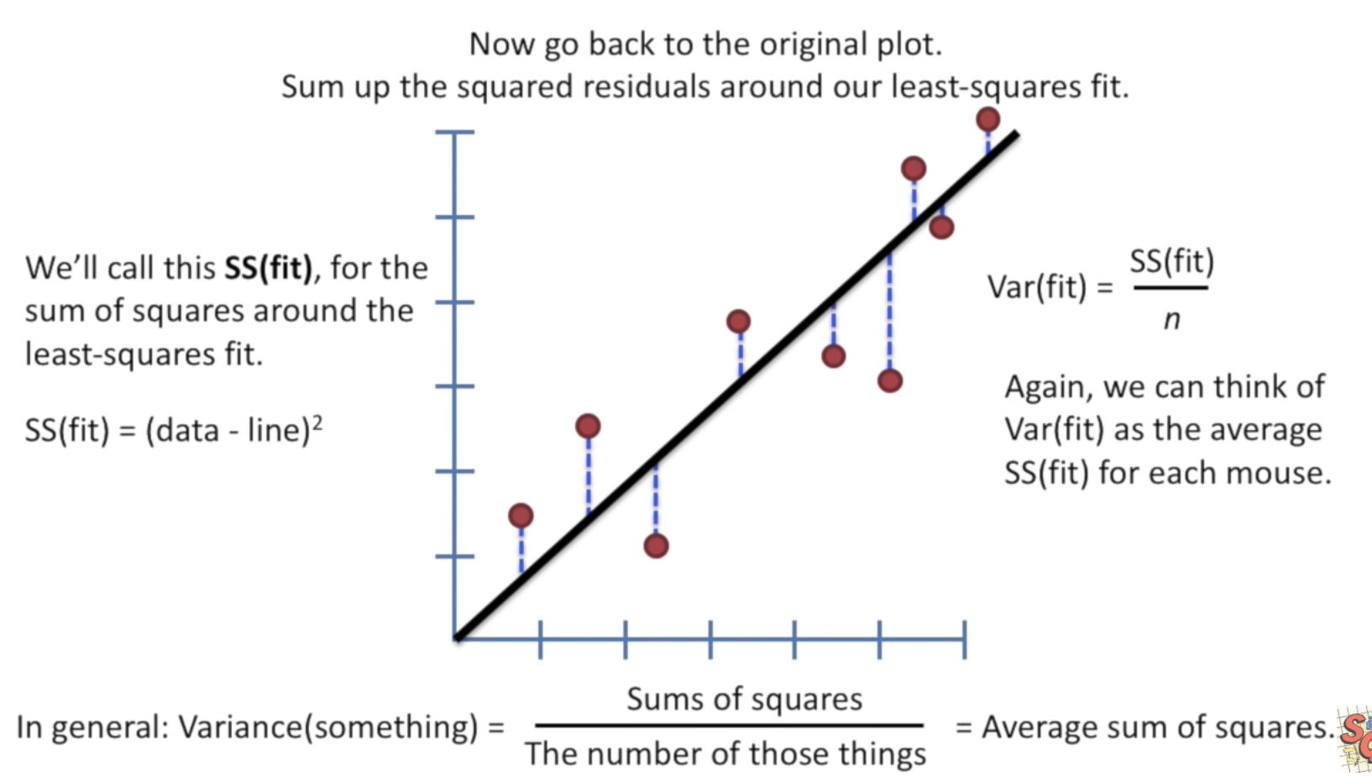

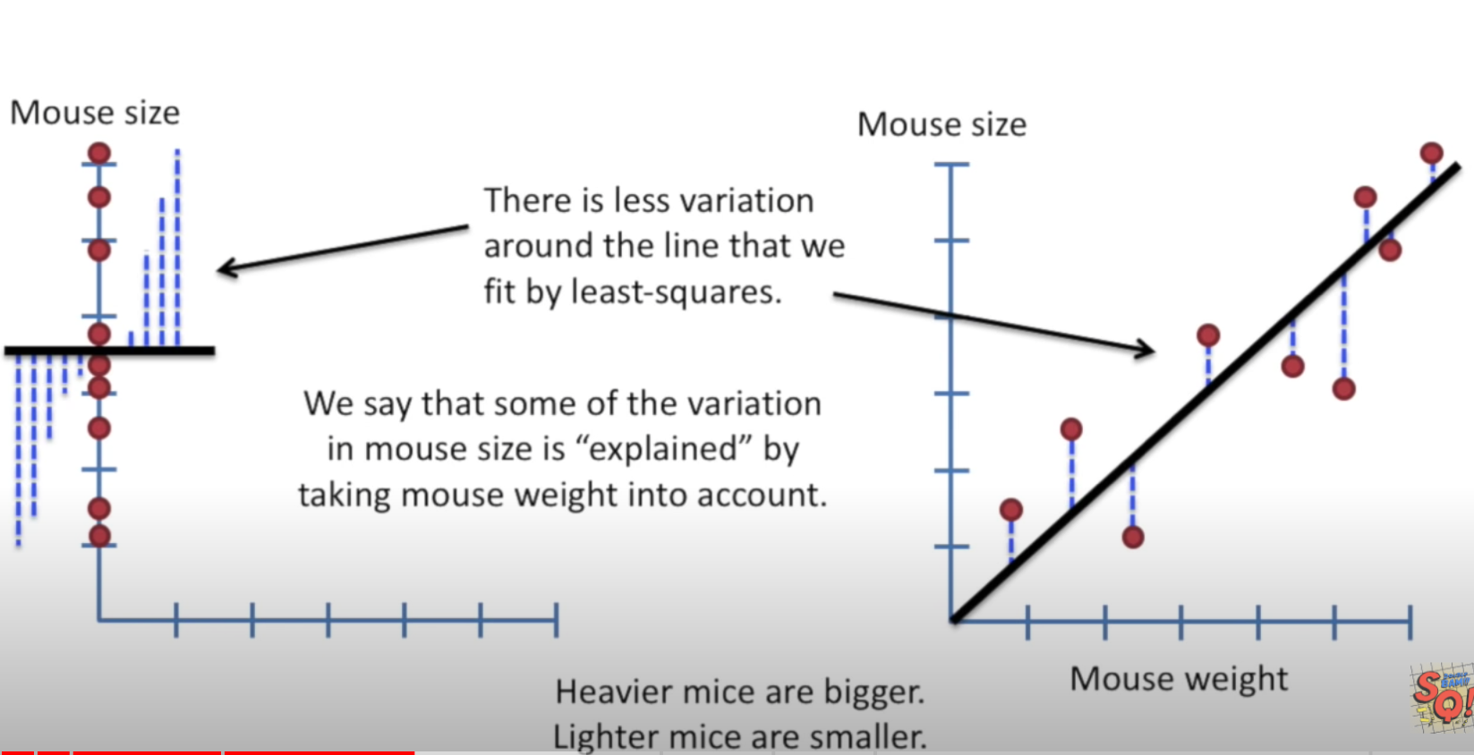

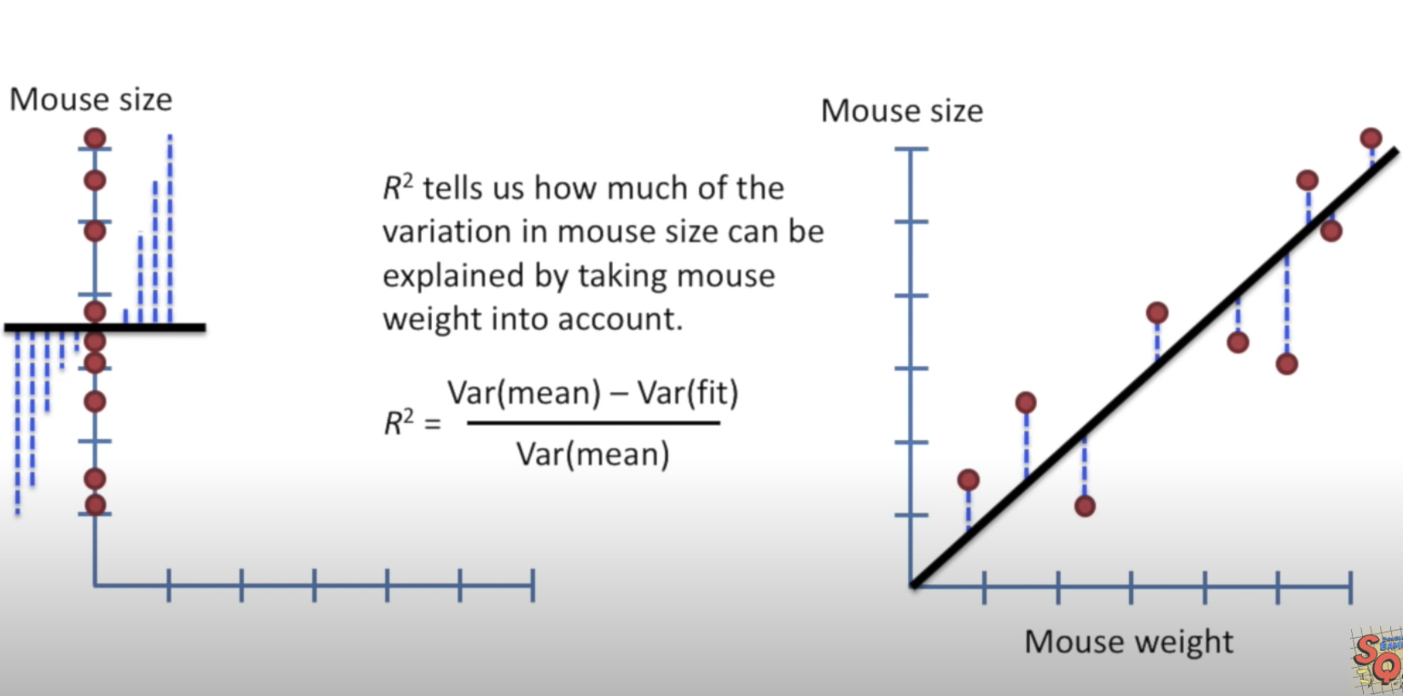

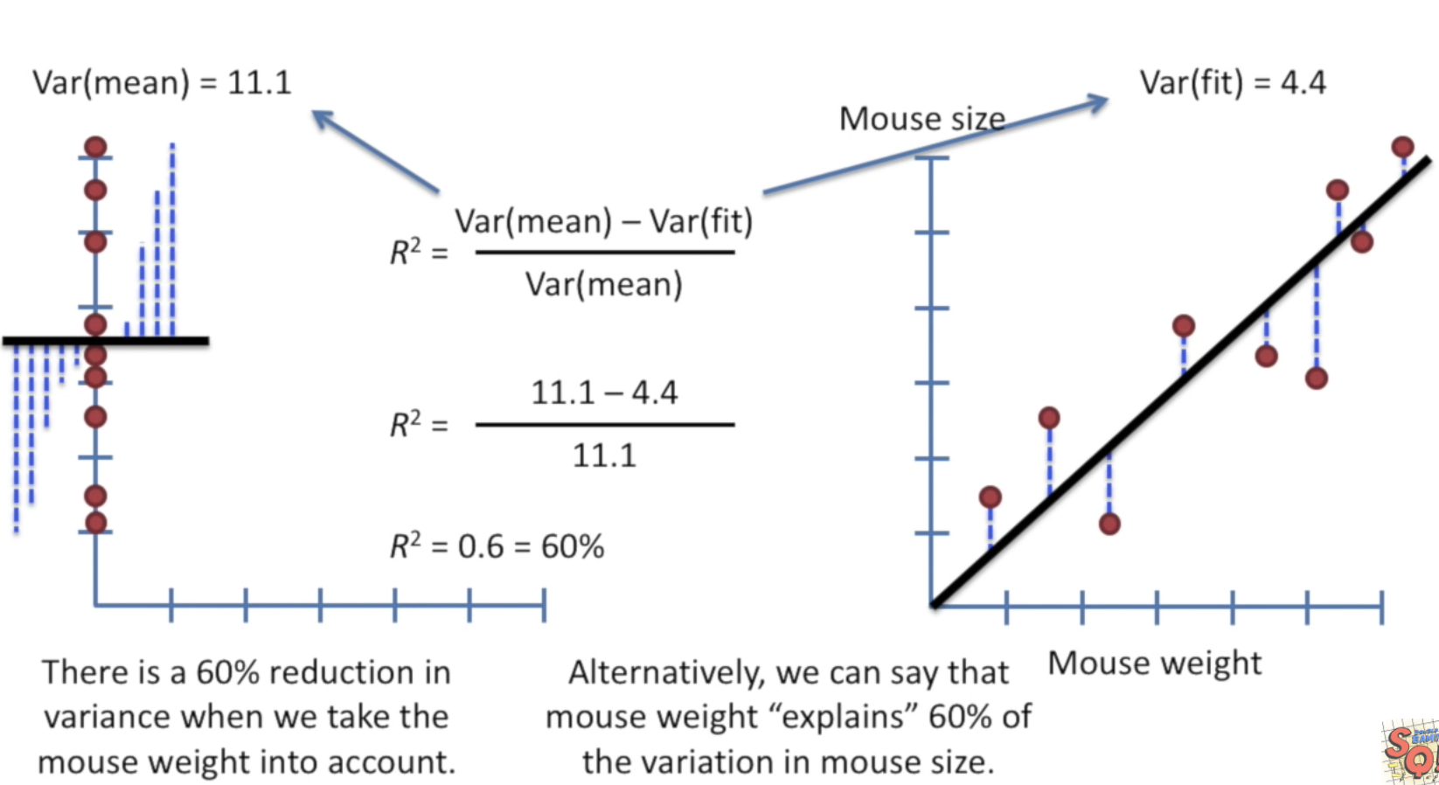

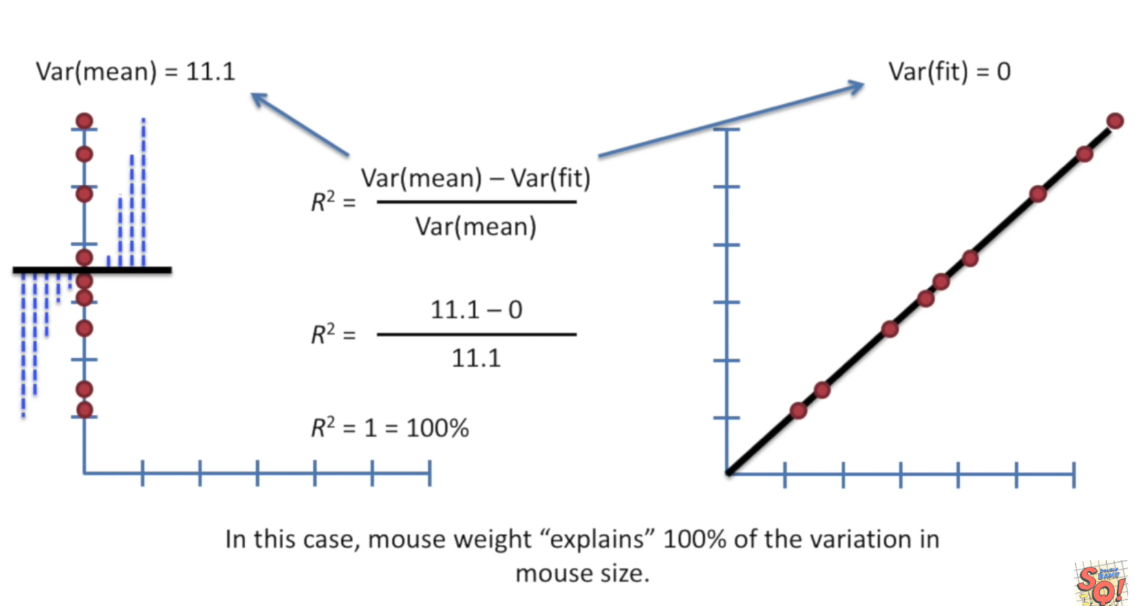

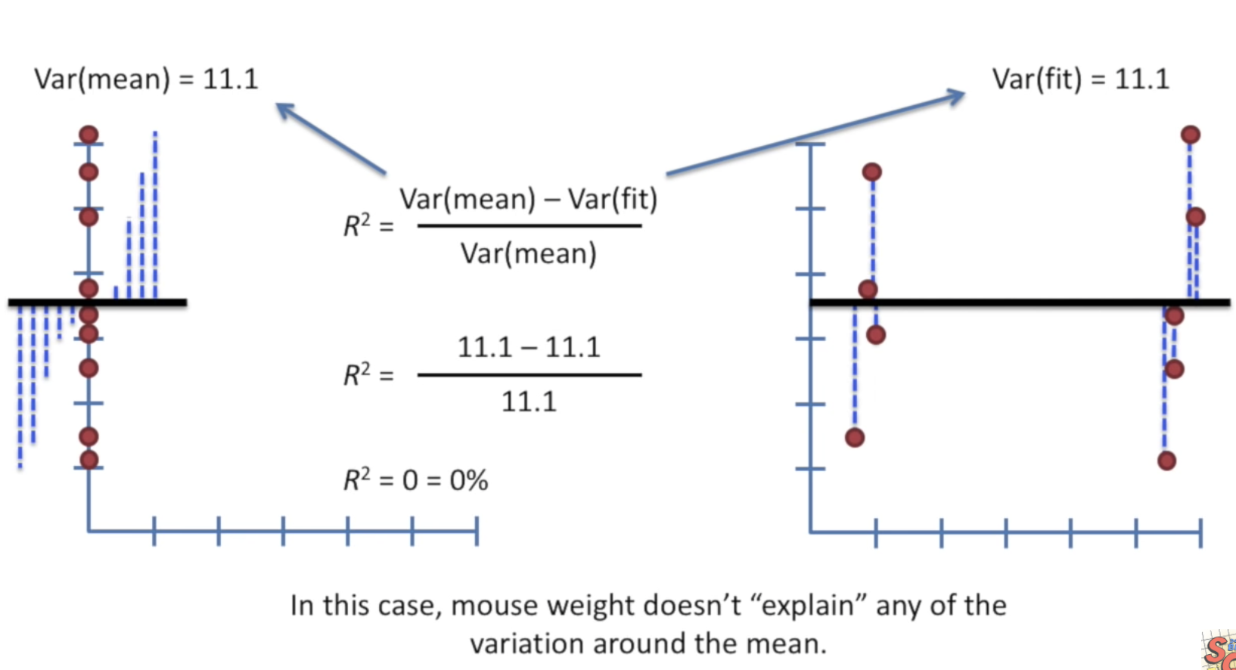

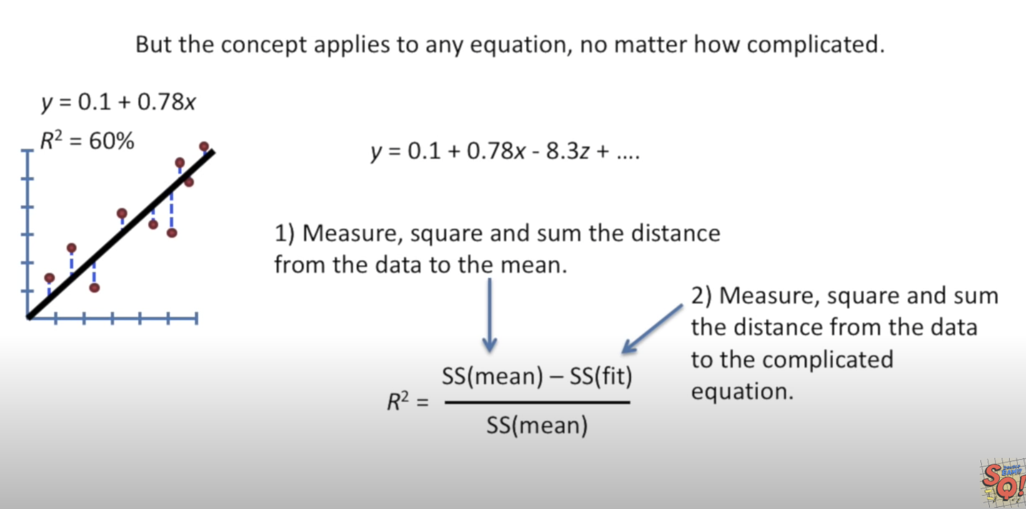

Linear Regression for more than one independent variable

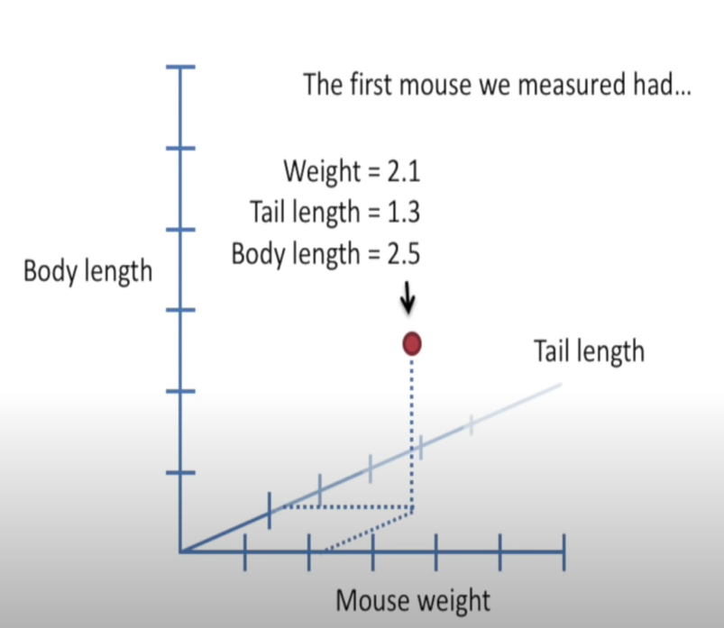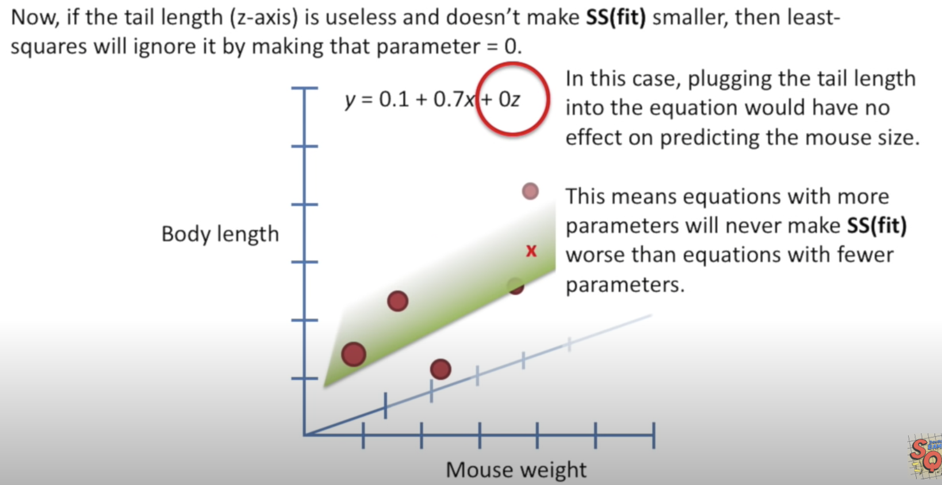

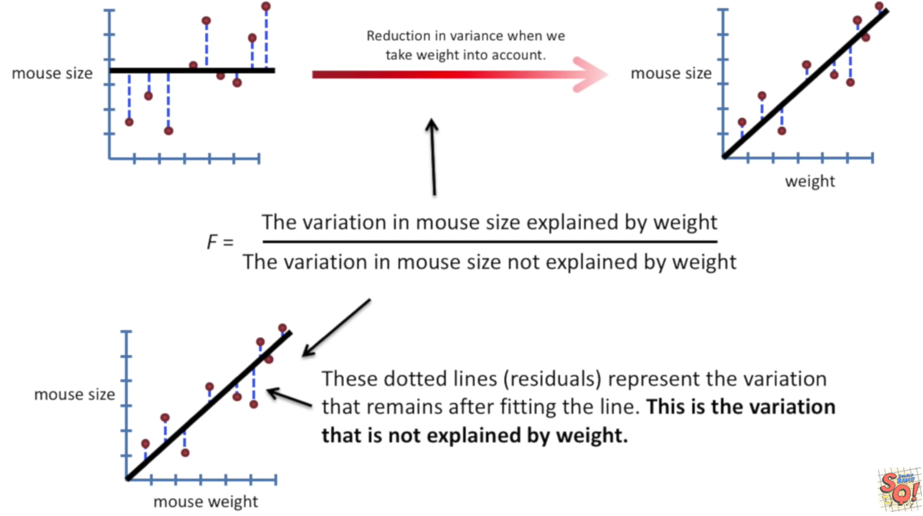

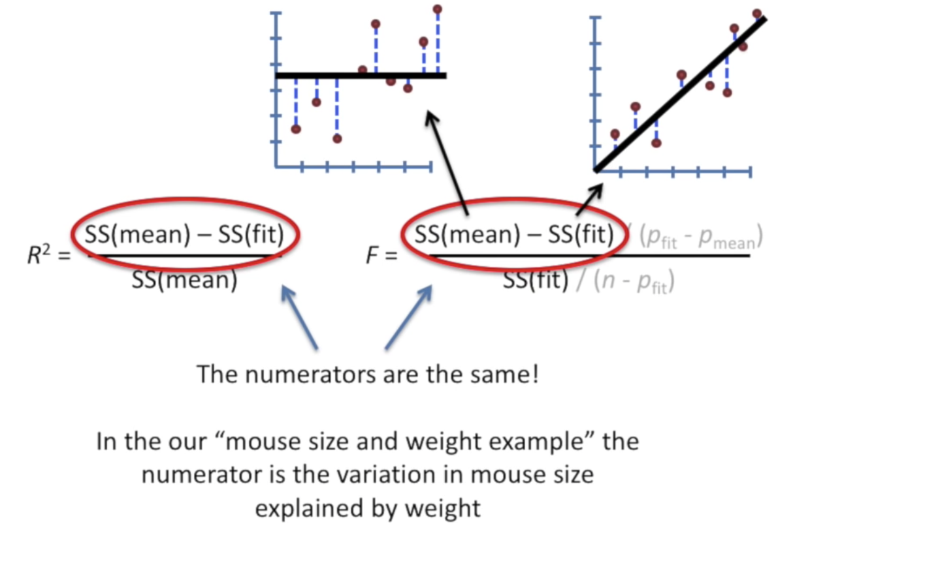

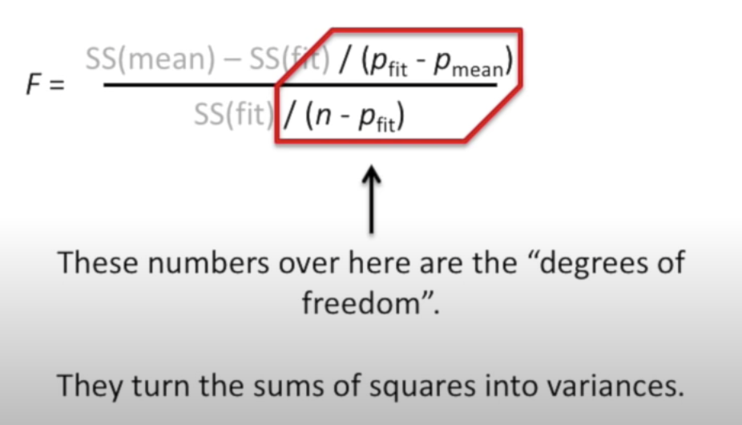

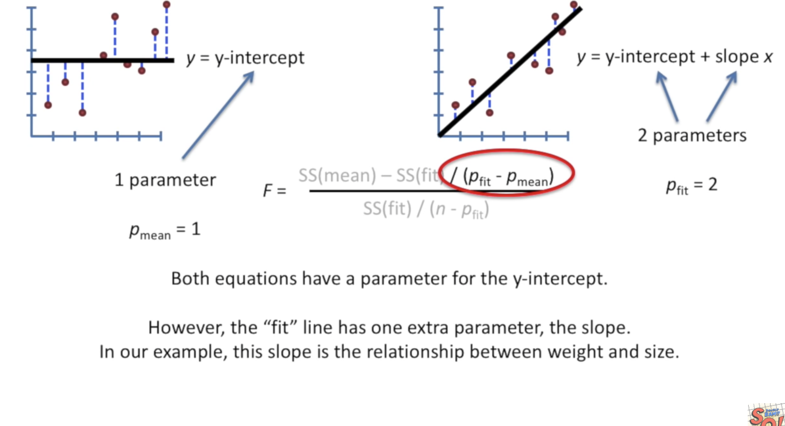

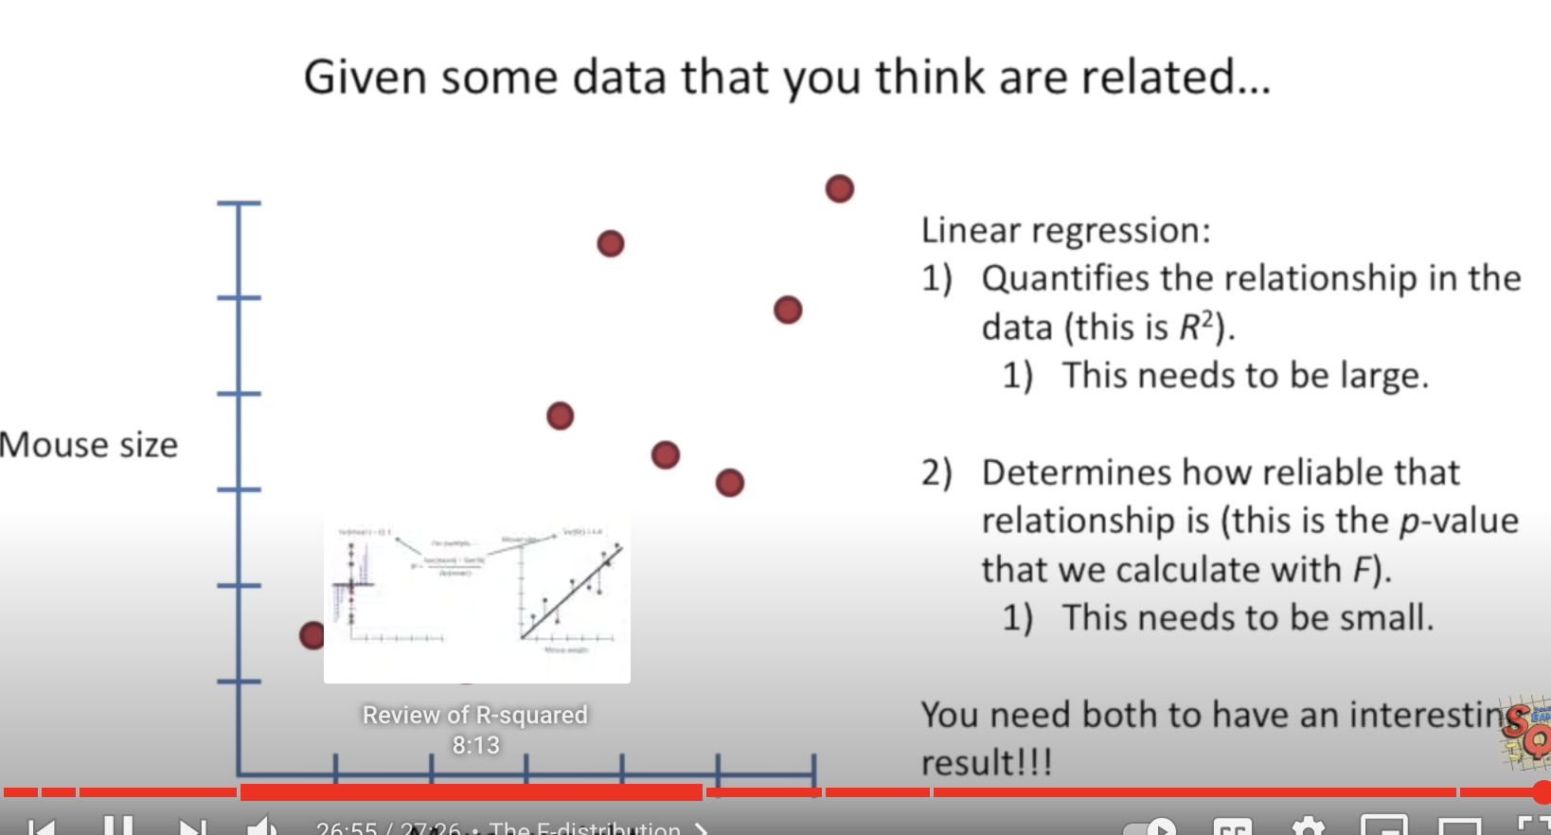

**Assumption In linear regression**

-There is a linear relationship between the dependent variables and the regressors, meaning the model you are creating actually fits the data

-The errors or residuals the data are normally distributed and independent from each other

-There is minimal Multicollinearity between explanatory variables

-Homoscadasticity – This means the variance around the regression line is same for all values of the predictor variables

Type of Linear Regression:

1. Simple Linear Rgression
2. Multiple Linear Regression

Multiple Linear Regression

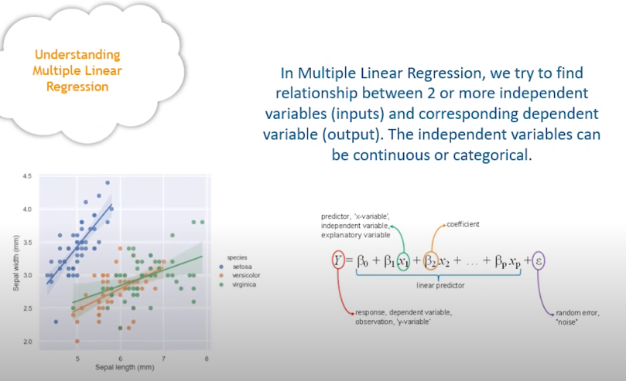

Types of Logistic Regression:

1. Binomial: eg: win vs loss, pass or fail, dead or alive

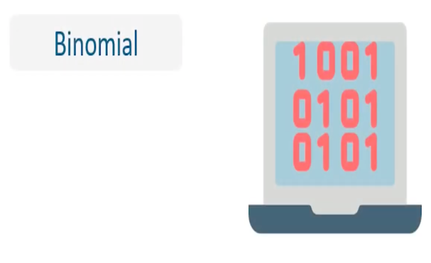

1. Multinomial : Target variable can have 3 or more types. Ed: disease a, b and c



1. Ordinal: good, better, very good. Grades as a, b, c



**Linear Vs Logistic Regression:**

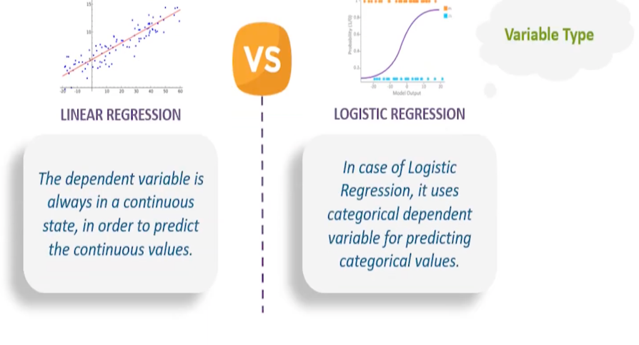

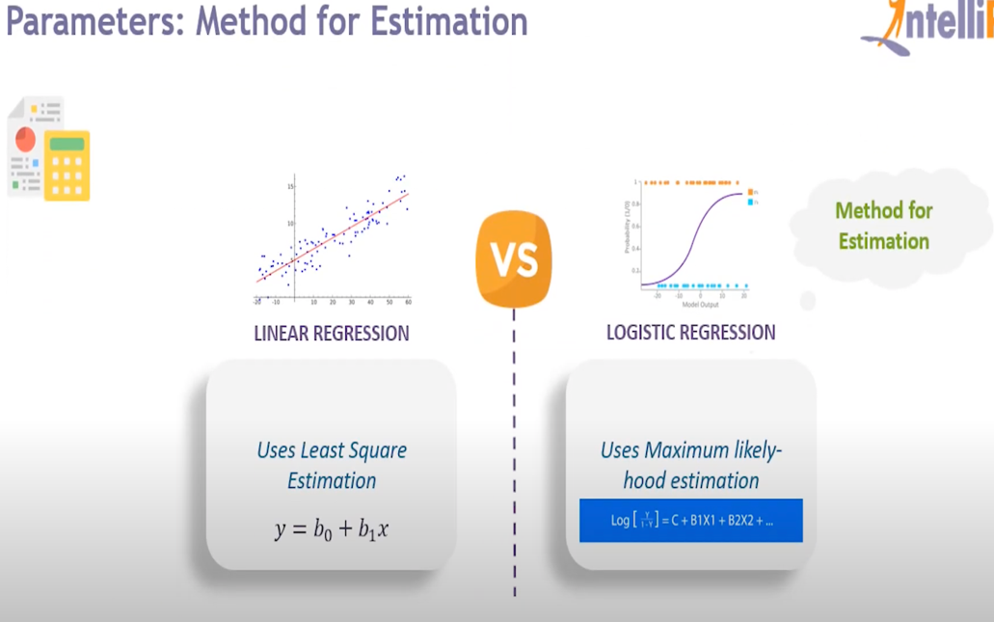

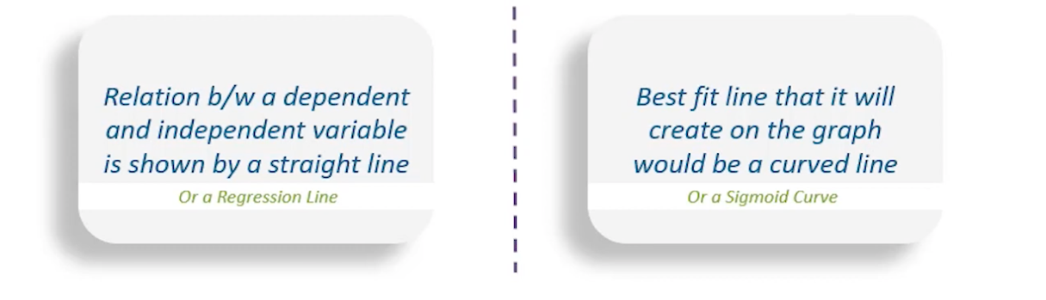

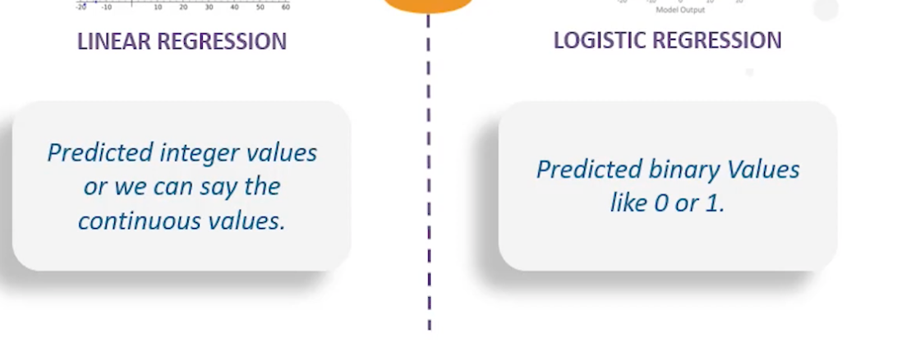

**Example of Linear Regression:**

1. Estimating the value of “Monthly Charges” when “Tenure” of the customer changes
2. Predicting Crop Yield based on the amount of rainfall
3. Marks scored by students based on the number of hours studied
4. Predicting salary based on years of experience

**Example of Logistic Regression:**

1. Pass or fail in exam
2. Email is spam or not

**Hypothesis:** A claim that we want to test

**Null Hypothesis:** H0 Currently accepted value for a parameter

**Alternative Hypothesis**: Ha Research Hypothesis- this is what we are going to test

Ex) Average weight of chocolate bar = 5 gm

H0 -- mu = 5 gm

Ha -- mu != 5 gm

**Possible outcomes of this test:**

* Reject Null Hypothesis
* Fail to Reject Null Hypothesis

**Test Statistic:** Calculate for sample data used to decide (reject or fail to reject null hypo)

Ex) Sample 50 bars

* Get Average value
* Calculate test statistic

**Statistically significant:**

Avg on Monday = 5.12 gm

Avg on Tuesday = 5.72 gm

Avg on Wednesday = 7.23 gm

**Level of Confidence:** How confident are we in our decision c =90%, 95%

**Level of significance:** alpha = 1-c

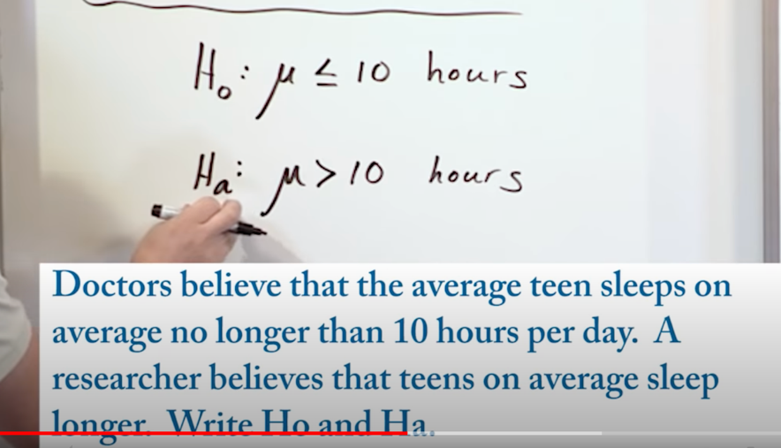

With ttest, we get the pvalue.

Below are the cases in which python libraries used for t-test

Independent samples t-test

* StatsModels : statsmodels.stats.weightstats.ttest_ind
* Scipy: from scipy.stats import ttest_ind

Paired samples t-test

* Scipy: from scipy.stats import ttest_rel

**StatsModels:**

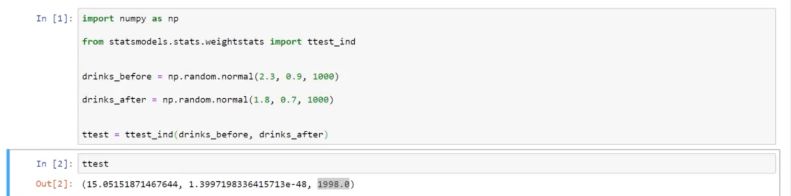

Values in output are tstat, pvalue and degrees of freedom

Degrees of freedom = len(drinks_before) -1+ length(drinks_after) -1

=1000-1+1000-1=1998

**Scipy:**

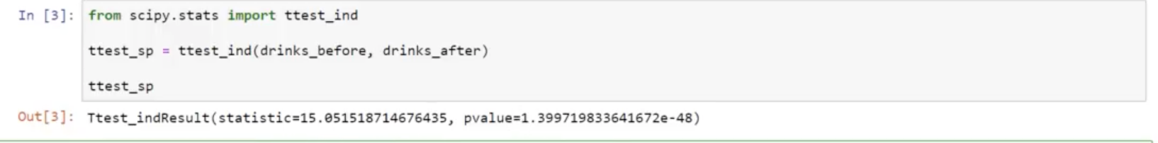

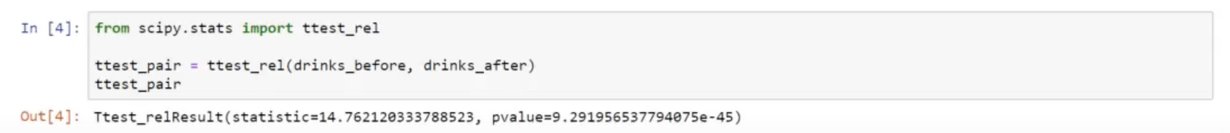

**Hypothesis testing on average price of automatic and manual cars**

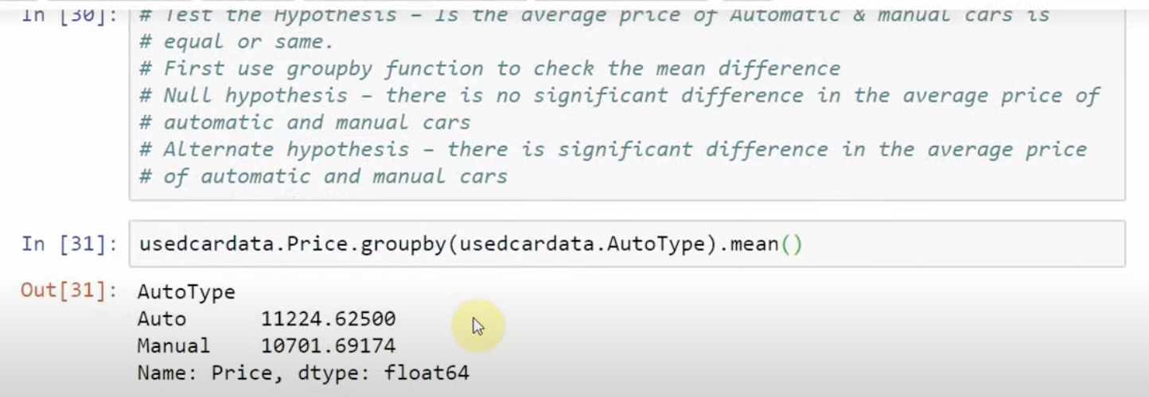

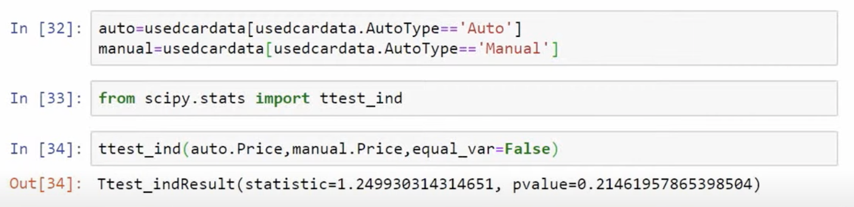

**Ttest on only one sample we use ttest_1samp**

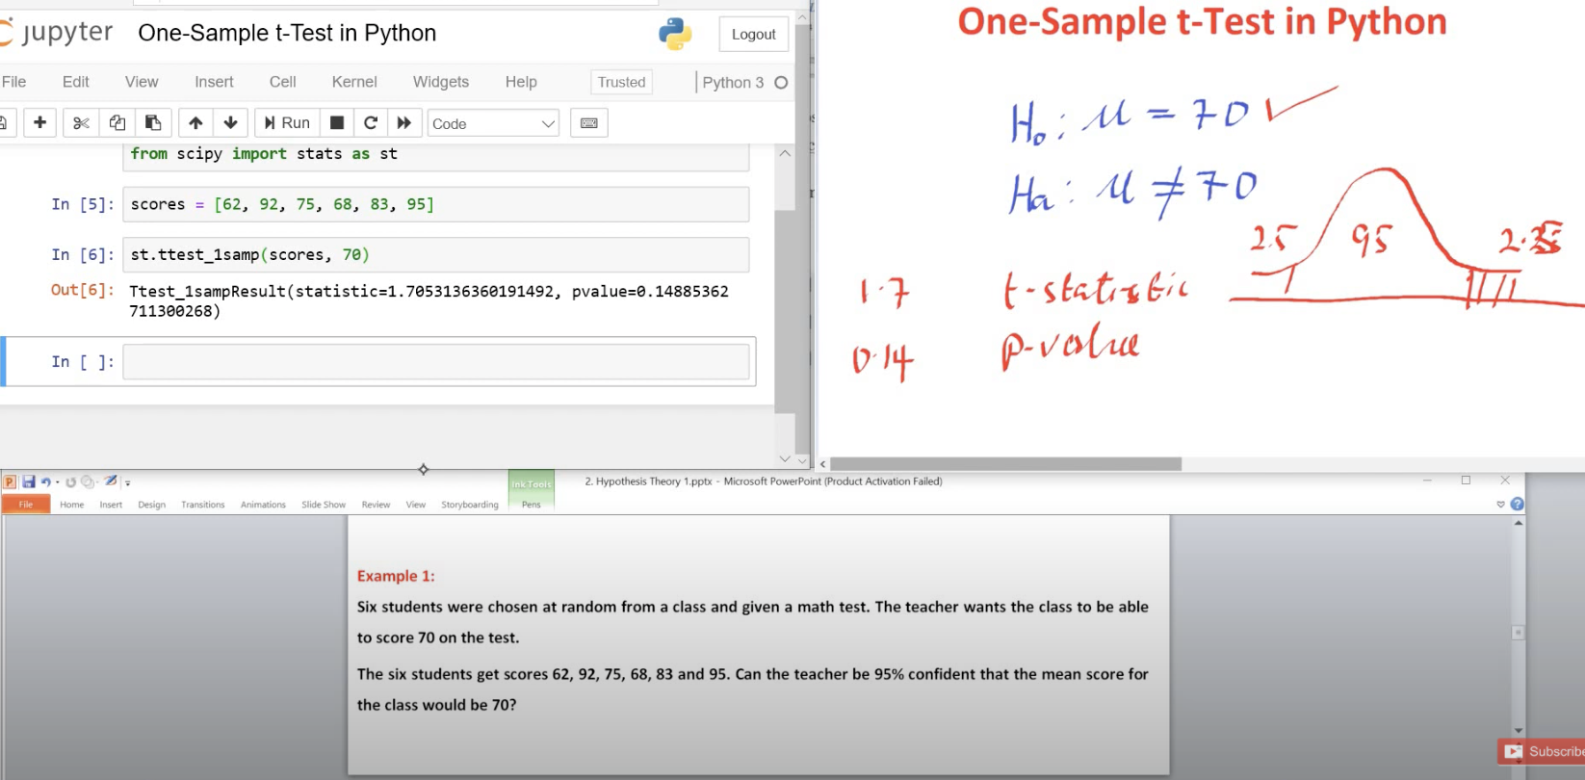

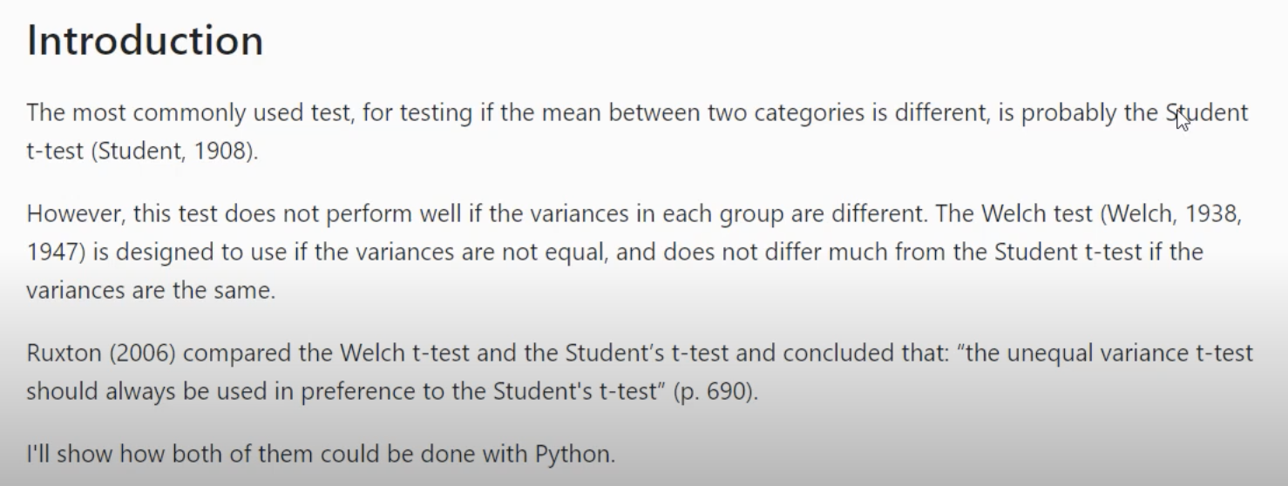

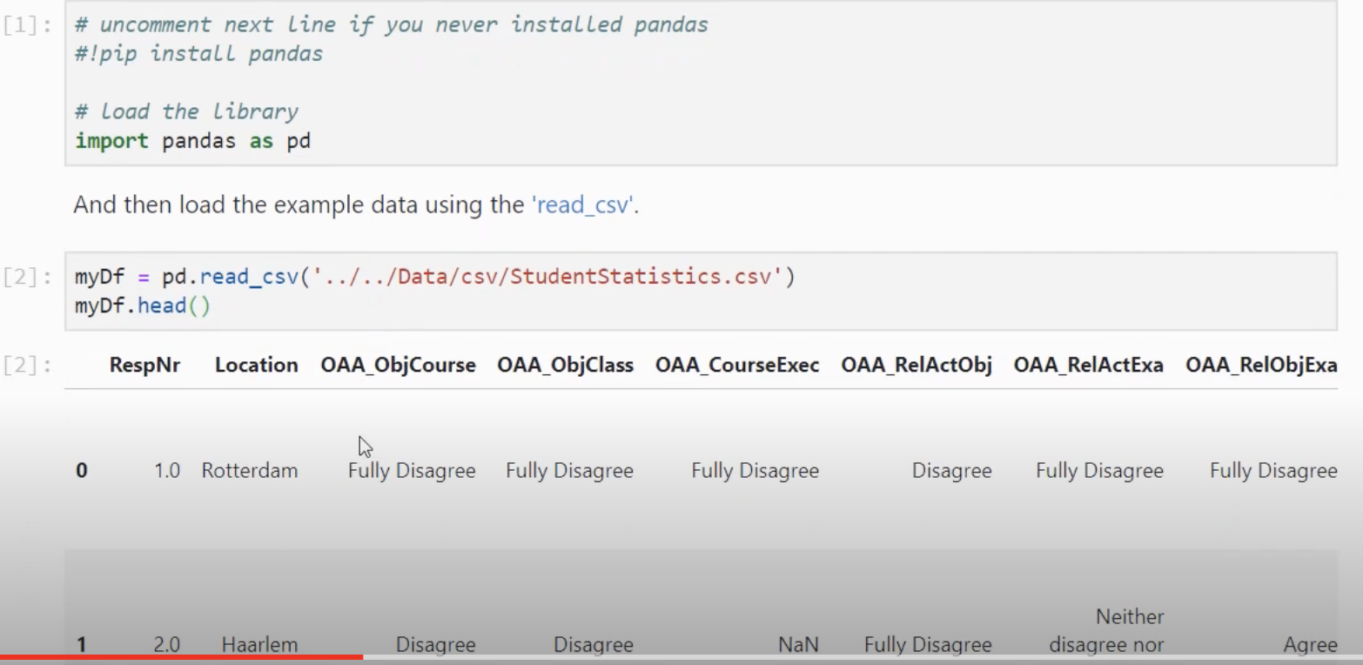

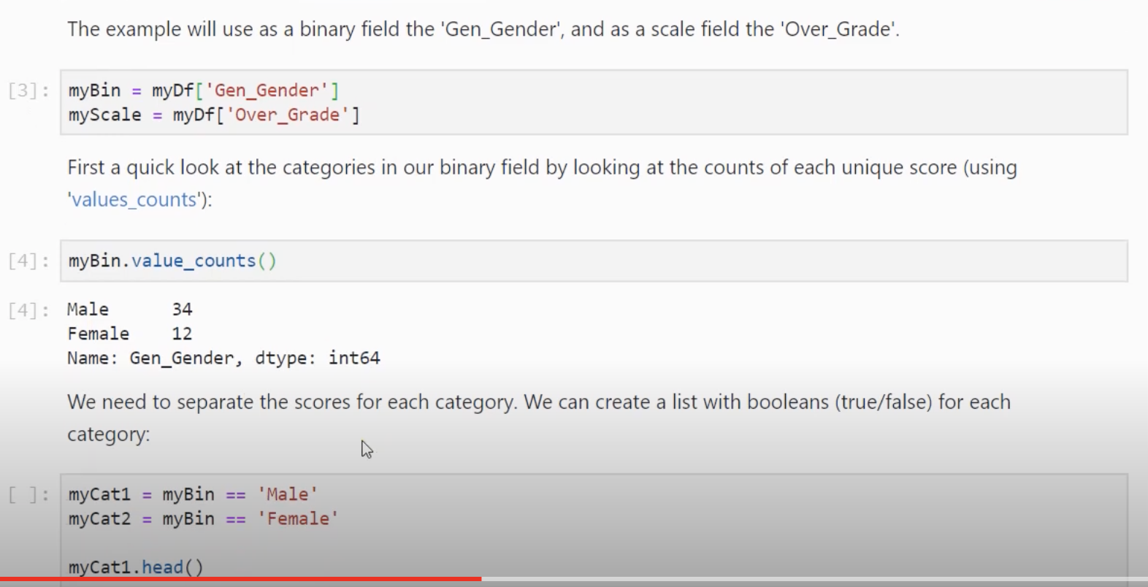

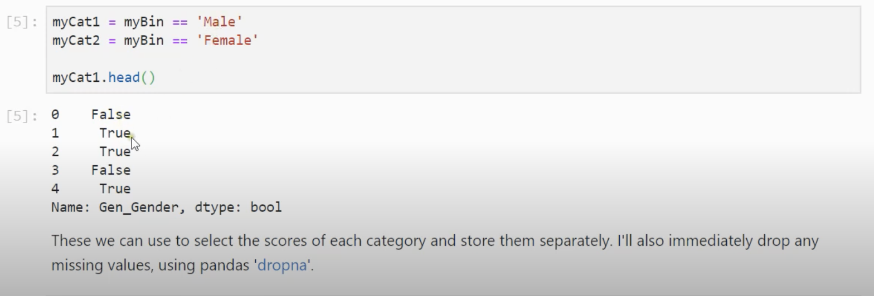

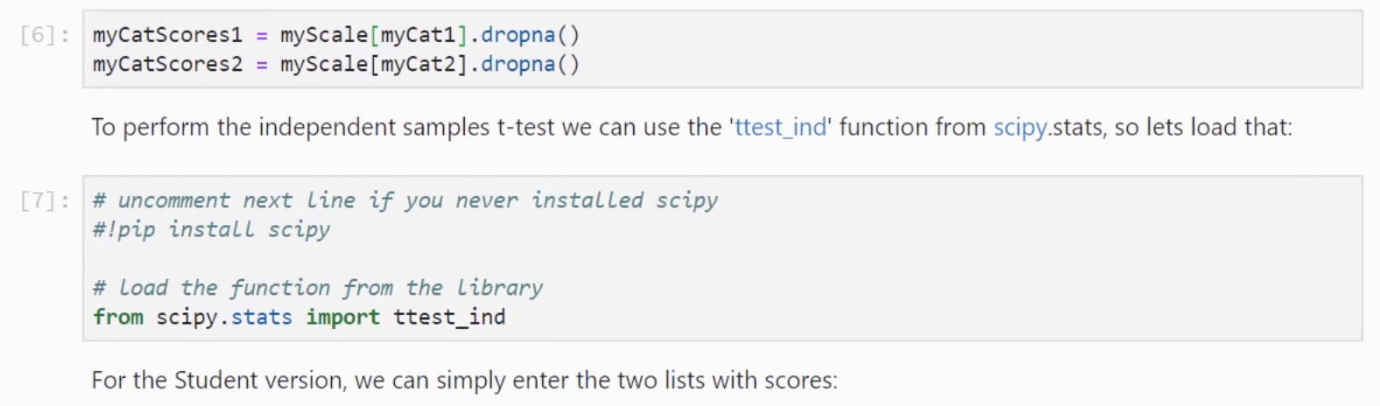

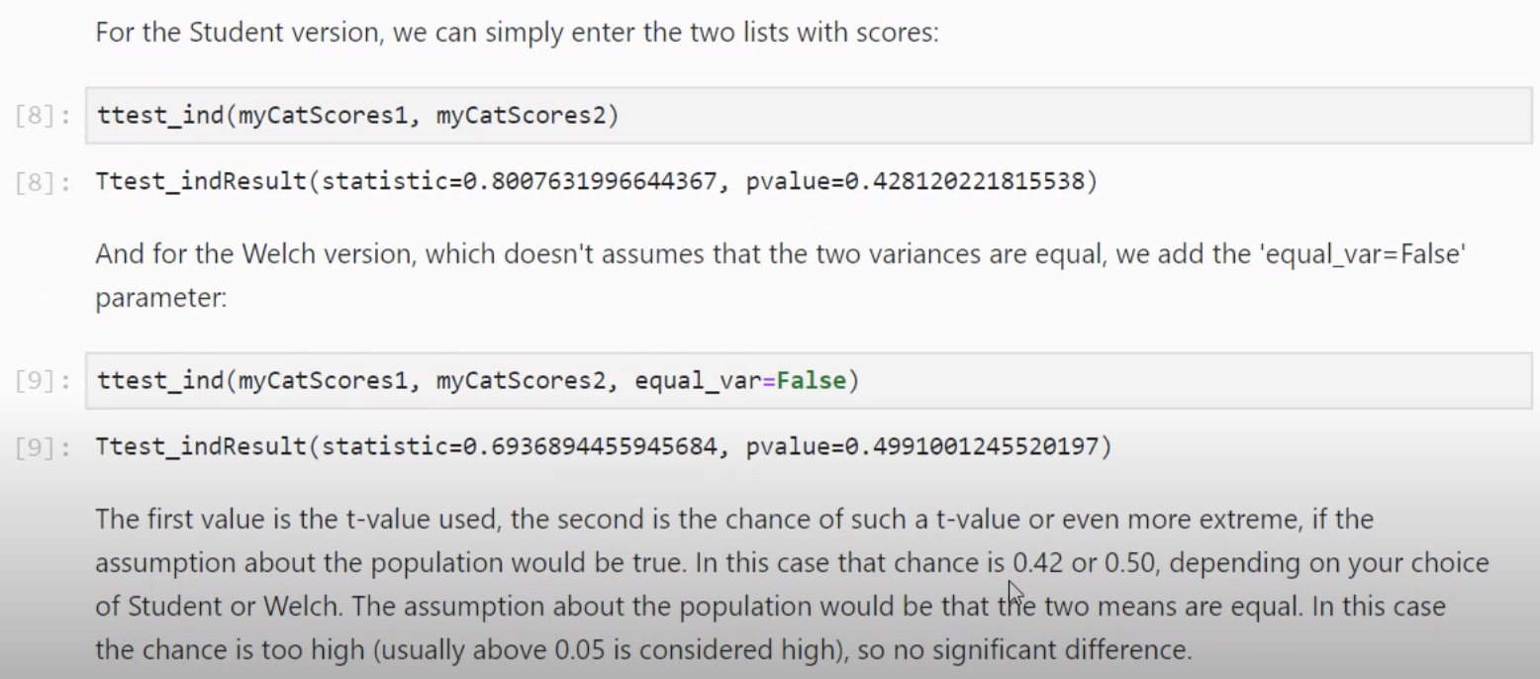

**There are three main types of t-test:**

* An Independent Samples **t**-**test** compares the means for two groups.
* A Paired sample **t**-**test** compares means from the same group at **different** times (say, one year apart).
* A One sample **t**-**test tests** the mean of a single group against a known mean.

A **paired t**-**test** is used when **we are** interested in the difference between two **variables** for the same subject. Often the two **variables are** separated by time. ... Since **we are** ultimately concerned with the difference between two measures in one sample, the **paired t**-**test** reduces to the one sample **t**-**test**.

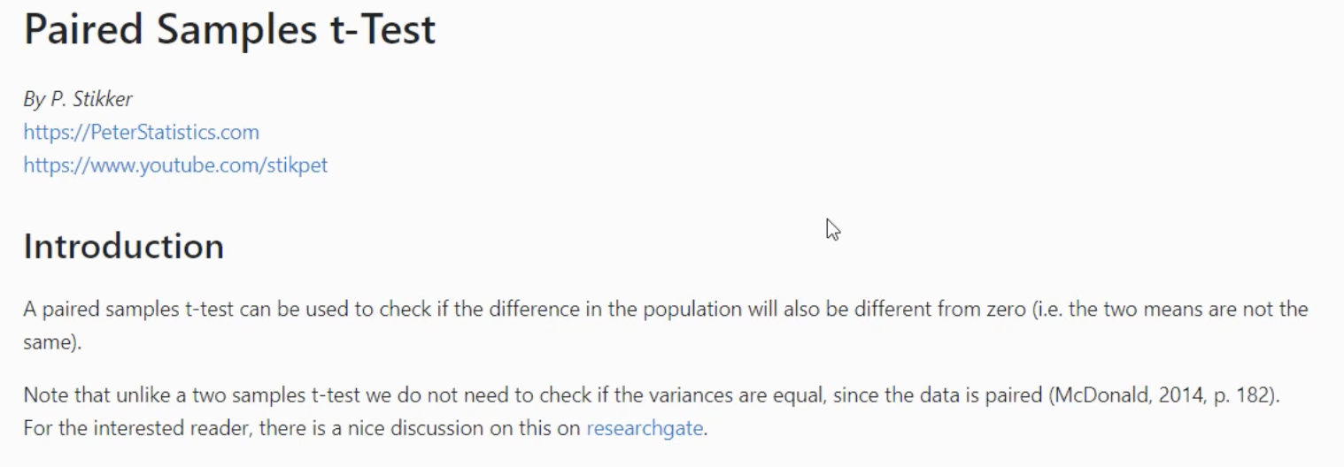

**P value:**

A p value is used in [hypothesis testing](https://www.statisticshowto.com/probability-and-statistics/hypothesis-testing/) to help you [support or reject the null hypothesis](https://www.statisticshowto.com/support-or-reject-null-hypothesis/). The p value is the evidence **against** a [null hypothesis](https://www.statisticshowto.com/probability-and-statistics/null-hypothesis/). The smaller the p-value, the stronger the evidence that you should reject the null hypothesis.

<https://www.statisticshowto.com/probability-and-statistics/statistics-definitions/p-value/>

* **A small p**(≤ 0.05), [reject the null hypothesis](https://www.statisticshowto.com/support-or-reject-null-hypothesis/). This is strong evidence that the null hypothesis is invalid.
* **A large p**(> 0.05) means the [alternate hypothesis](https://www.statisticshowto.com/what-is-an-alternate-hypothesis/) is weak, so you do not reject the null.

**Null Hypothesis:**

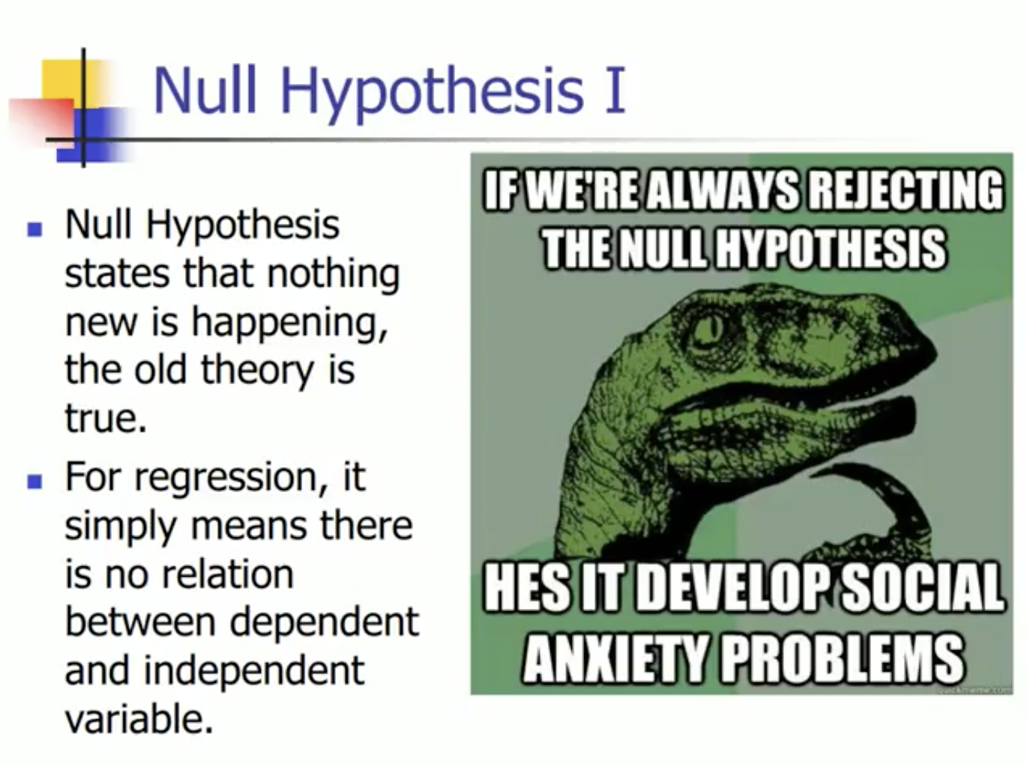

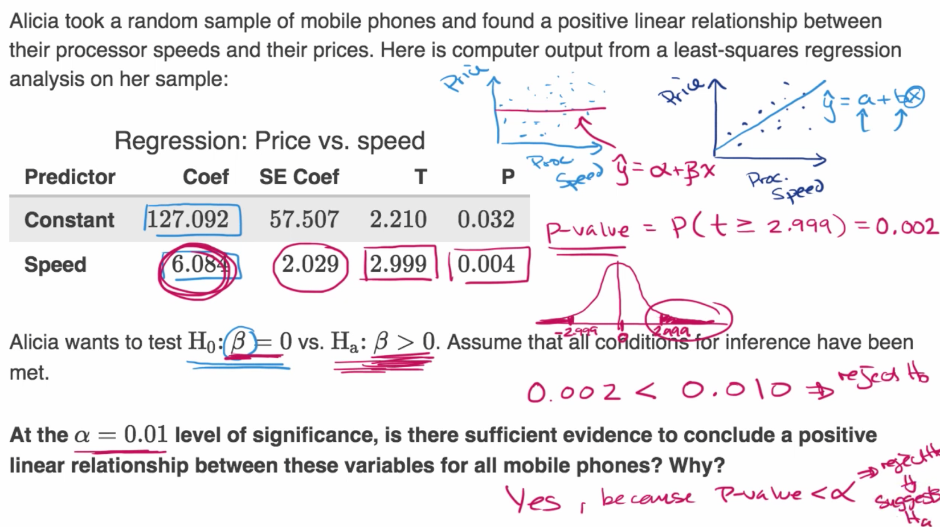

**Note: In Linear Regression often we check whether m is 0 or not(that means whether there is any linear relationship between dependent (y) and independent (x) variable)**

**y = mx + c**

**y = b0+ b1*x1 +b2*x2 + b3*x3**

**x1, x2, x3 are independent variable**

**In Null hypothesis we assume that b1, b2 b3 are 0 that is independent variable is not dependent.**

**So, if p is less, we reject the null hypothesis**

**Statistical Interaction:**

When you think of an interaction, a social interaction or a drug interaction might come to mind. But did you know that there might be an interaction amongst the variables in your research? In statistics, an interaction is a special property of three or more variables, where two or more variables interact to affect a third variable in a non-additive manner. In other words, the two variables interact to have an effect that is more than the sum of their parts.

To illustrate, think of a drug interaction: barbiturates alone have a depressive effect on your central nervous system. Alcohol alone has a depressive effect on your central nervous system. Taken together, these two drugs strengthen the effect of the other drug, beyond the effect that that drug would normally produce, so much so that you could fall into a coma!

<https://www.statisticssolutions.com/statistical-interaction-more-than-the-sum-of-its-parts/>

Imp Note:

<https://www.statisticshowto.com/interaction-effect-interacting-variable/>

An interaction effect happens when one [explanatory variable](https://www.statisticshowto.com/explanatory-variable/) interacts with another explanatory variable on a [response variable](https://www.statisticshowto.com/dependent-variable-definition/). This is opposed to the “[main effect](https://www.statisticshowto.com/main-effect/)” which is the action of a single independent variable on the dependent variable.

For example, let’s say you were studying the effects of a diet drink and a diet pill (the explanatory variables) on weight loss. The “main effects” would be the effect of a diet drink on weight loss, and the effect of the diet pill on weight loss. The interaction effect happens when the drink and pill taken at the same time. It’s possible the combination could speed up weight loss, or even slow it down. **Synergy** in medicine, where two drugs work together to produce an effect greater than their additive individual effects, is a special case of an interaction effect.

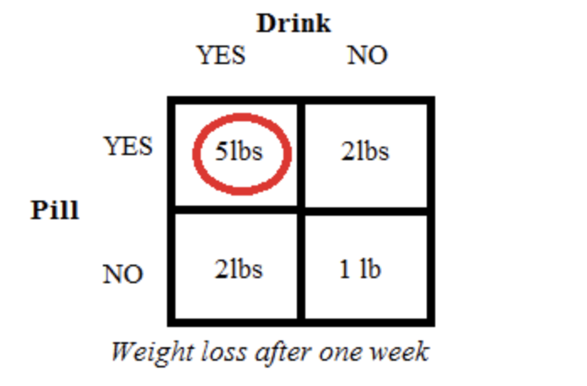

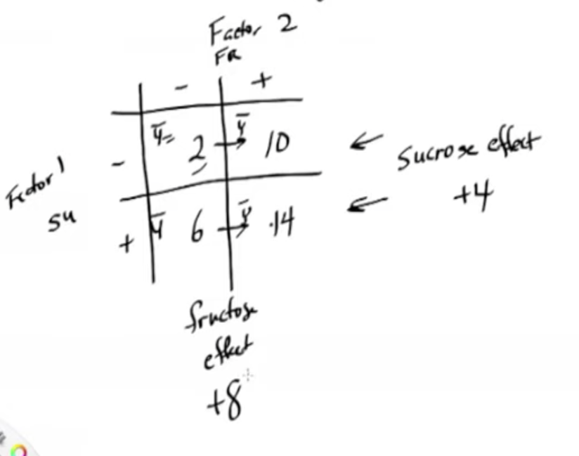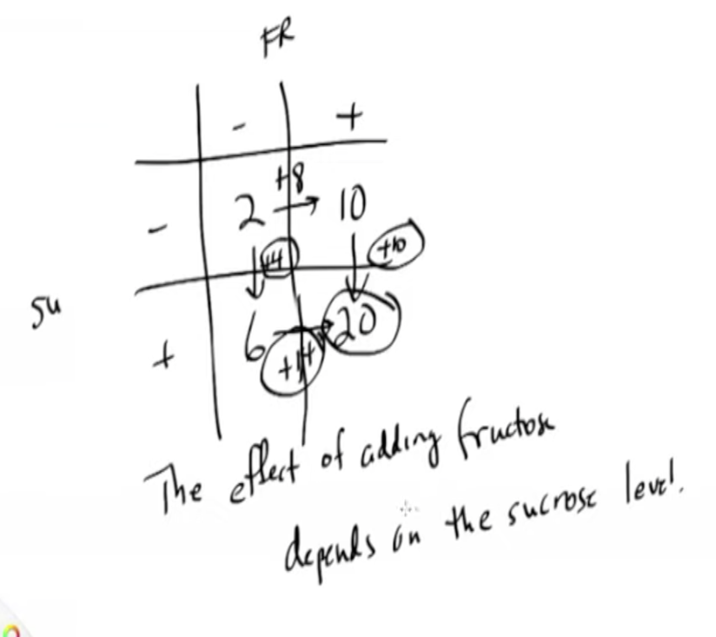

**Selection Bias:** To overcome selection bias you should do random selection.

E.g.: If you want to know in a particular town whether girls wear pink t-shirt. You will select majority of population who wears pink t-shirt. This is classic example of selection bias.

**Supervised learning:** Data is split into training and testing. Data is labelled means input and output are labelled

There are 2 types of supervised learning:

1. Classification: data is classified into various groups e.g.: mail is classified into spam and non-spam:

When output variable is category such as “red” or “blue” and “disease” or “no disease”. Eg: Decision Tree, Logistic Regression

1. Regression: Regression is used to identify a continuous quantity. When output is real value such as “dollars” or “weight”. Eg: Regression Tree/Random Forest, Linear Regression

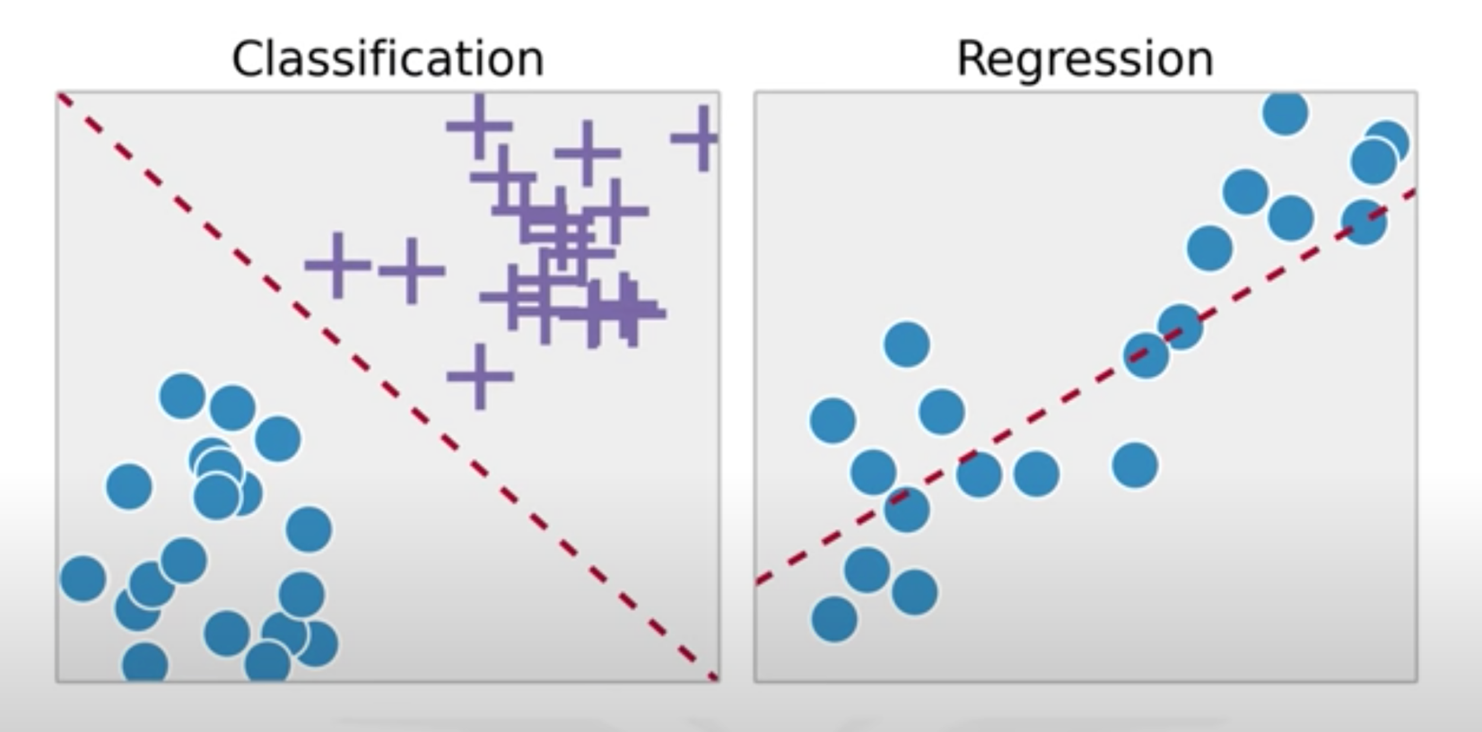

Supervised:

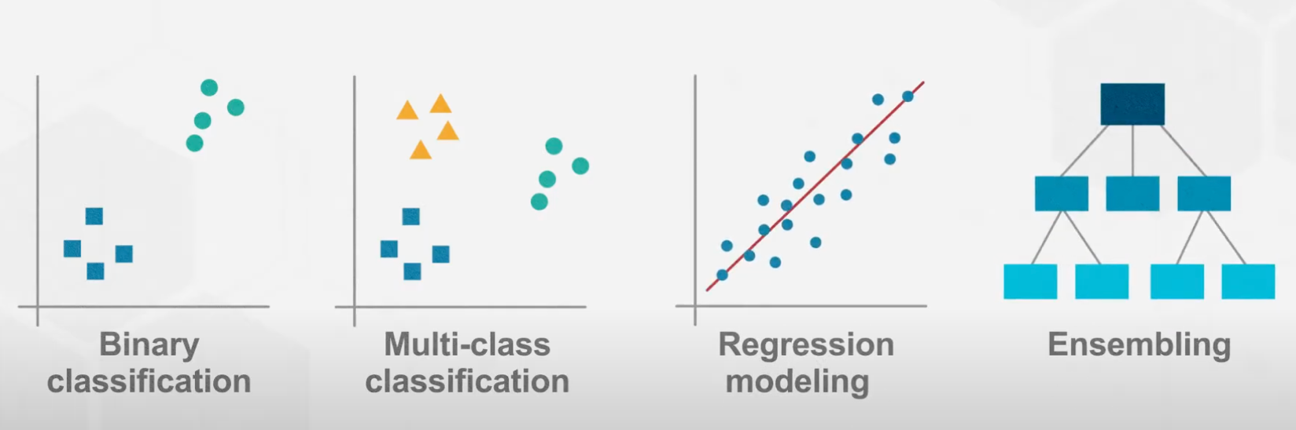

Unsupervised:

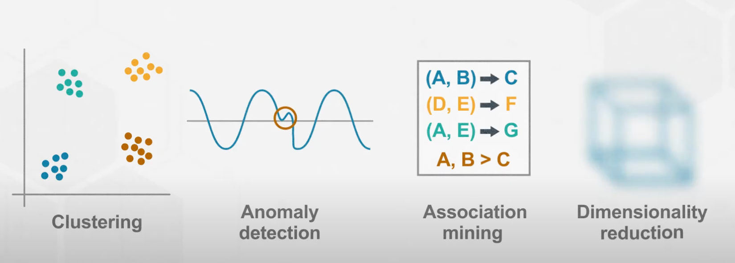

Supervised Unsupervised and Reinforcement Learning:

**Definition:**

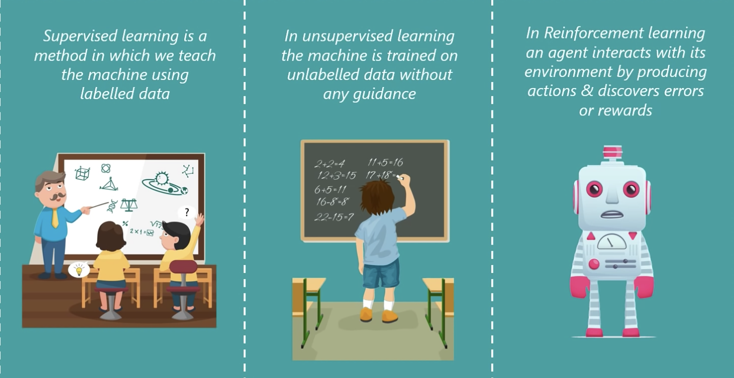

**Type of Problems:**

**Classification** is about predicting label or class: Email spam and non-spam

Regression is about predicting continuous quantity: e.g., predicting weight of a person

**Association** basically involve discovering patterns in data finding cooccurrences. people who tend to buy bread also buy jam

**Clustering** is used for cases that involve targeted marketing. List of customer and info. Cluster these customer based on their interest

**Anomaly detection**: Credit card fraud

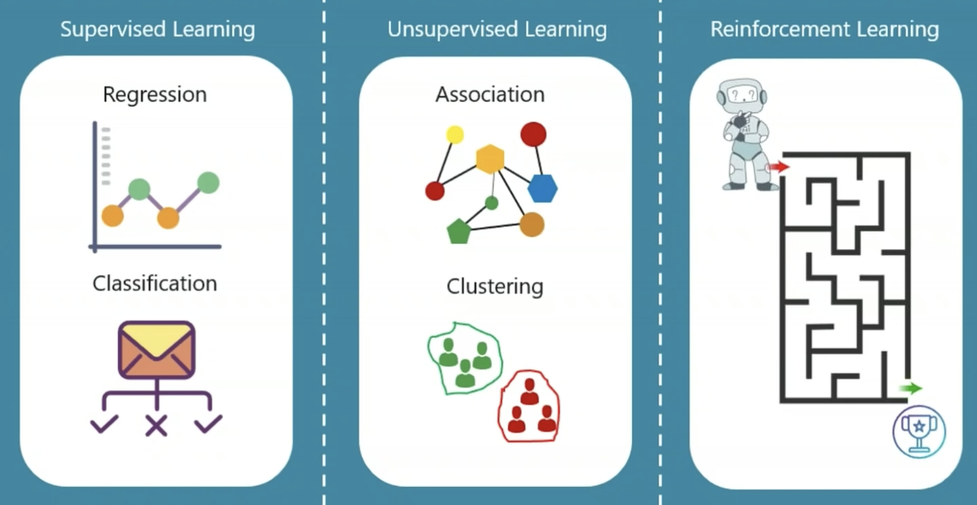

**Type of data:**

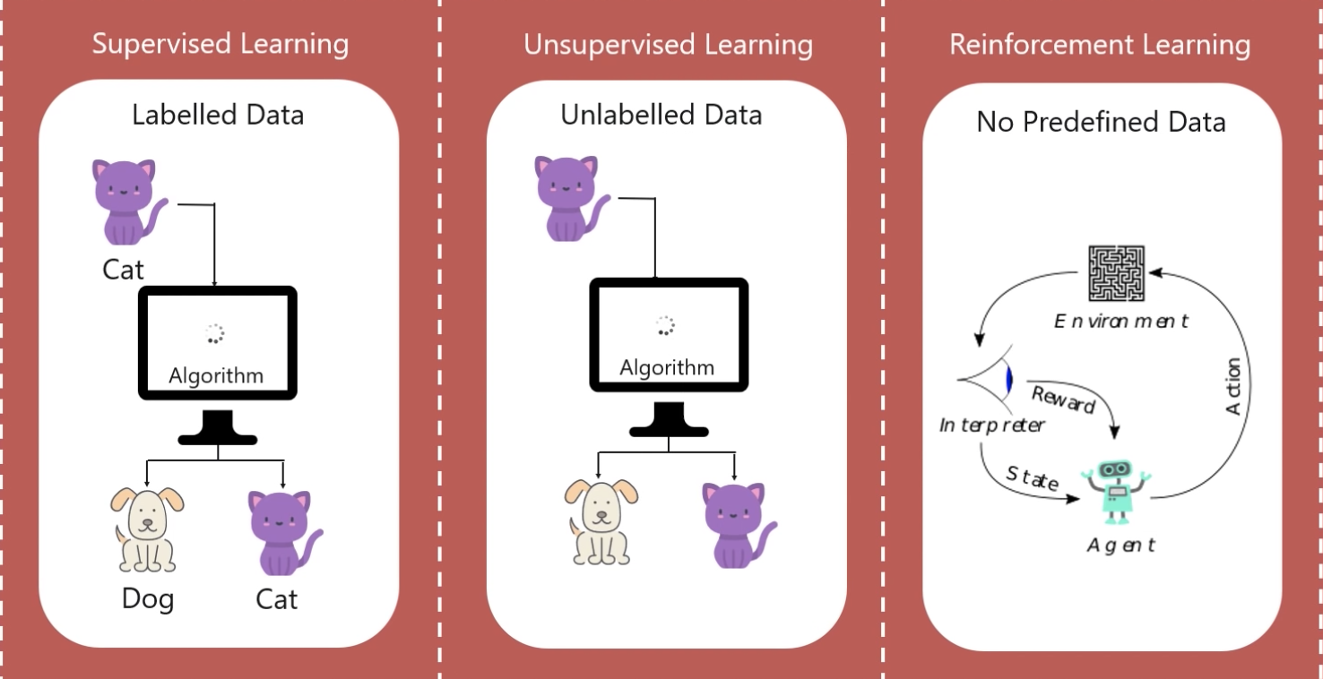

**Training:**

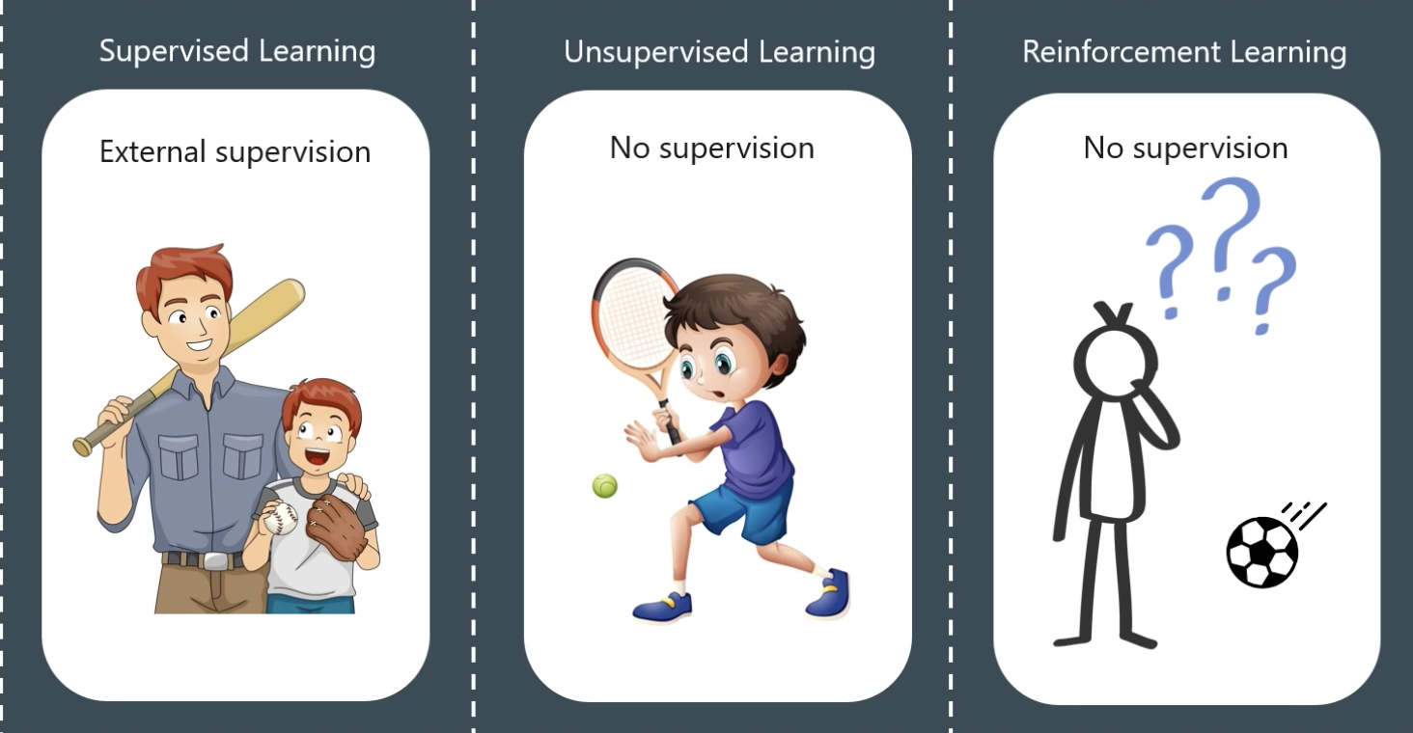

**Aim:**

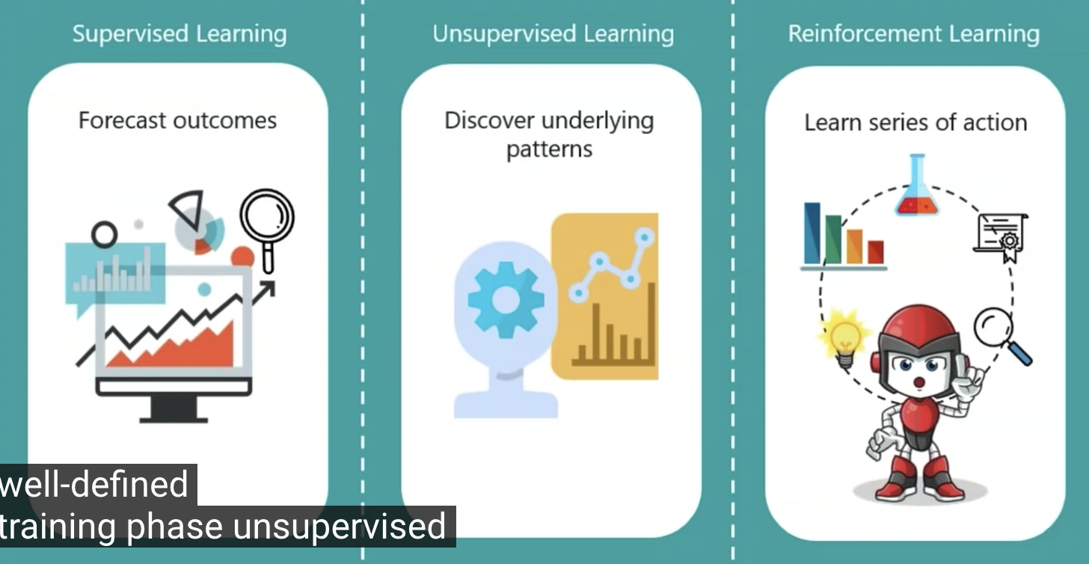

**Approach:**

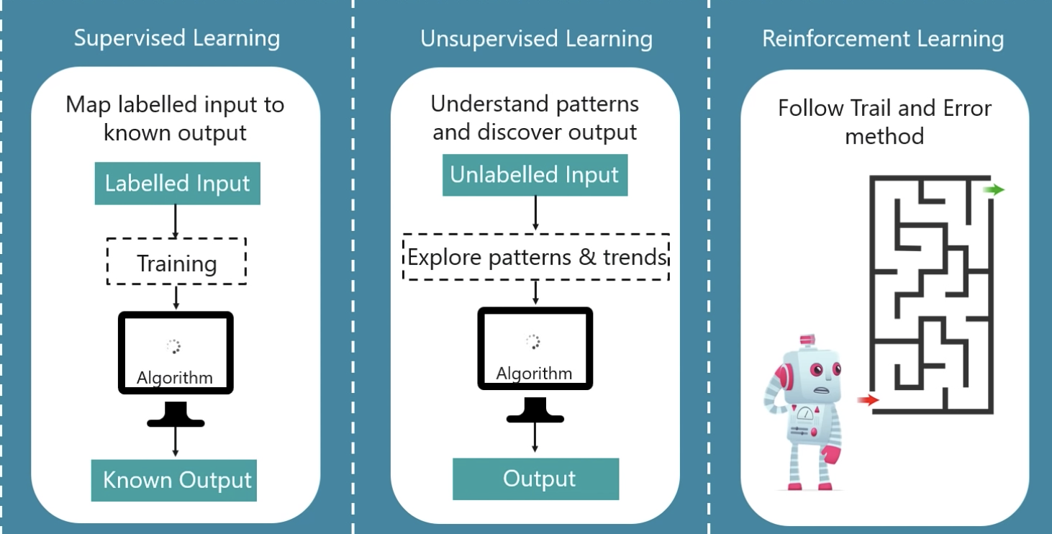

**Output feedback:**

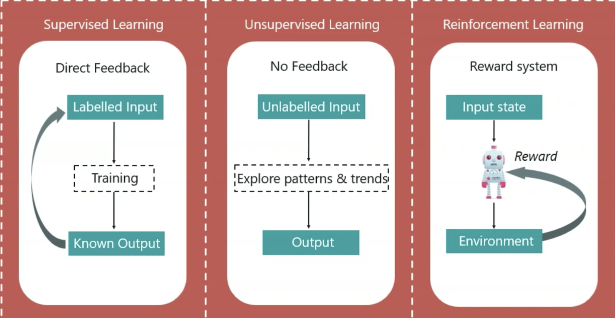

**Popular algorithms:**

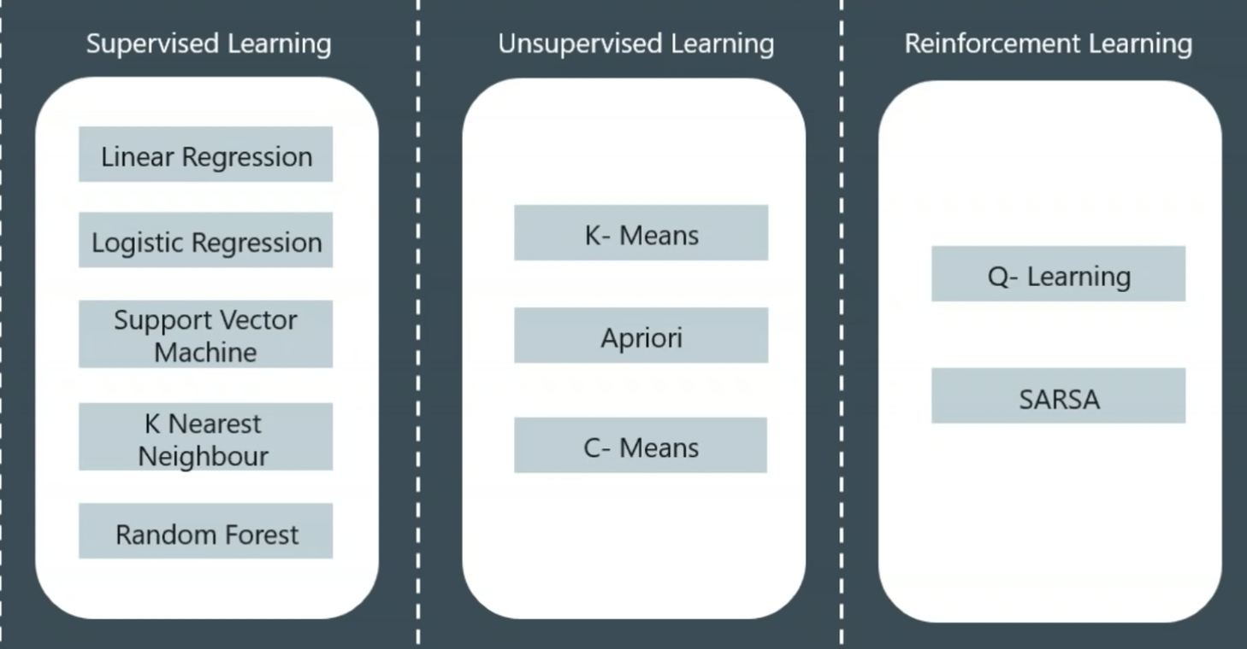

**Applications:**

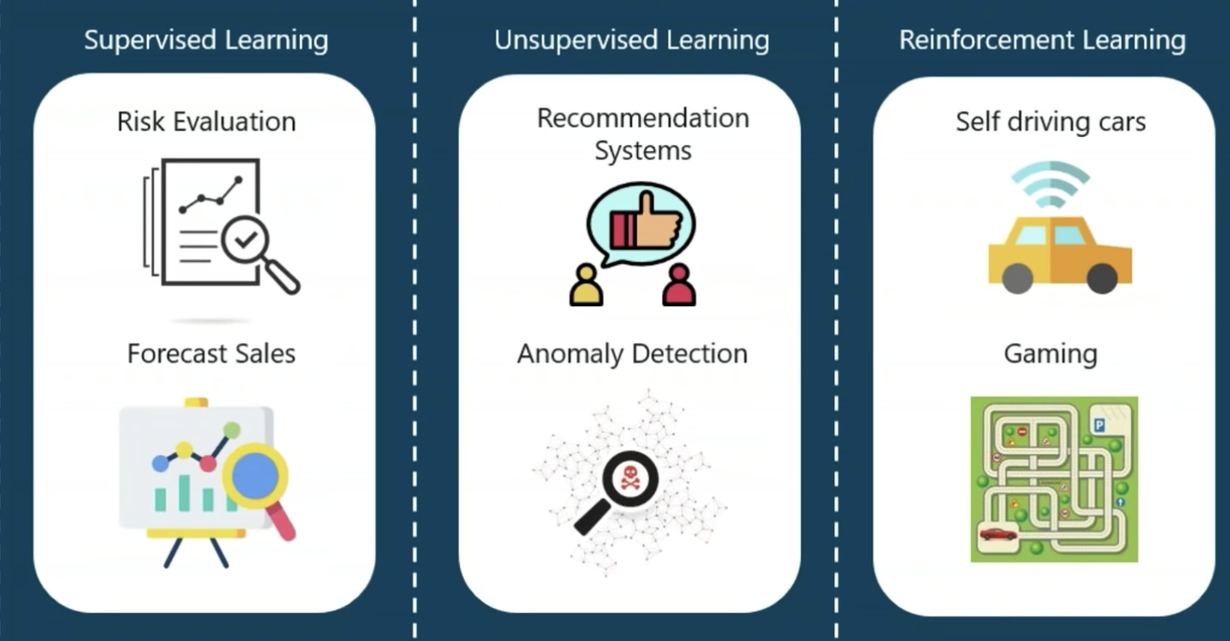

**When to use Linear Regression and Logistic Regression?**

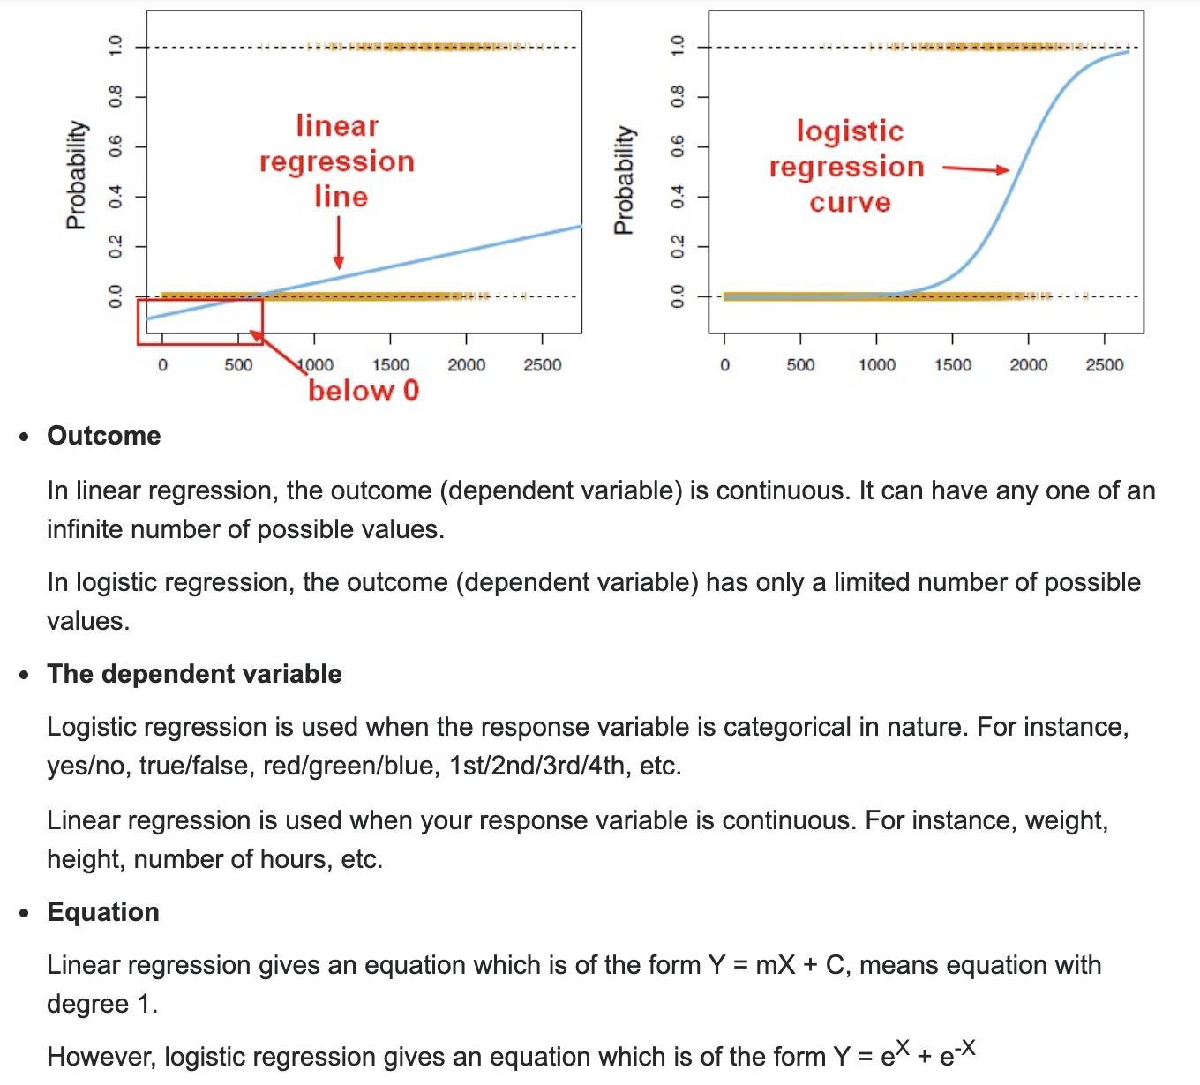

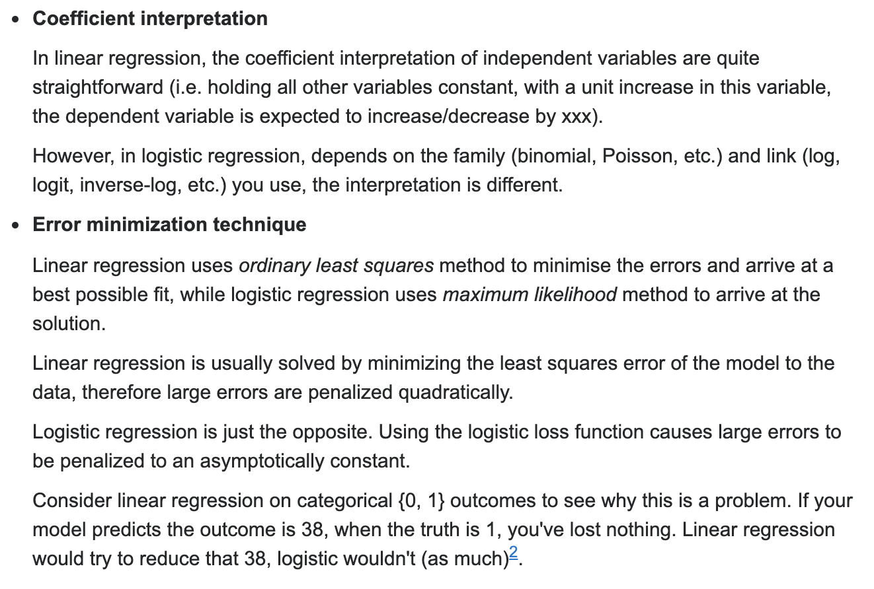

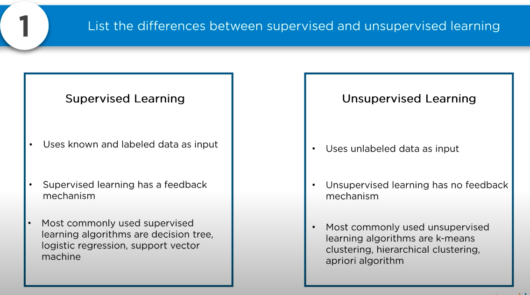

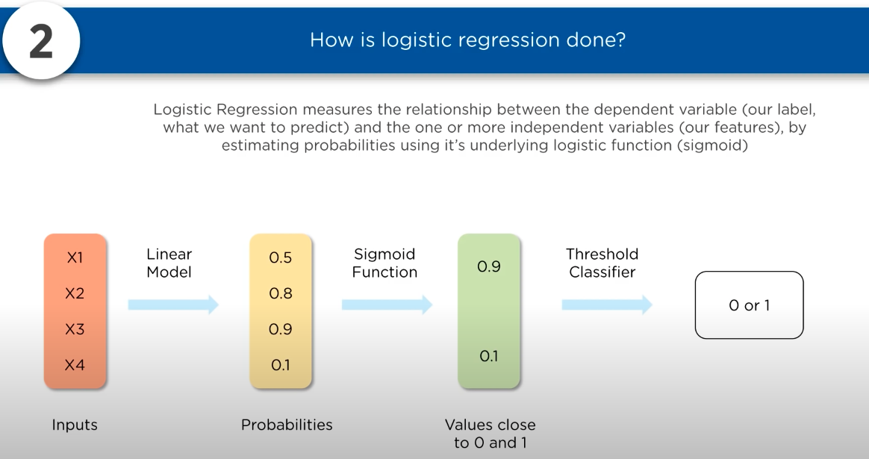

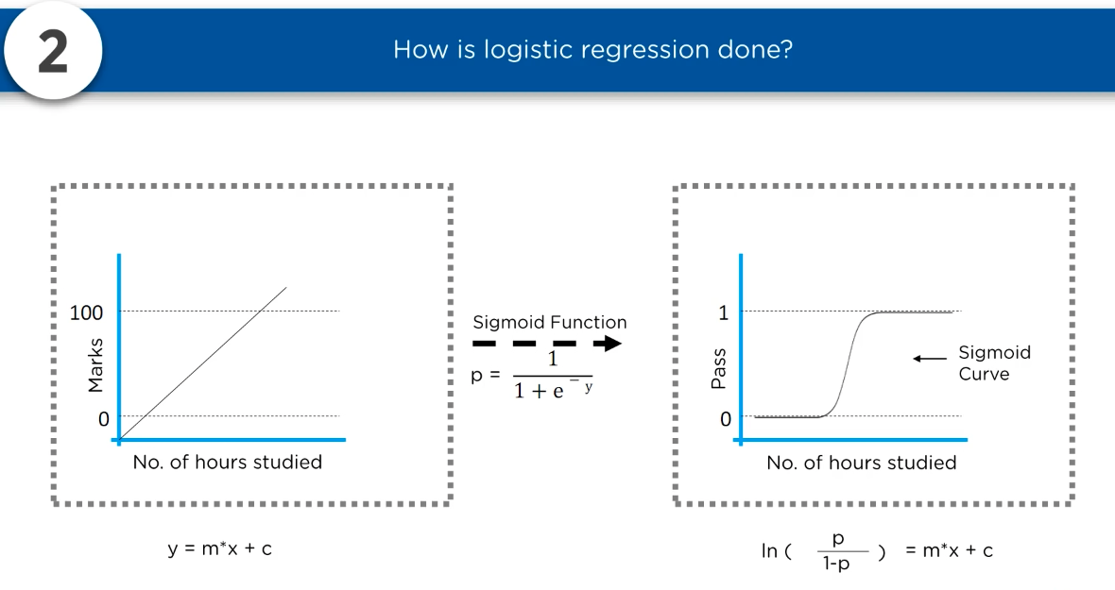

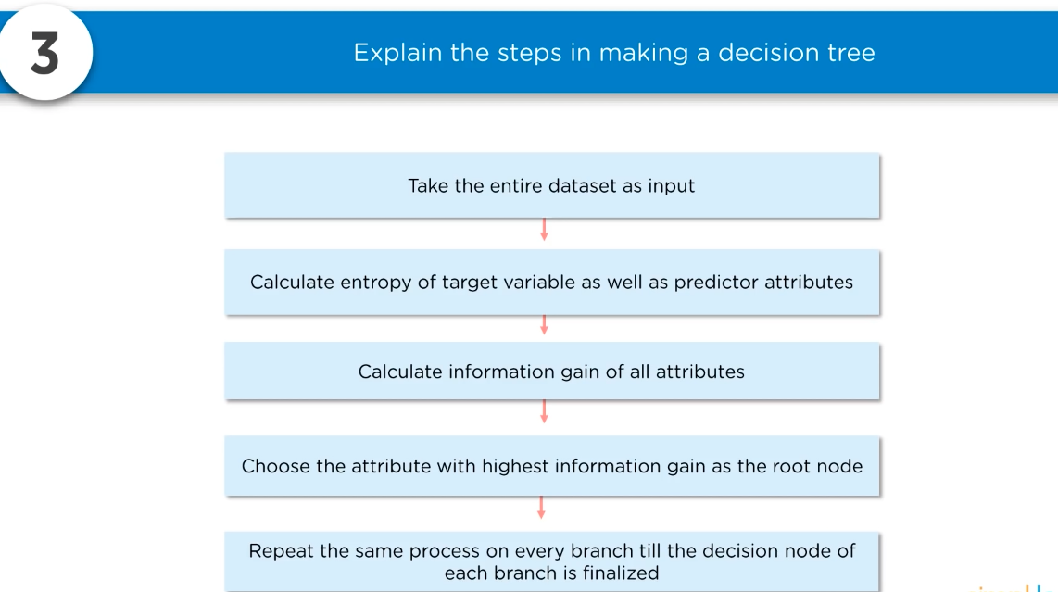

Entropy – how chaotic it is

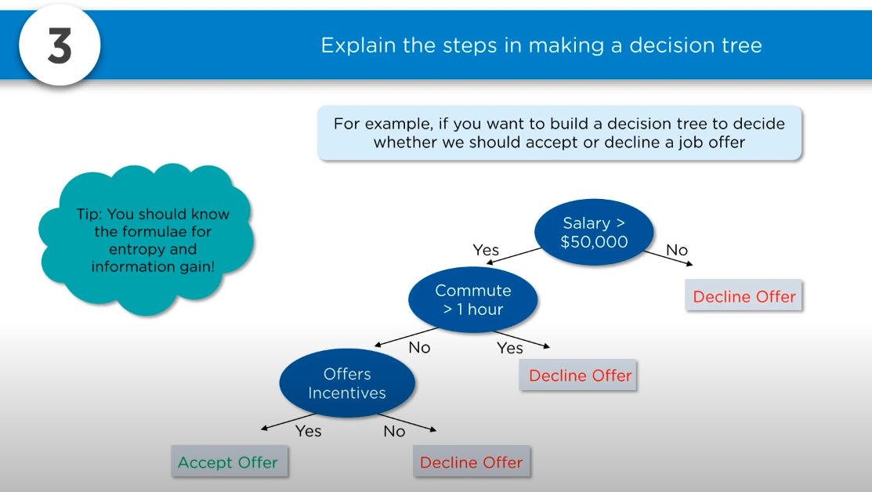

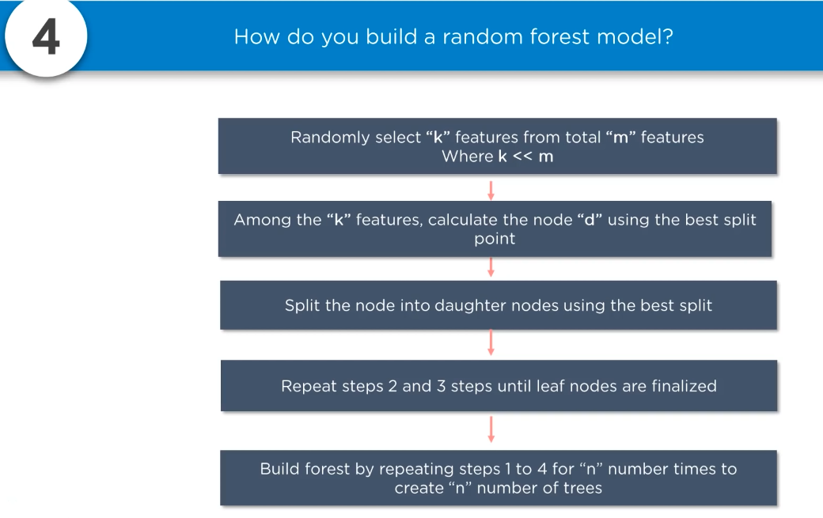

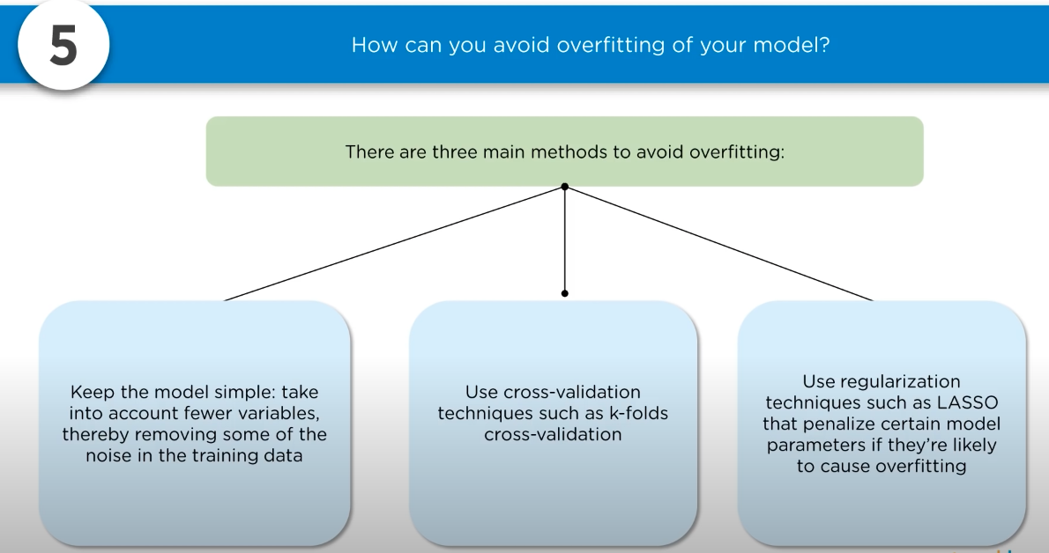

Overfitting: your model is only set for very small amt of data thereby ignoring the larger picture

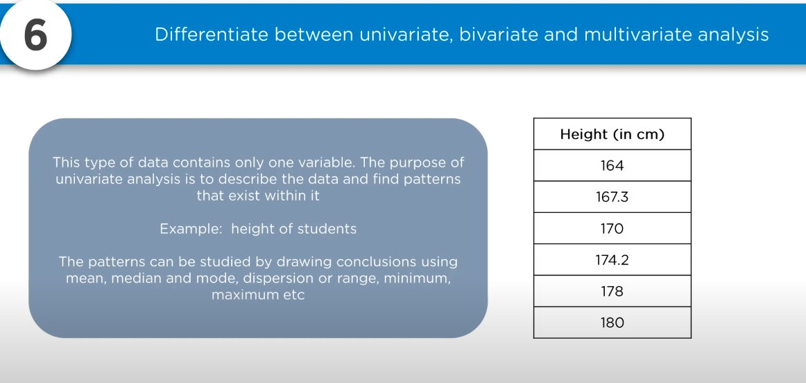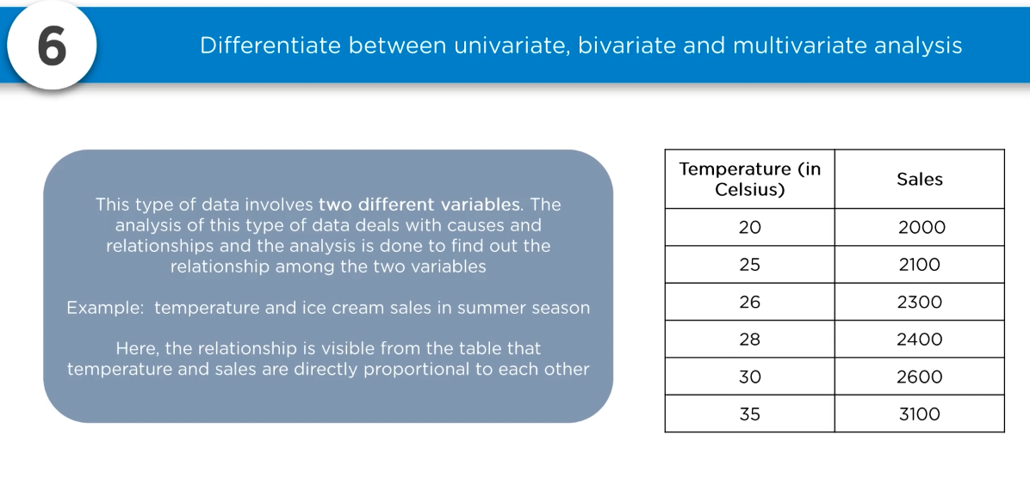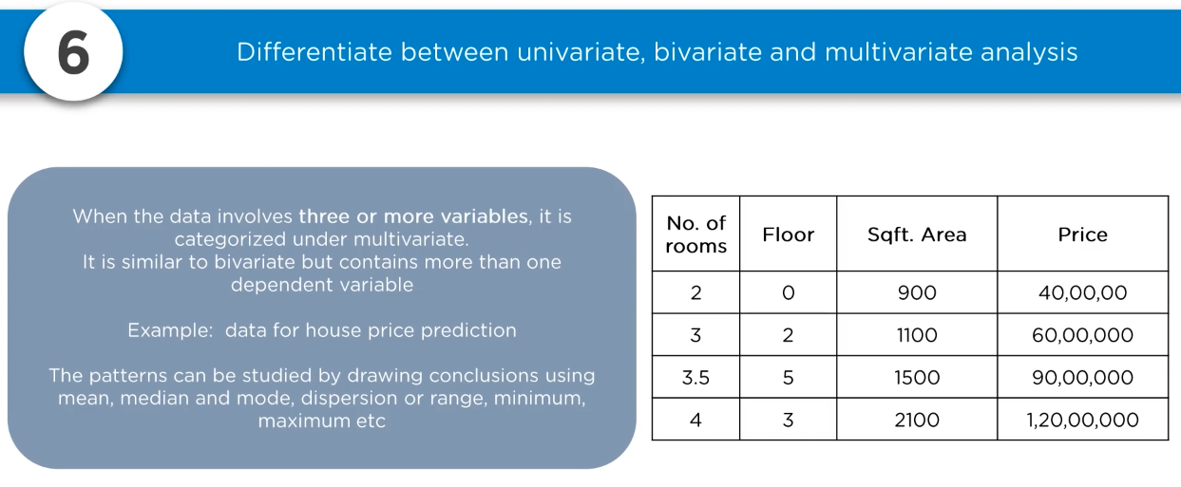

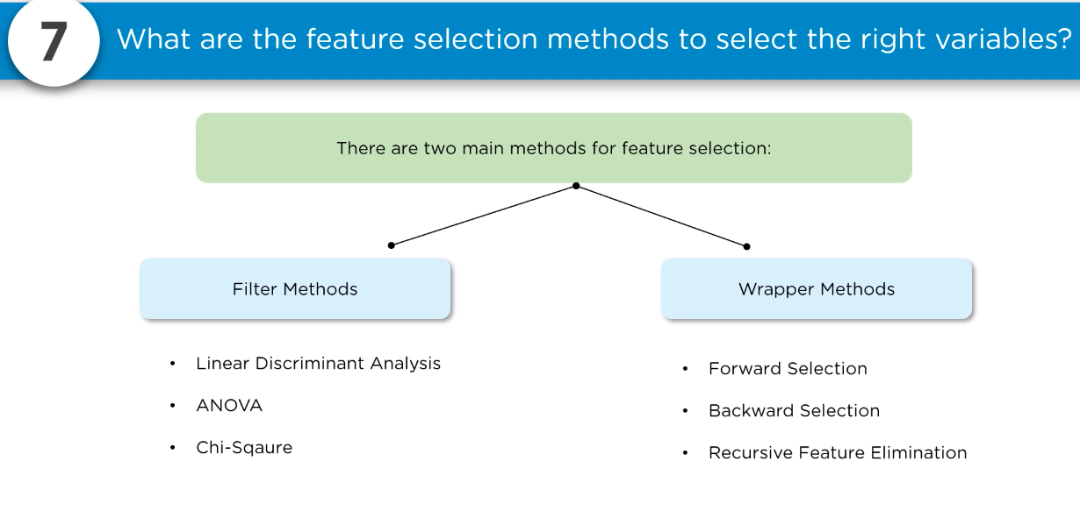

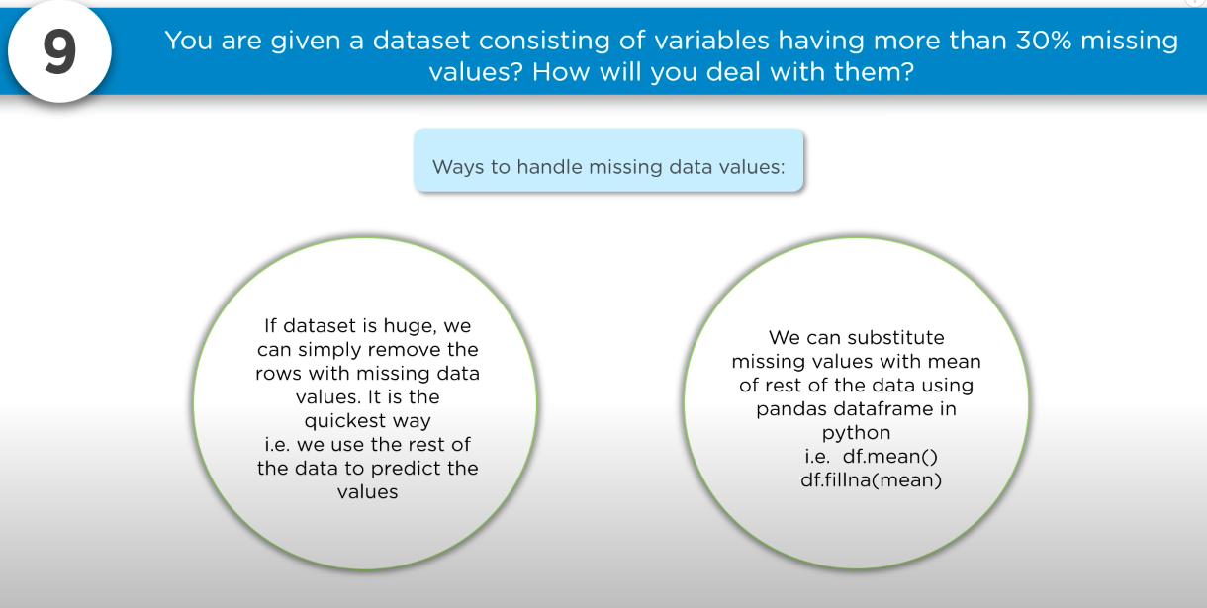

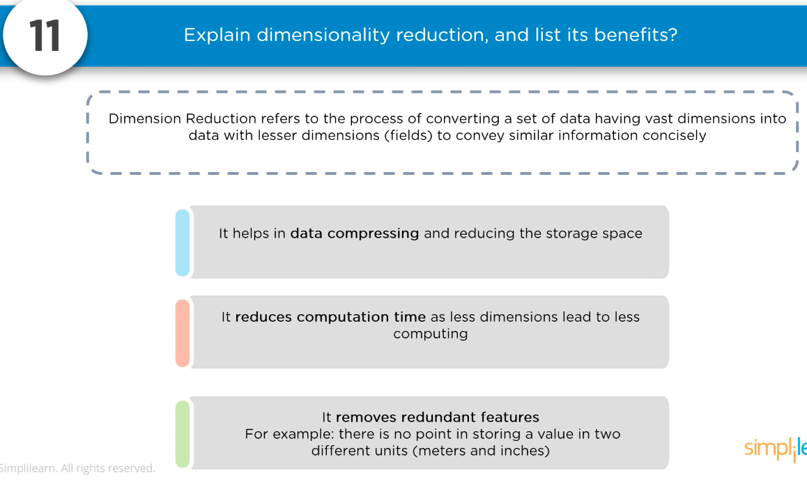

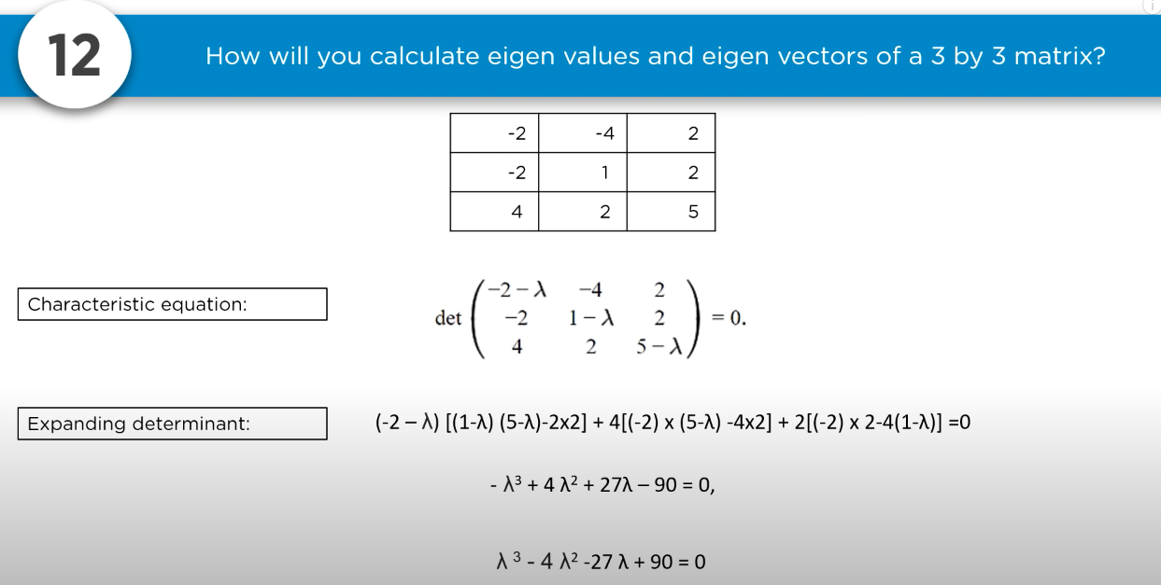

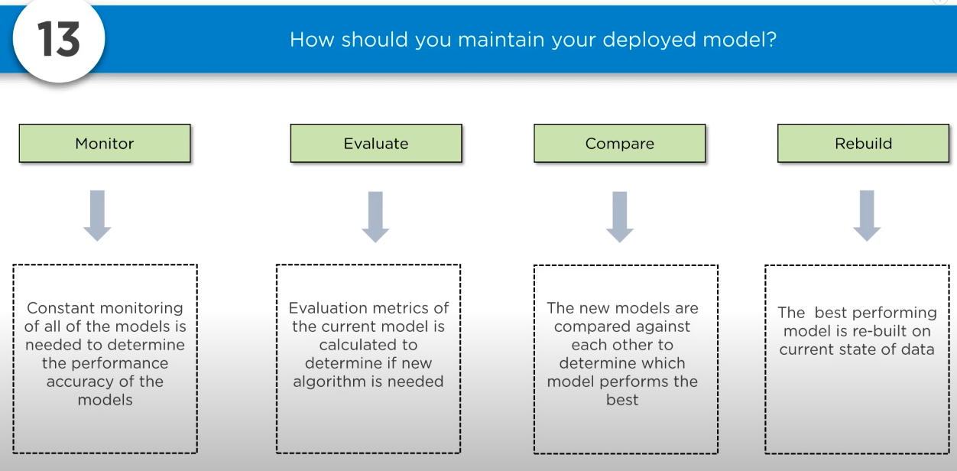

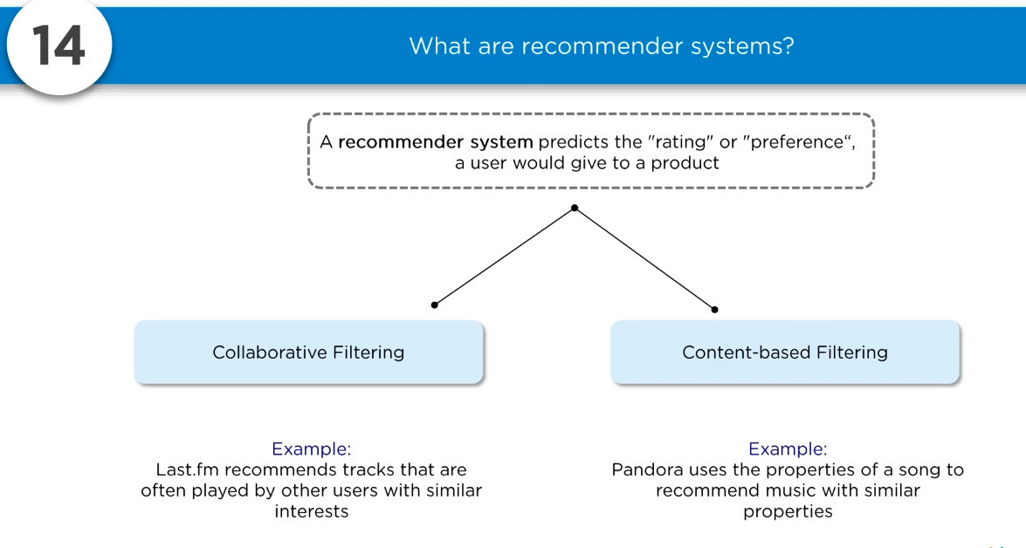

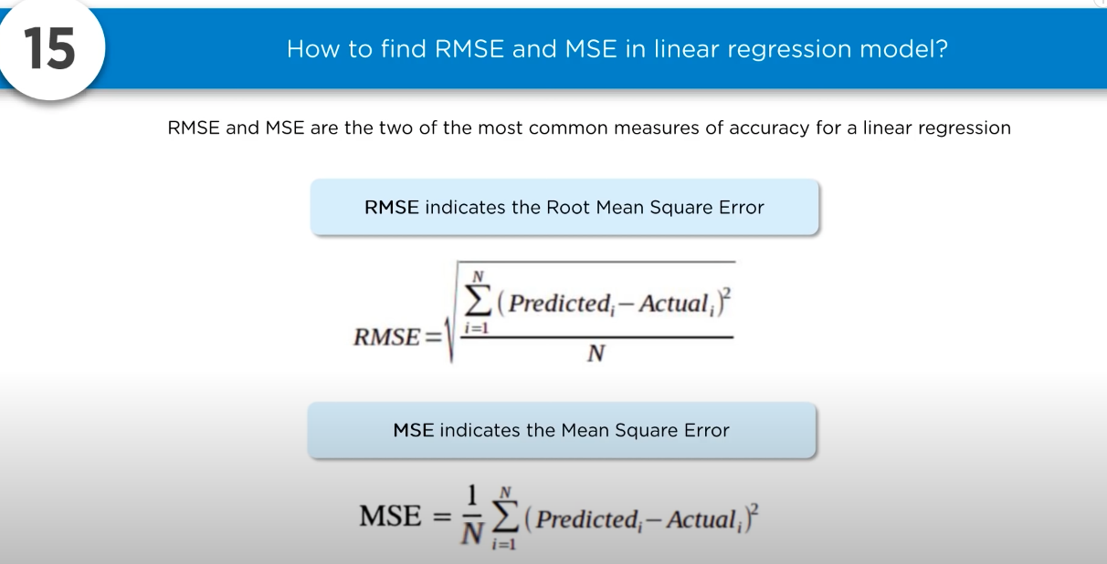

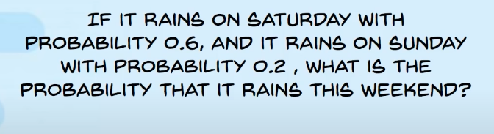

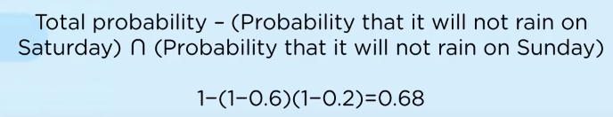

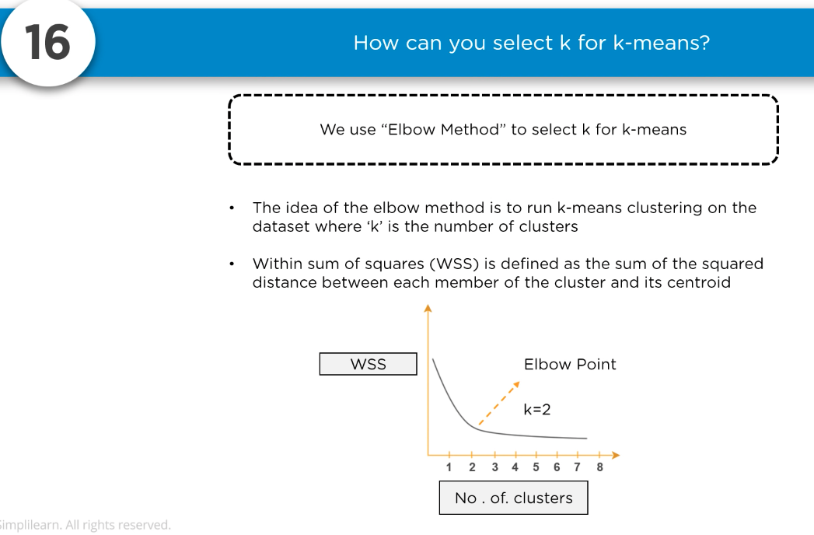

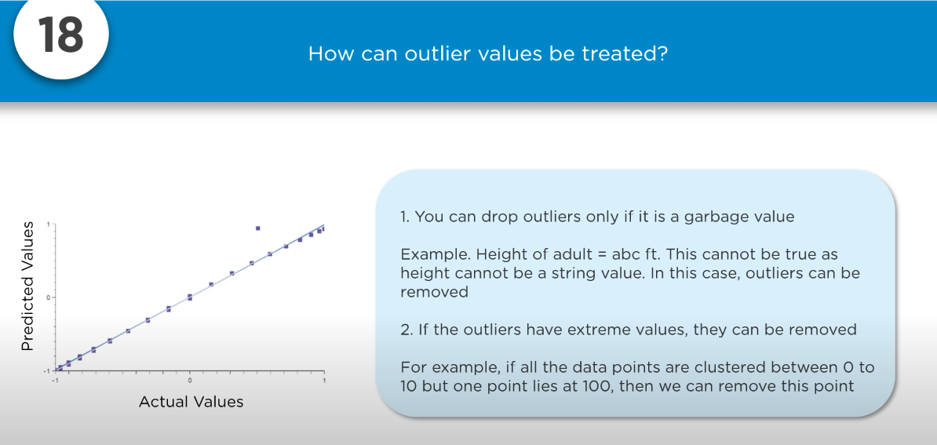

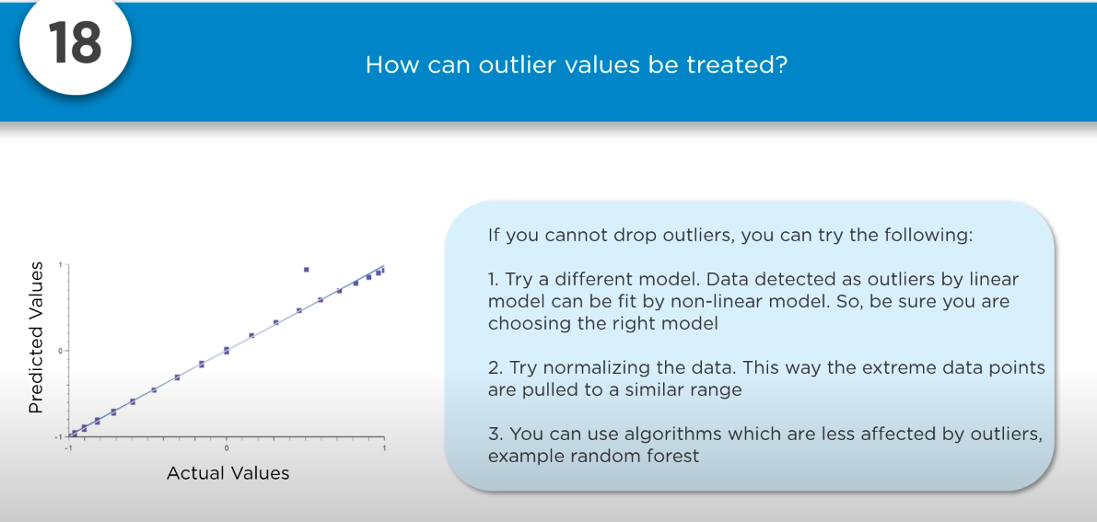

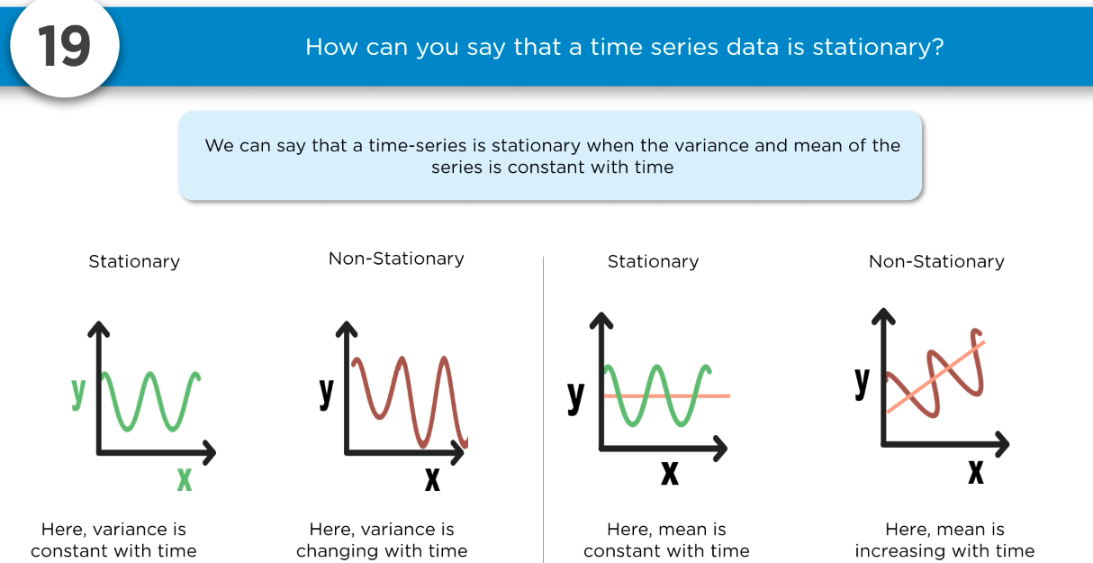

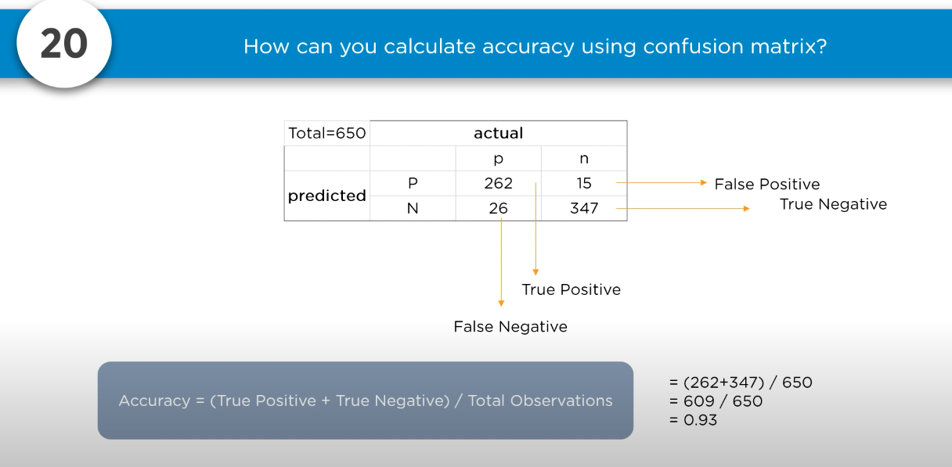

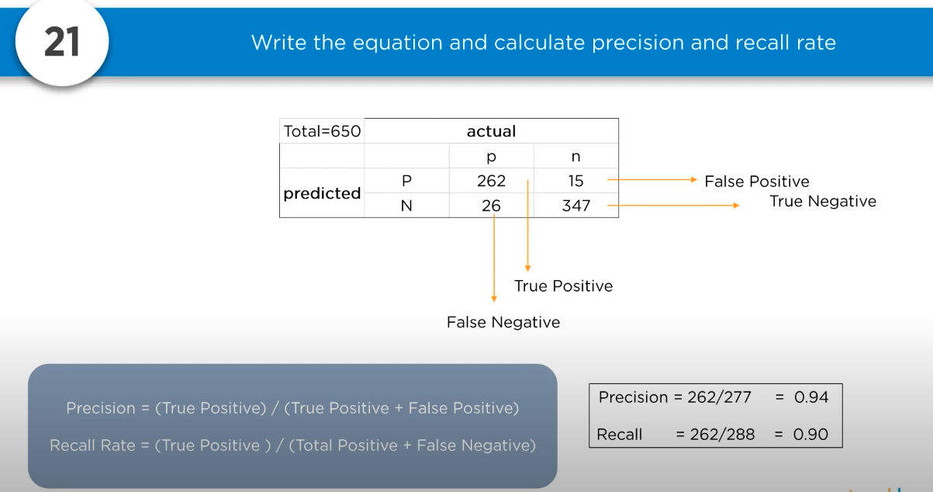

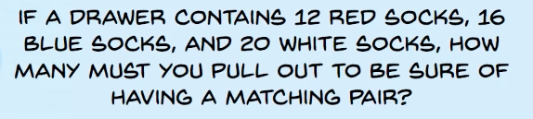

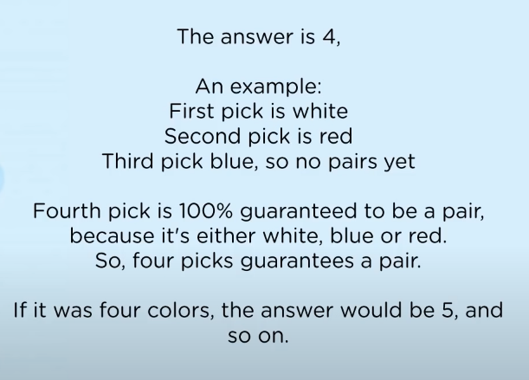

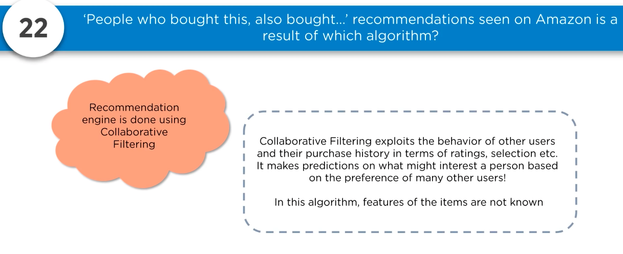

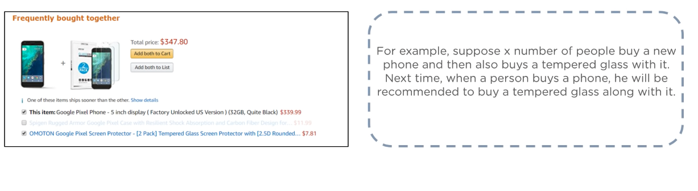

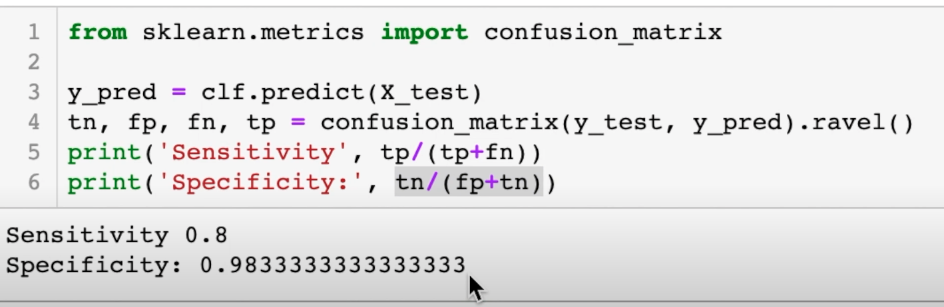

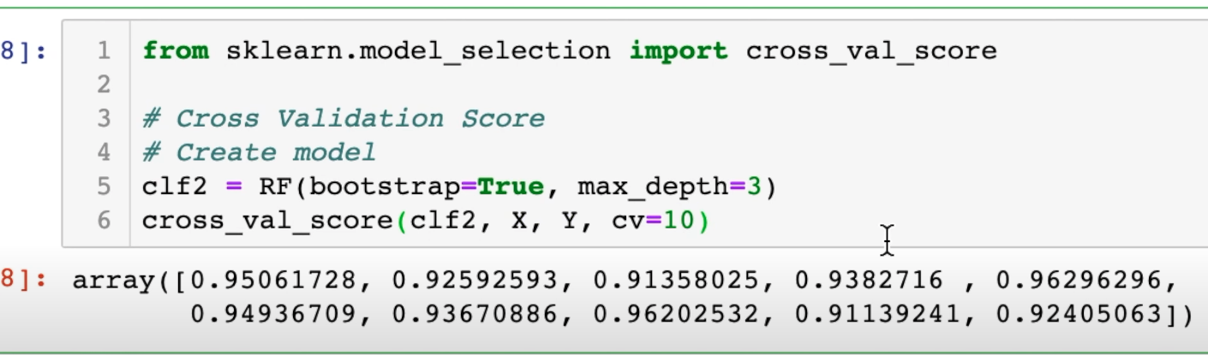

<https://www.youtube.com/watch?v=fd5HsK6aOkg&ab_channel=RylanFowers>

**Optimal stopping:**

Optimal stopping is concerned with the problem of choosing a time to take a particular action, in order to maximize an expected reward or minimize an expected cost

**When you are in race with the time and your options are limited, few aspects of decision making are important like when to stop.**

**E.g.: Buying house in California**

**It turns out 37 percent. 1/e**

[**https://en.wikipedia.org/wiki/Secretary_problem**](https://en.wikipedia.org/wiki/Secretary_problem)

[https://youtu.be/tVRGadNoHC](https://youtu.be/tVRGadNoHC0)

**Multi armed bandit:**

[**https://www.youtube.com/watch?v=e3L4VocZnnQ&ab_channel=ritvikmath**](https://www.youtube.com/watch?v=e3L4VocZnnQ&ab_channel=ritvikmath)

**You are to eat from 3 rest for 300 days. How much happiness**

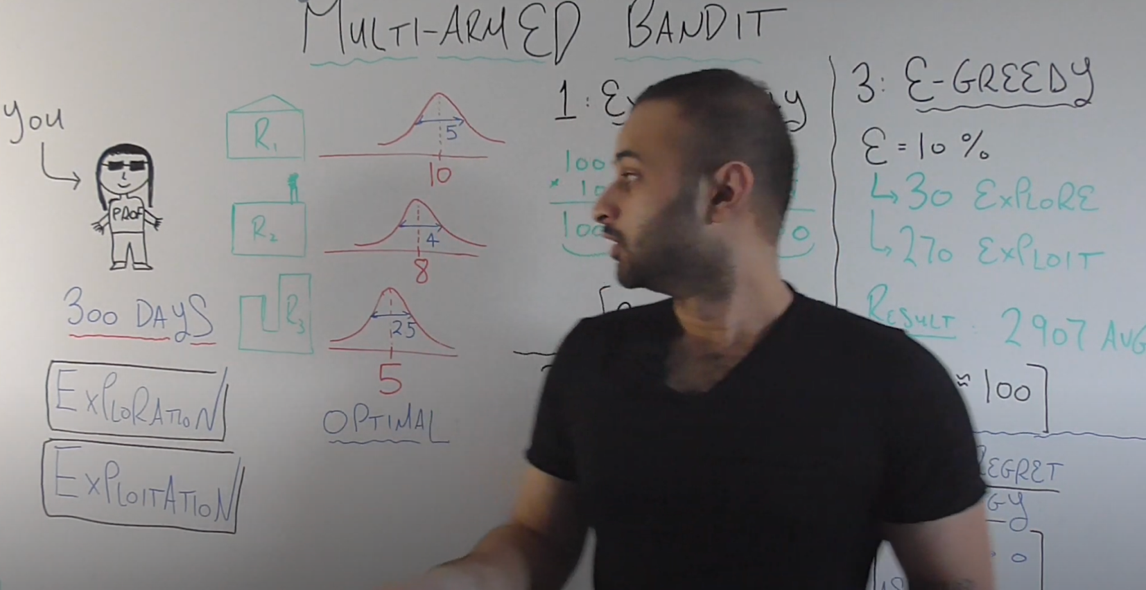

R1 – average Happiness 10, sd = 5

R2 – average Happiness 8, sd=4

R3 – average Happiness 5, sd=2.5

Initially you don’t know the distribution about how happy u will be with these restaurants. Your goal over these 300 days to select a restaurant that makes u happy

Exploration: Going to these restaurants enough time to understand which one u liked the best

Exploitation: Once u have a good idea which restaurant makes u the happiest, continue going to that restaurant for the remaining days after u have explored

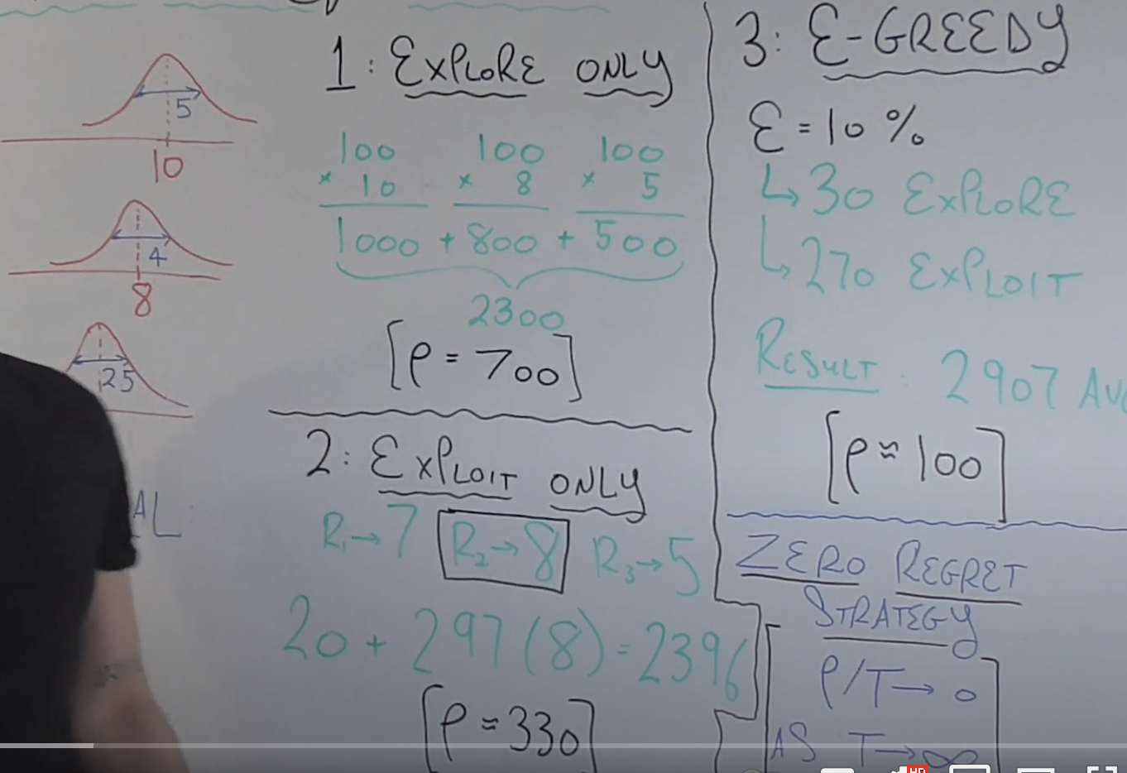

1. **Explore Only:** Using all the 300 days to explore. Average happiness is 2300. Regret is the diff between avg happiness and max happiness. Max happiness = 10*300

Regret = 3000-2300

So, explore only is 700 points away from the optimal. So its not great

1. **Exploit only**: we will only use 3 days. And then from these three days whichever restaurant gives more happiness we will start going to that restaurant for 297 days. The problem with this methods is you might not get the best happiness from the best restaurant for the first time u visited. Suppose u got R1=7, r2=8, r3=5

Now, average happiness is 8*297+7+5 +8= 2396

Regret =330

1. **Epsilon Greedy:**

**Epsilon =10 per = 0.1**

**30 days explore**

**270 days exploit**

**Result = 2907 avg**

**Regret =100**

**Zero regret strategy: as days goes to infinity regret will tend to zero**

**Thompson sampling:**

It consists of choosing the action that maximizes the expected reward with respect to a randomly drawn belief

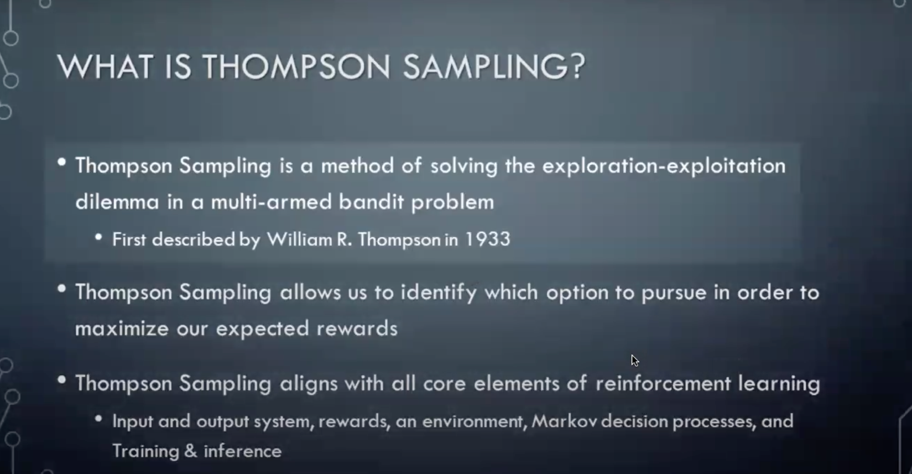

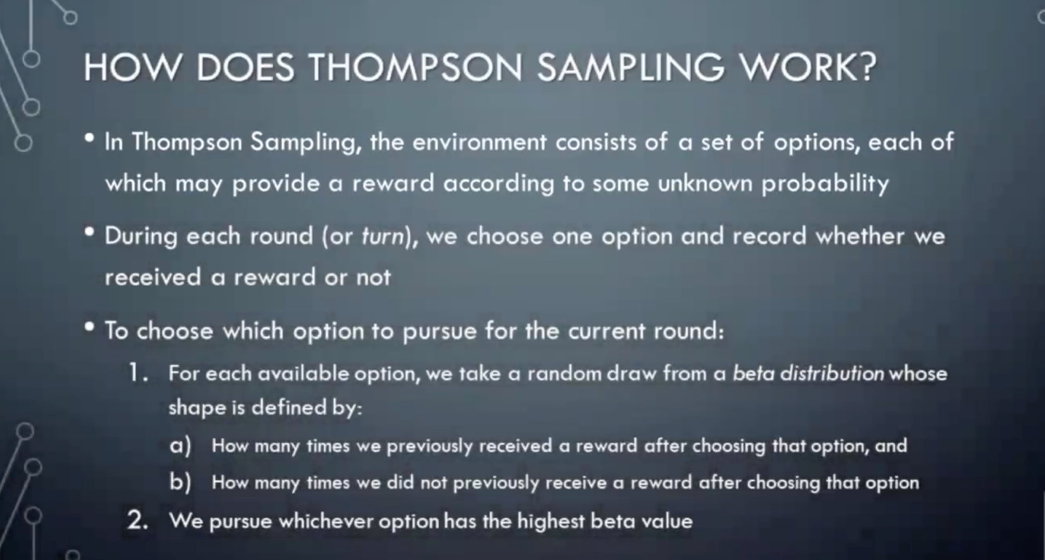

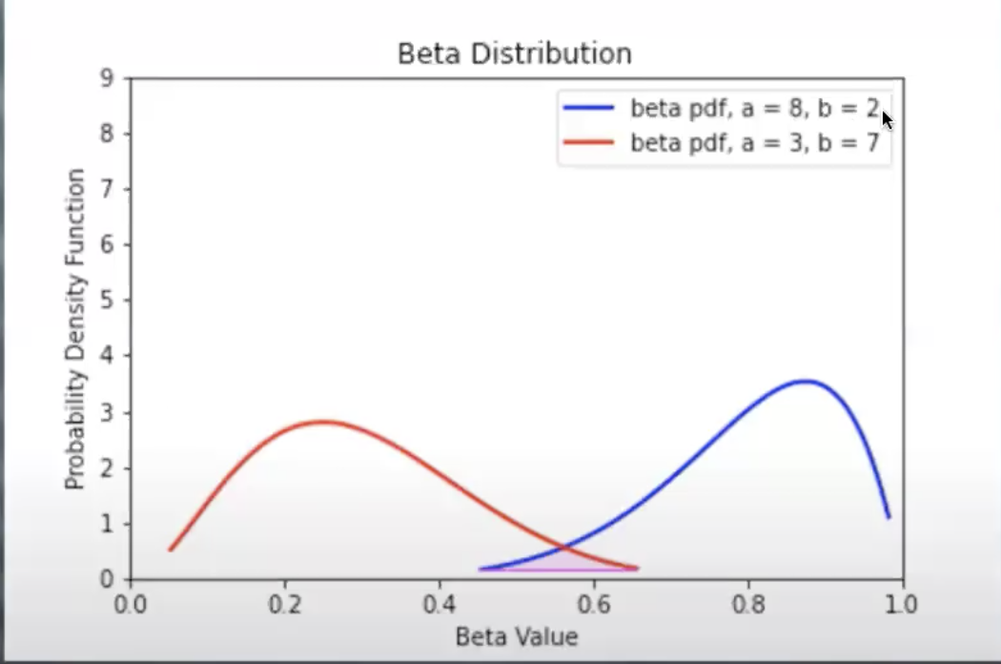

Red – slot machine 1

Blue- slot machine 2

As the beta value of slot machine 2 is more, we will select slot machine 2. After selecting the shape of beta distribution will change

**Beta distribution:**



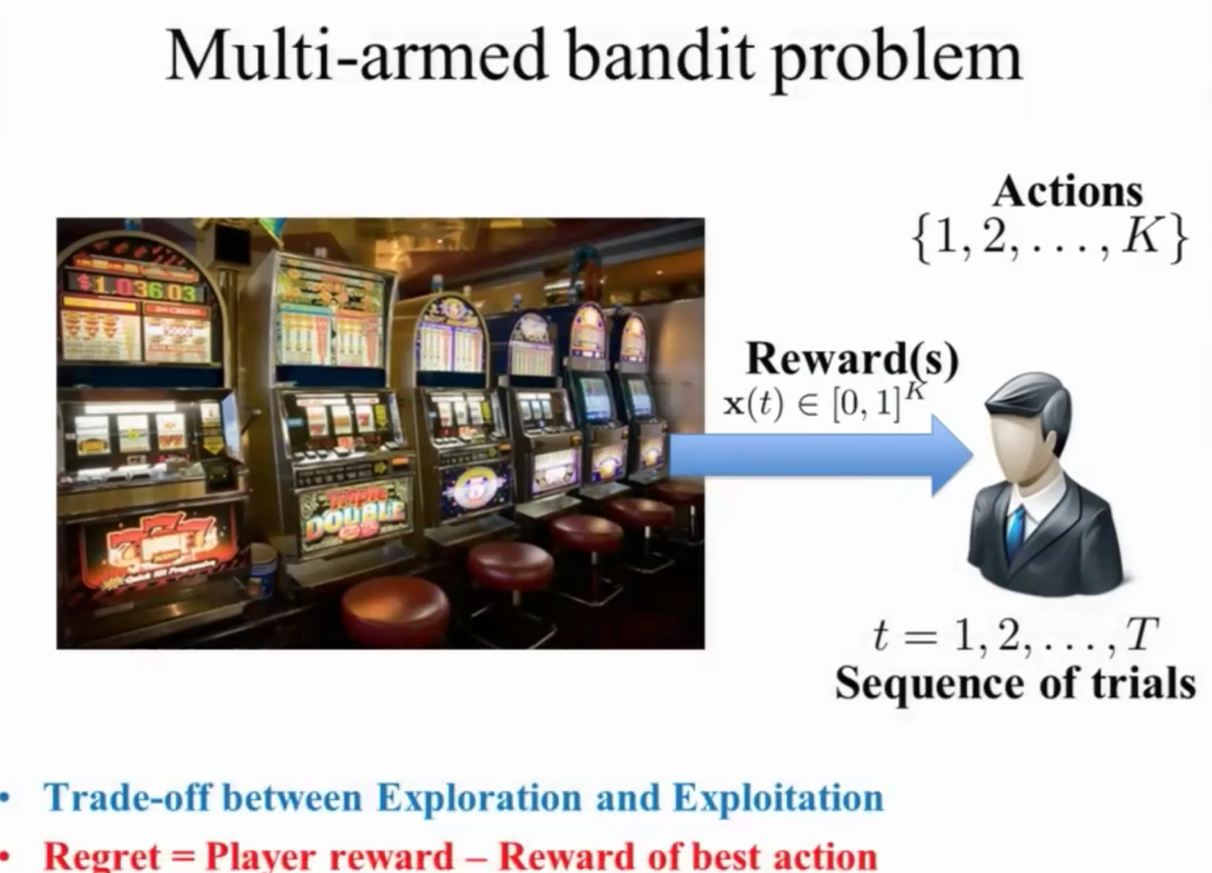

Action: 1) Pulling a slot machine

2) taking a drug or not

Rewards:

1. Money
2. Health status

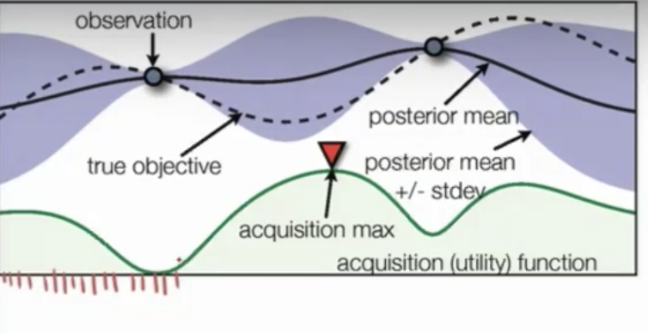

If u take x axis in green, you will get a rewrd range of purple color

The question is what should we choose?

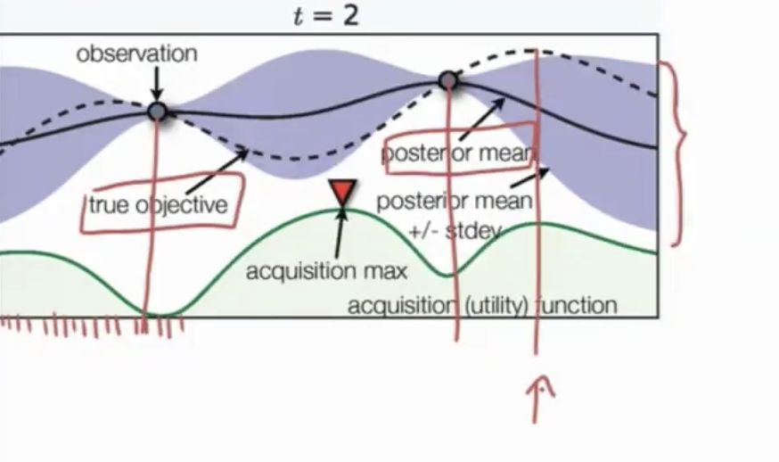confidence interval}

Purple color is mu+sd and mu-sd

Our function is to find the peak marked by arrow. Solid line represent whats going in our head. Dotted line represent the real world

Green part is acquisition function

**After pulling the machine where we get maximum reward, now next point is which point to try next**

**We should sample at max acquisition**

**Upper Confidence Bound**

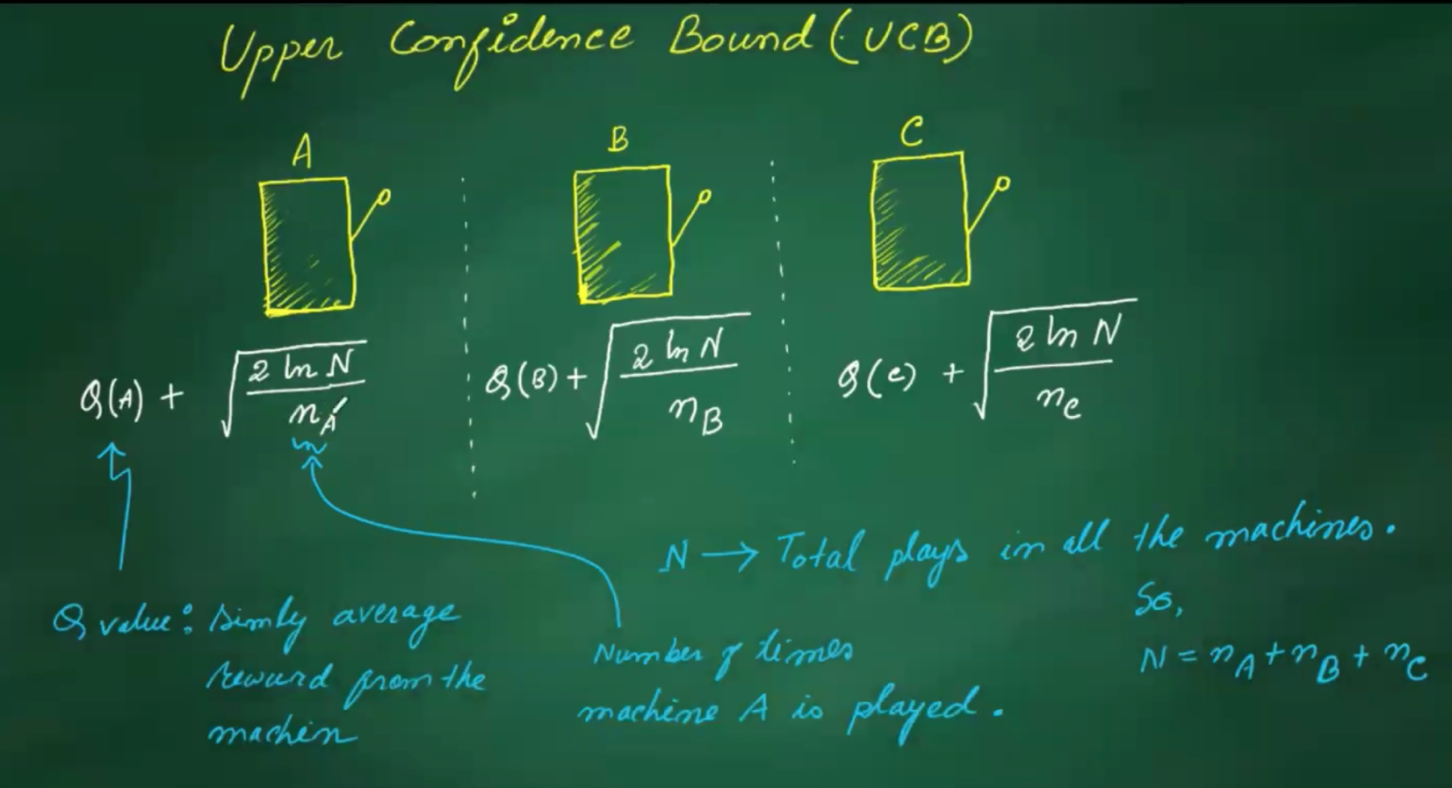

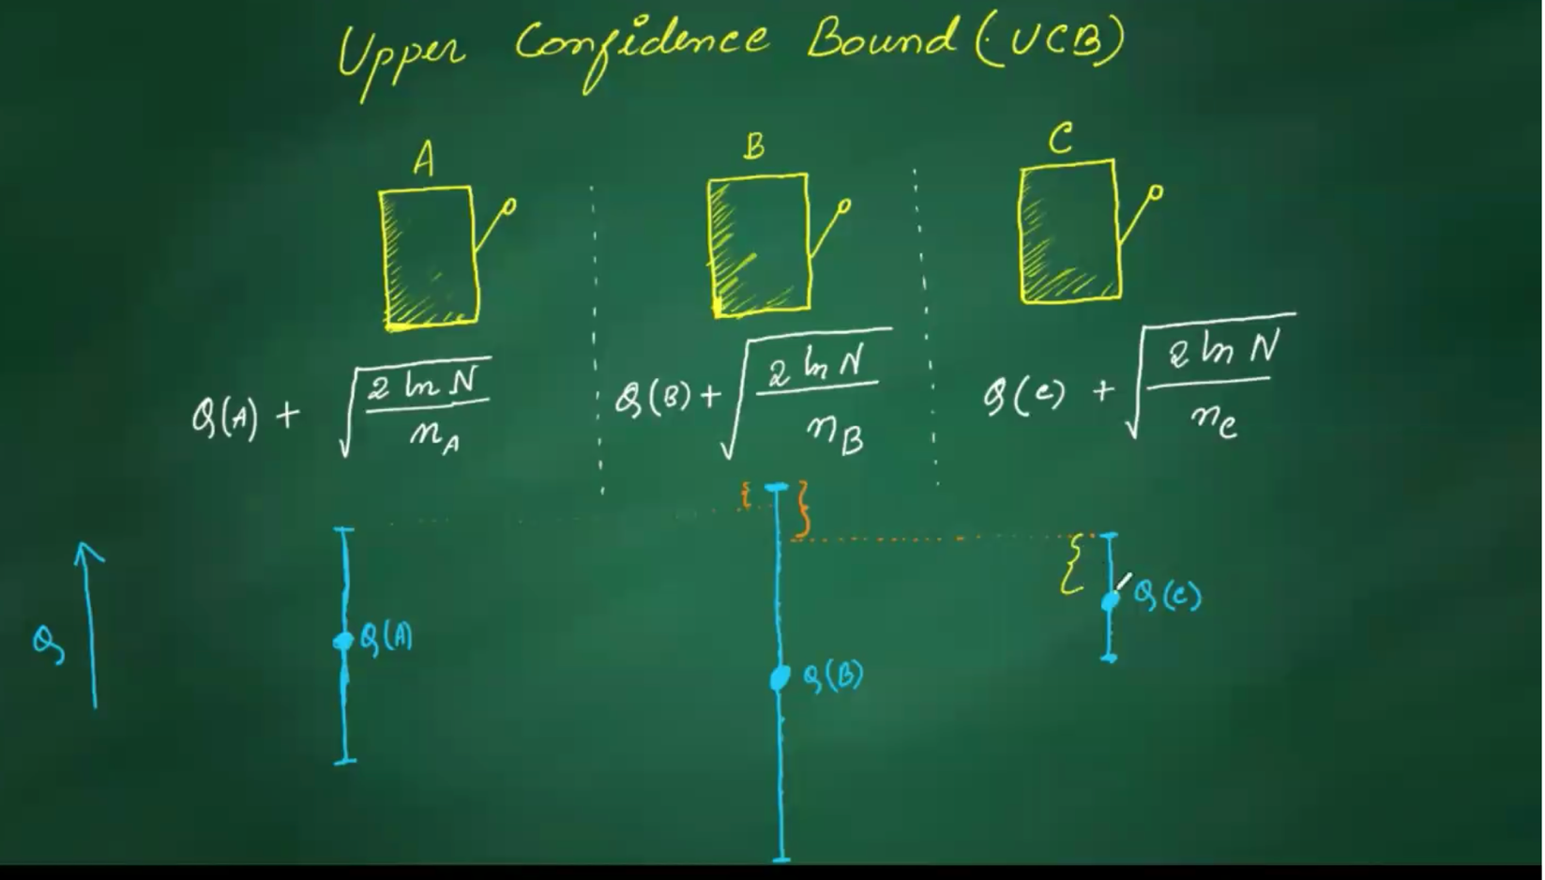

**The equation is for UCB, but hyperparameter c is not given(should be corrected)**

**Machine C has maximum Q value but . m/c C has lower bound**

**In UCB, restaurants with fewer visits have the advantage**

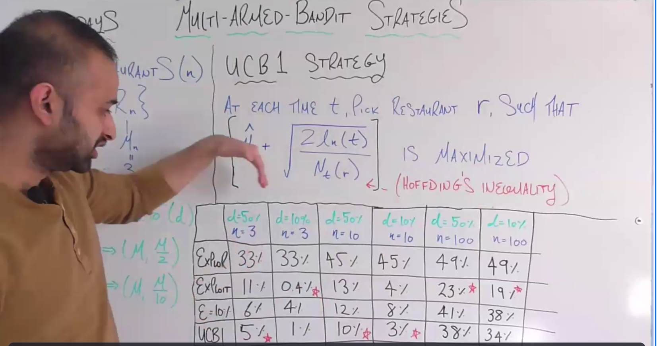

**D is for distribution. For 1st column, distribution is fat by 50 percent**

**Percentage inside boxes are regret percent**





**Understanding Exploration and exploitation**

[**https://ramesharvind.github.io/posts/reinforcement-learning/multi-armed-bandits/**](https://ramesharvind.github.io/posts/reinforcement-learning/multi-armed-bandits/)

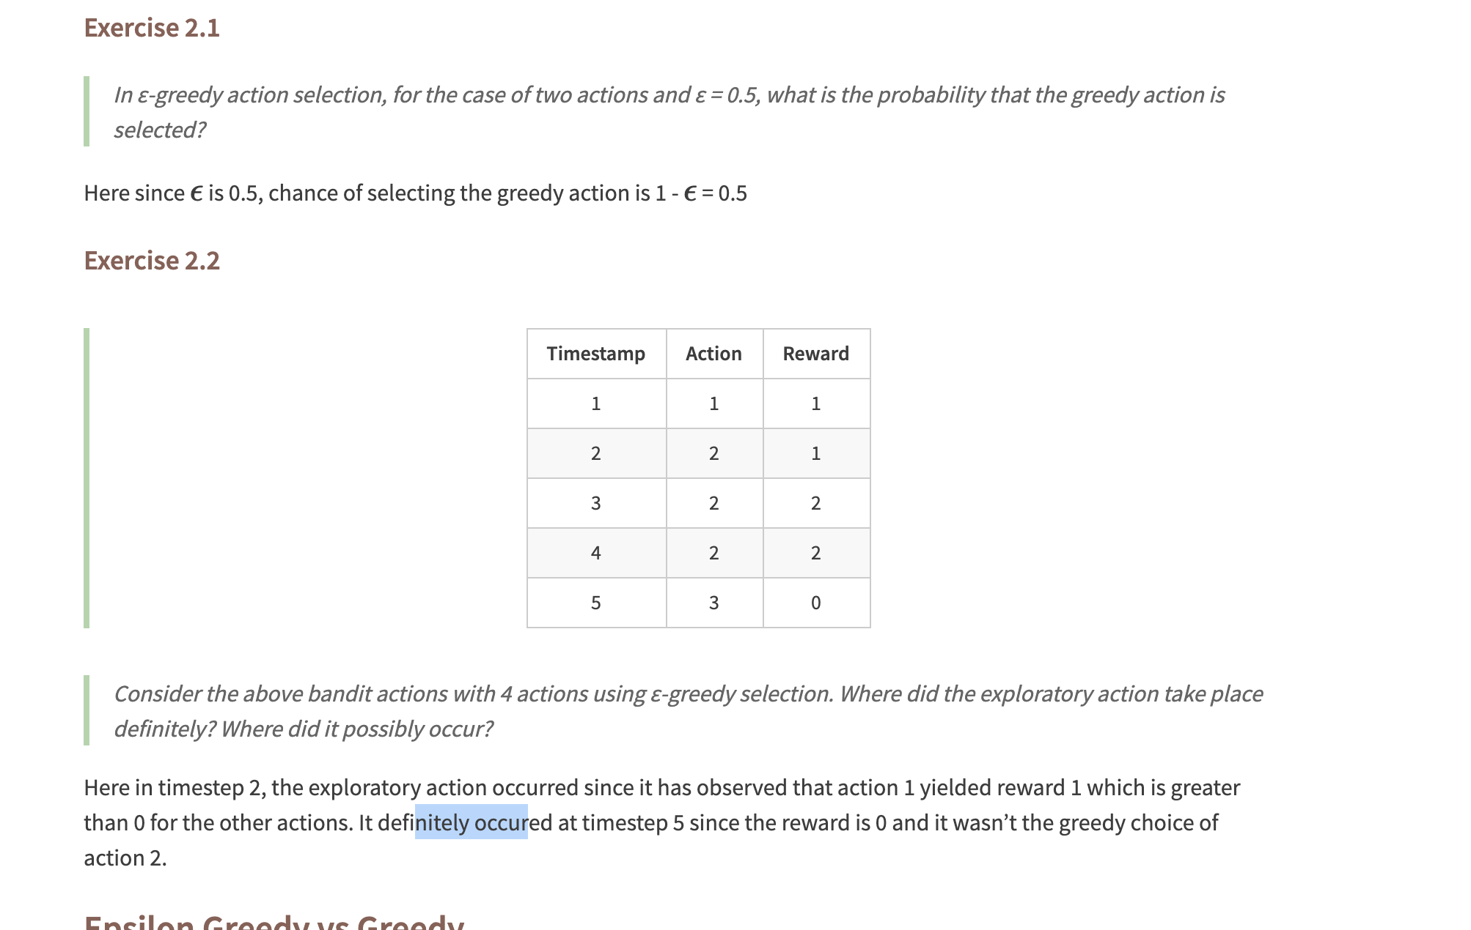

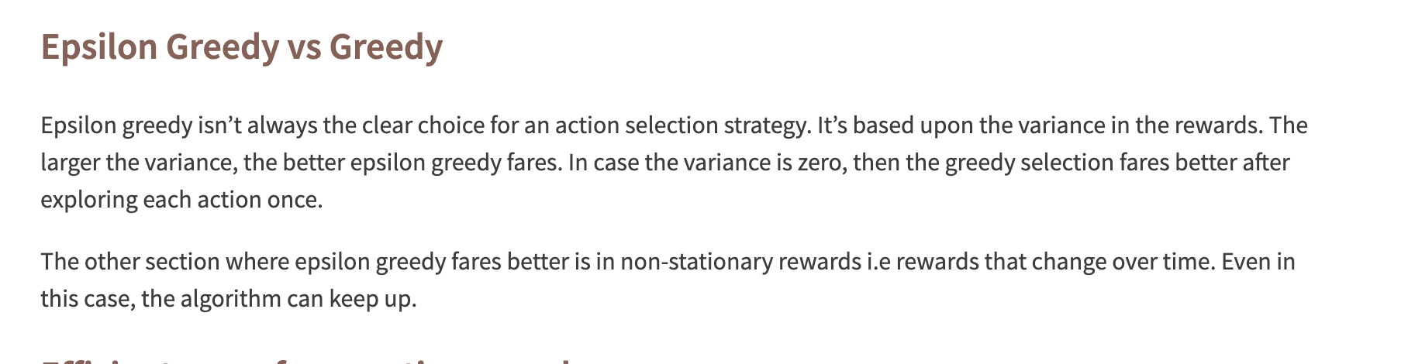

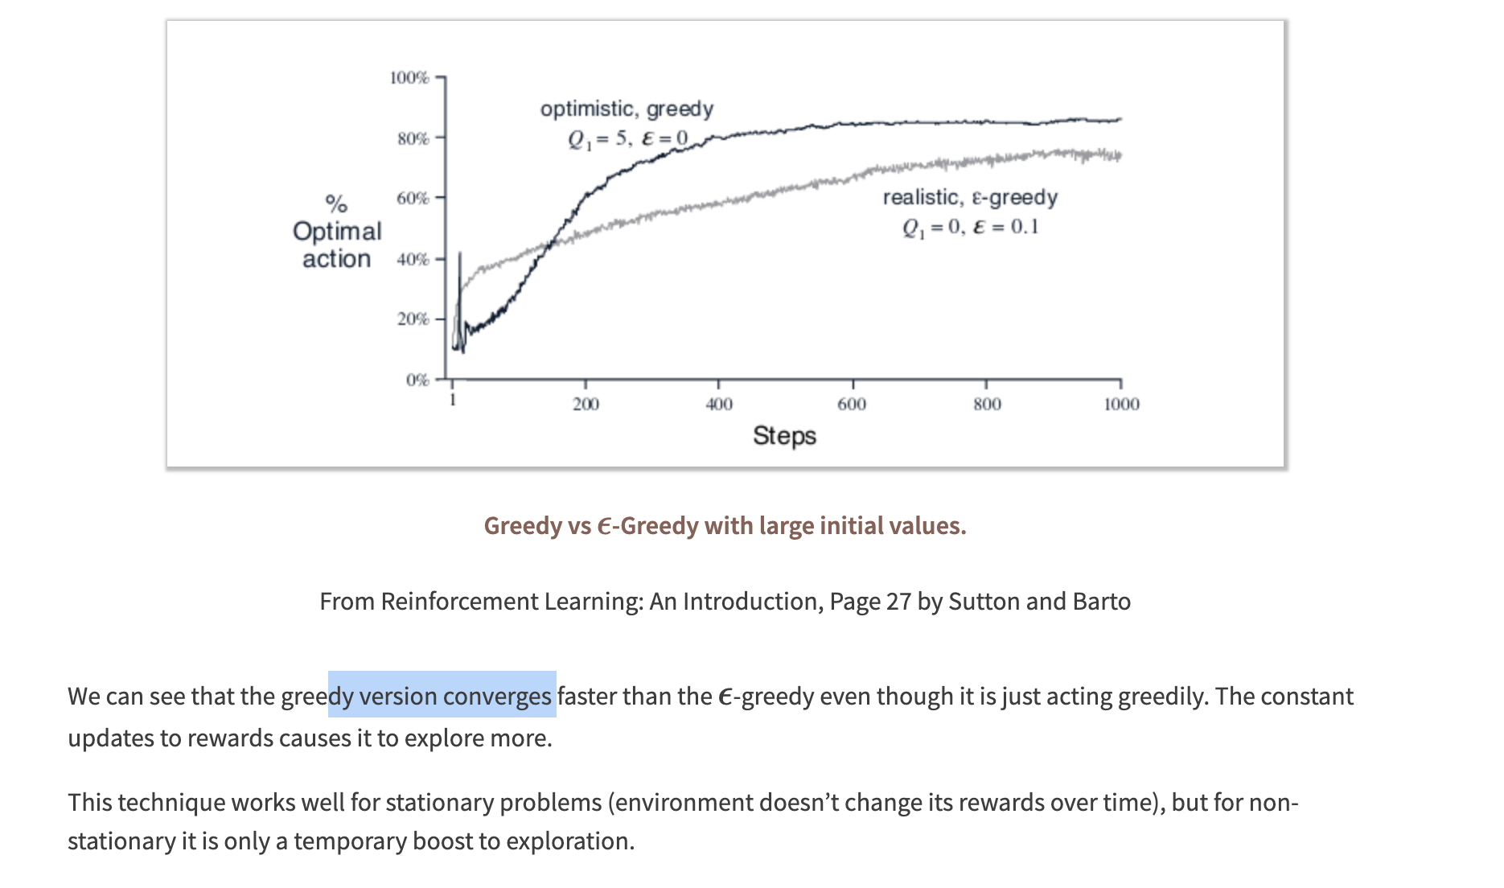

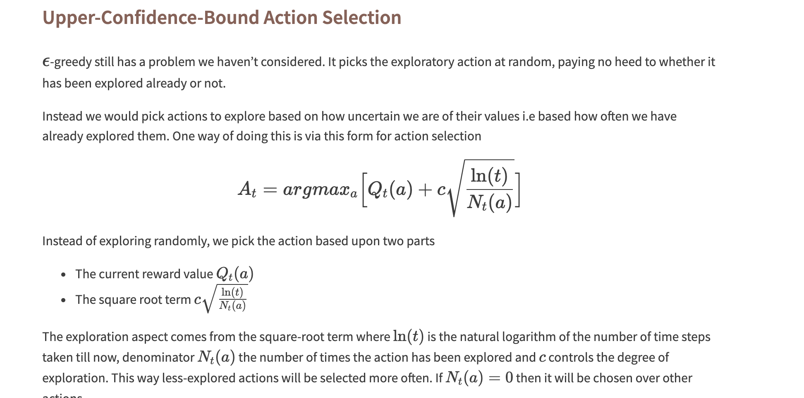

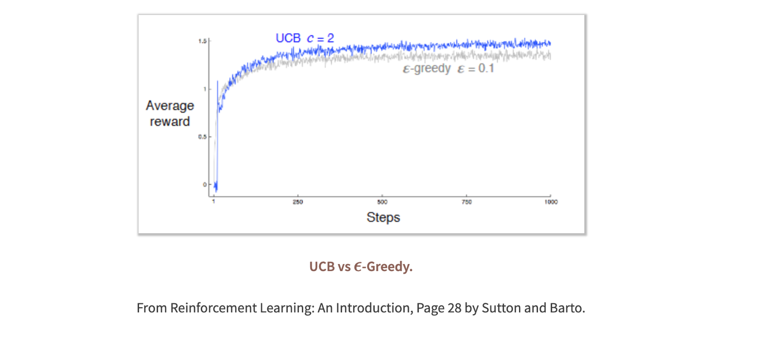

**Sutton and Barto Question answers:**

[**https://micahcarroll.github.io/learning/2018/05/17/sutton-and-barto-rl.html**](https://micahcarroll.github.io/learning/2018/05/17/sutton-and-barto-rl.html)

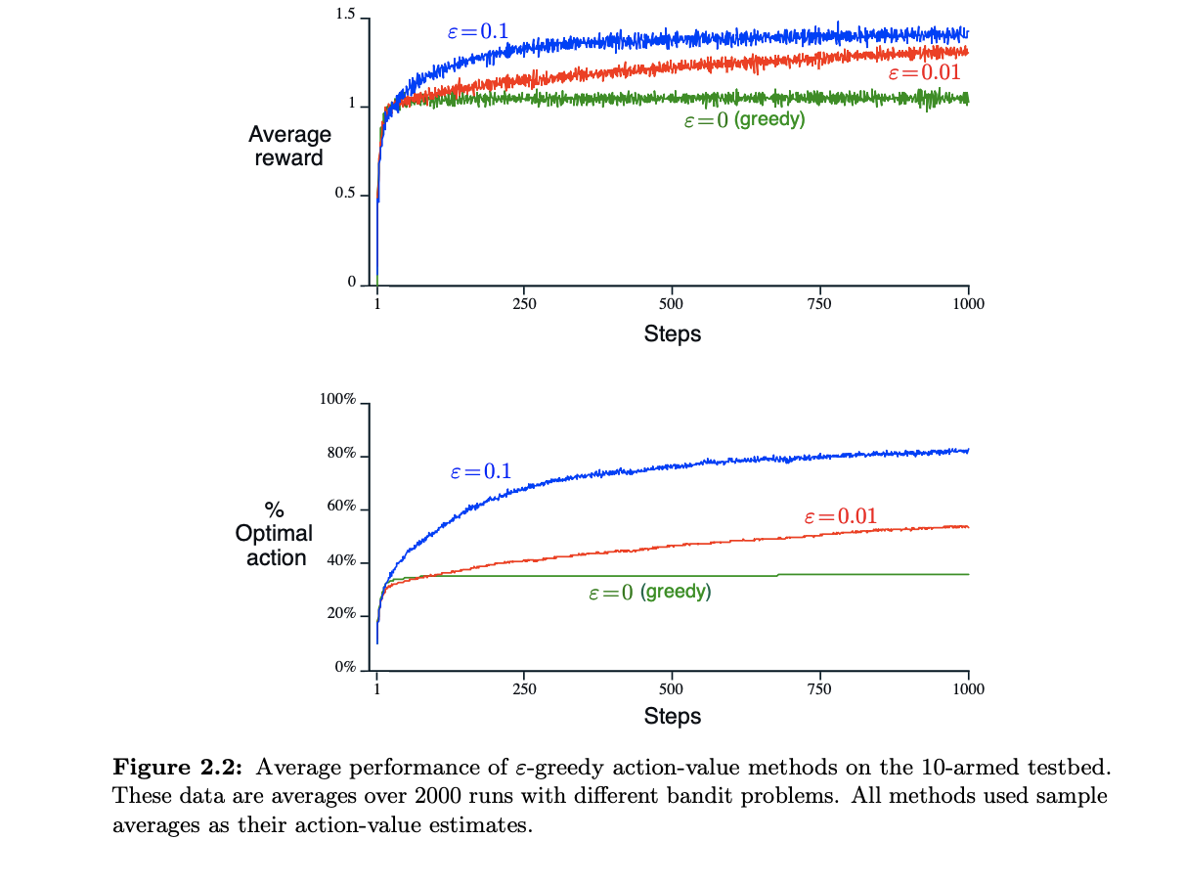

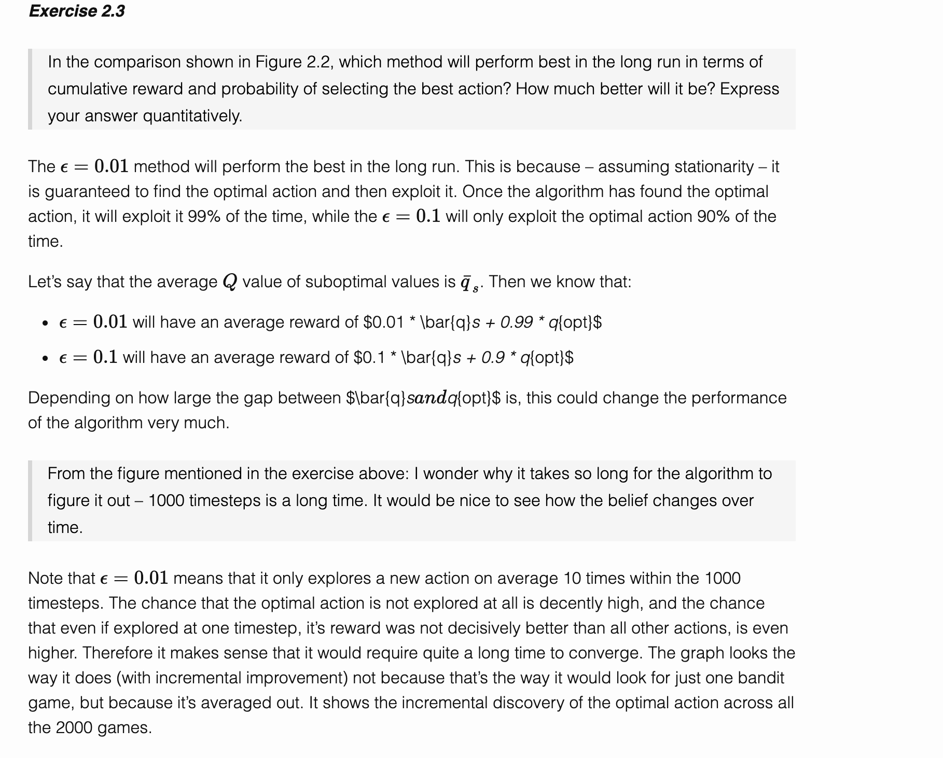

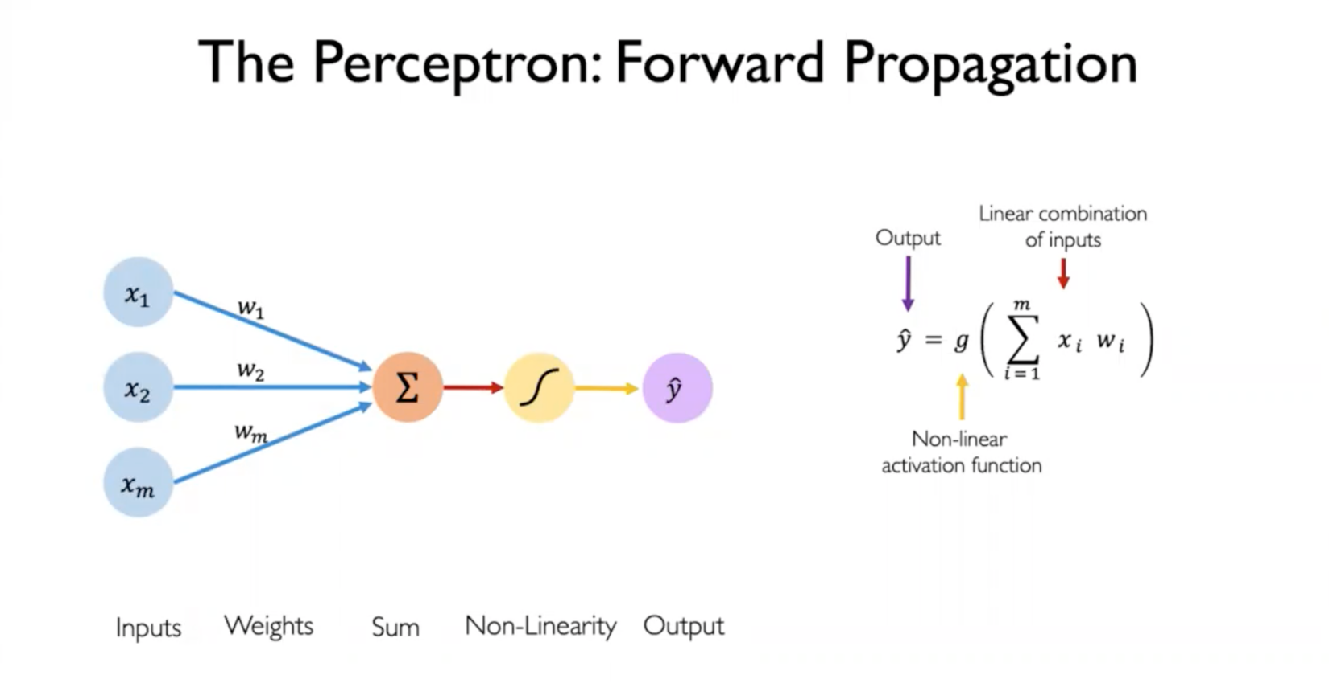

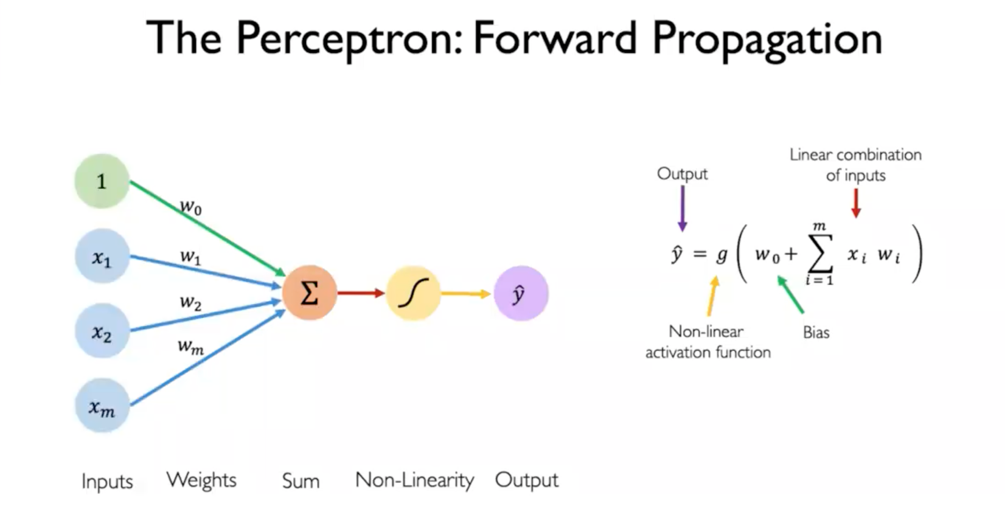

**Thers is a bias w0 which allows the activation function to shift left or right**

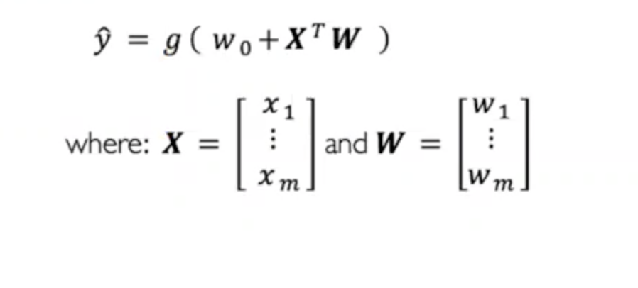

**X and W are vectors**

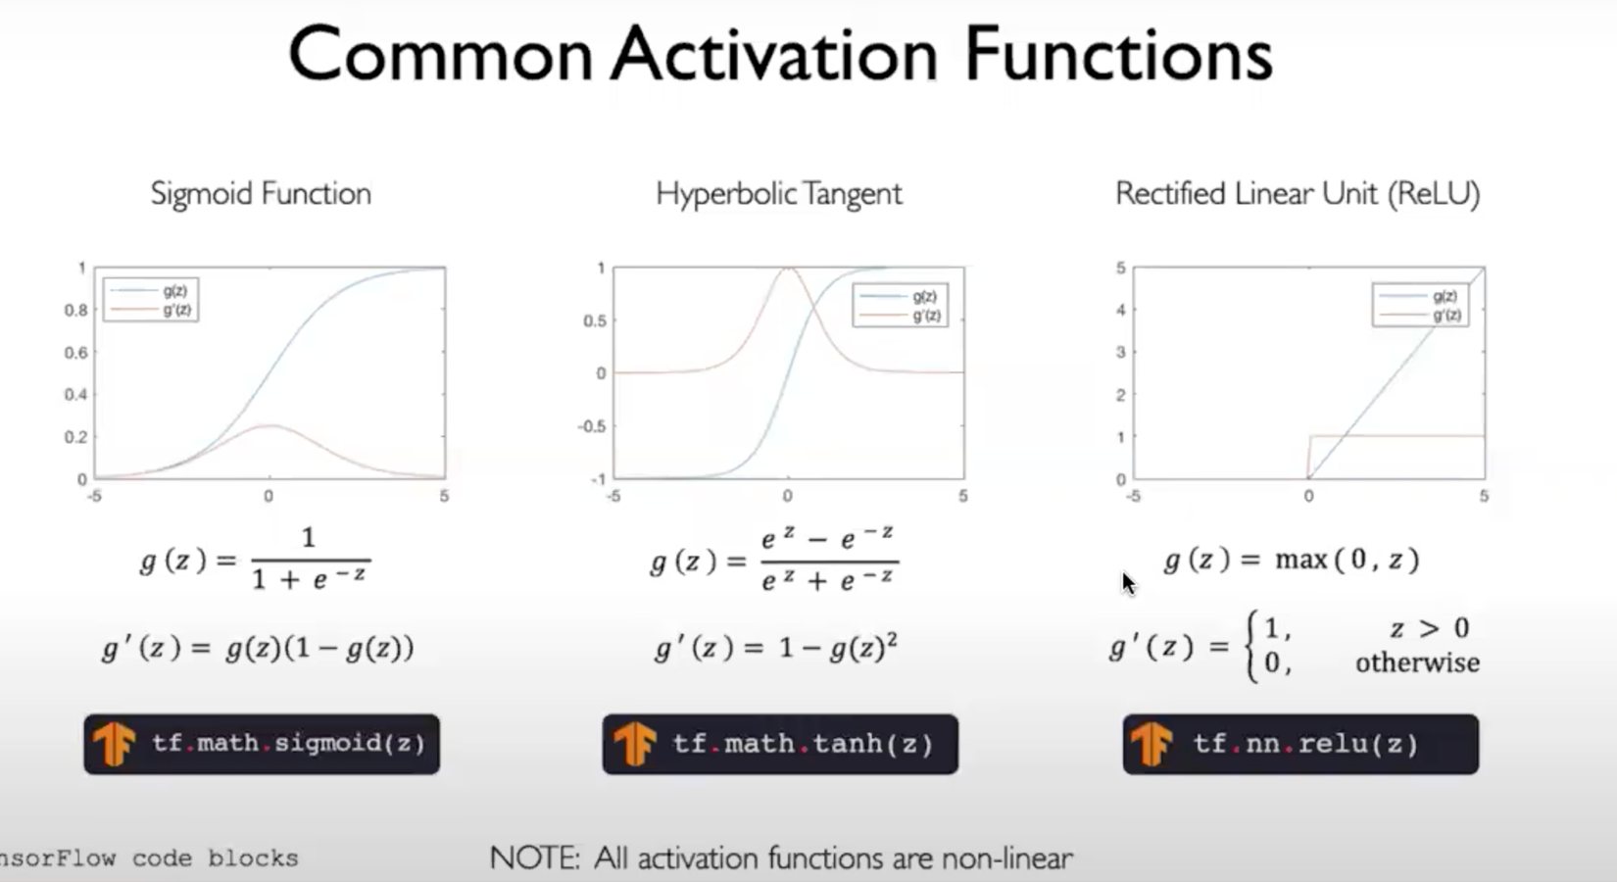

**Sigmoid is not practically used, because its derivative is small. Typically, the derivative of sigmoid will be between 0 and 0.2. Hence, Relu is most commonly used than sigmoid or hyperbolic functions**

**The purpose of activation function is to introduce non linearities in the network**

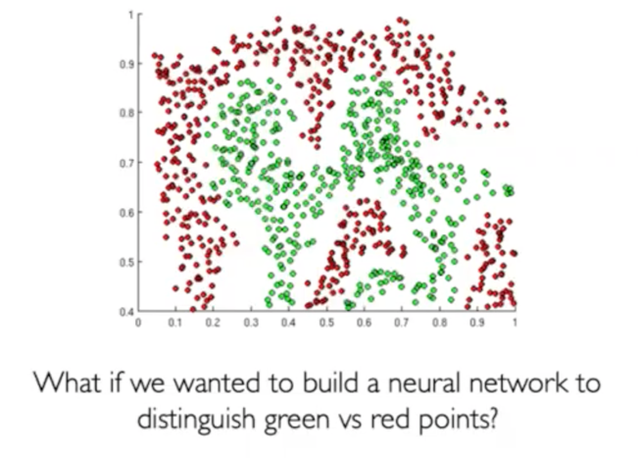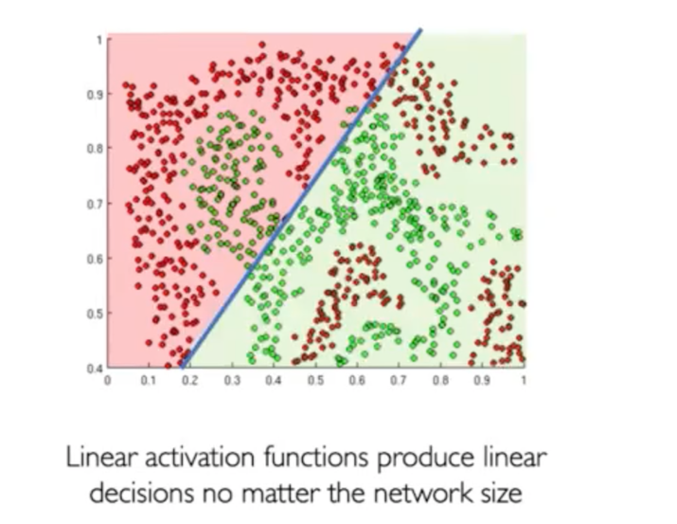

**The right figure shows how neural network will work with linear activation function**

**Below shows the benefit of non linear activation function**

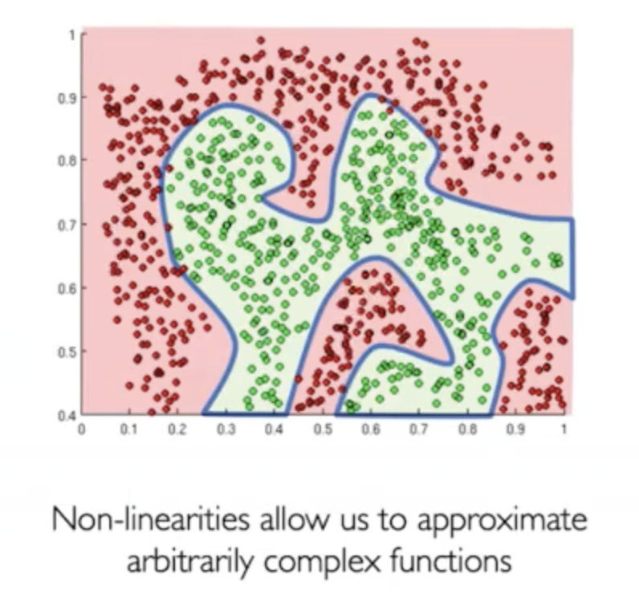

**The fig below shows a standardize supervised learning problem**

**As we have label**

**Pass and Fail are dependent variable**

**Independent variable x1 and x2**

**We can use any supervised learning for this**

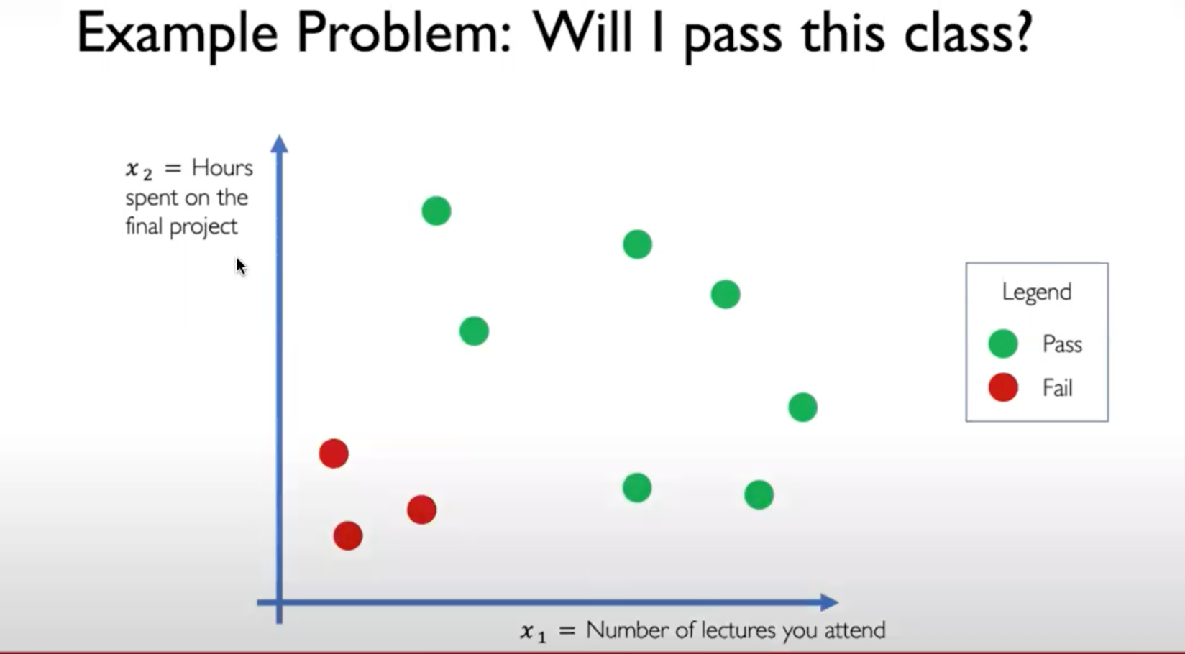

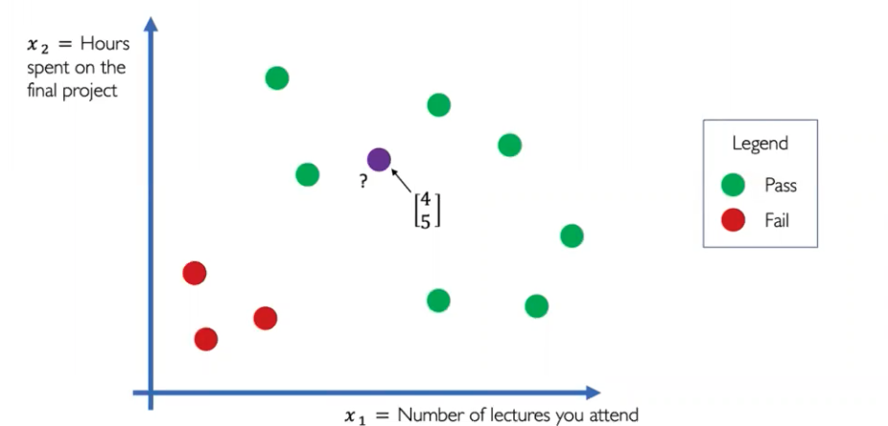

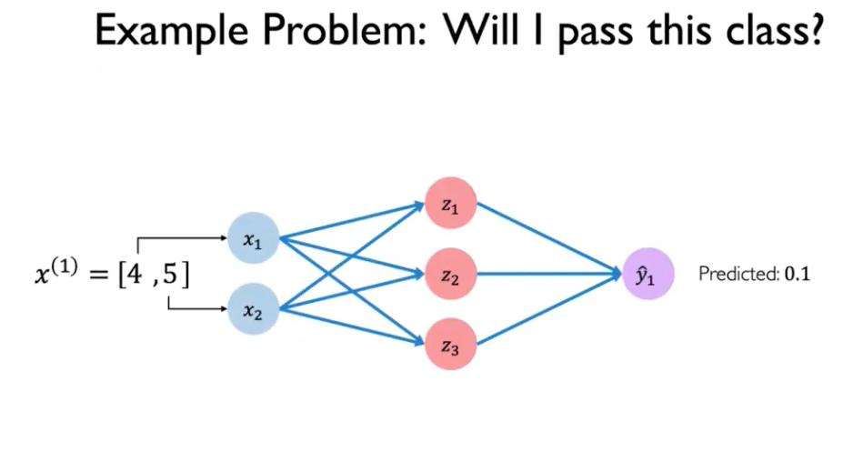

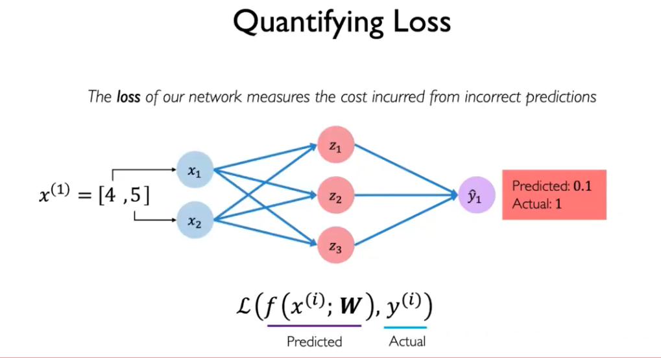

**How wrong a prediction was? This we have to teach neural network**

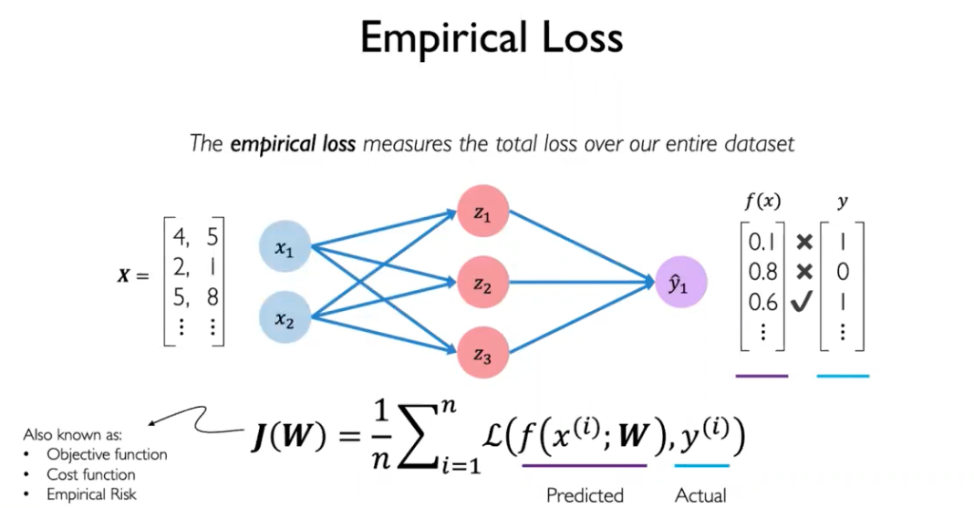

**Not just one student, but for list of students**

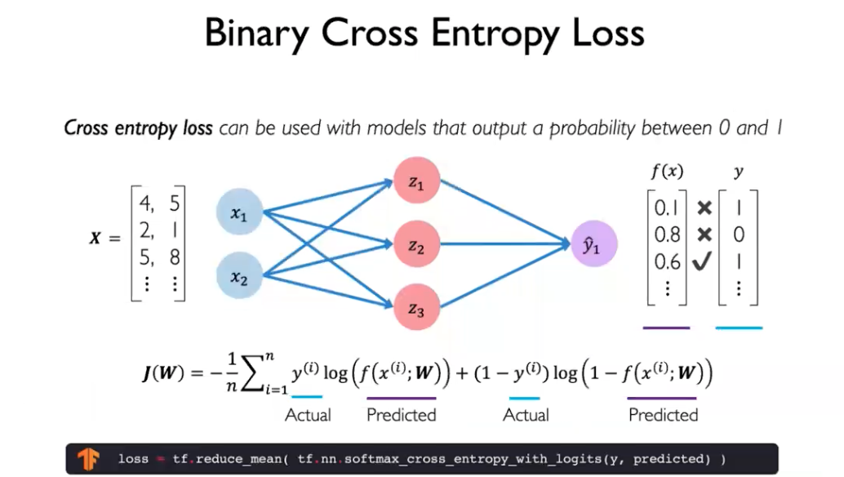

Binary – will I pass or not

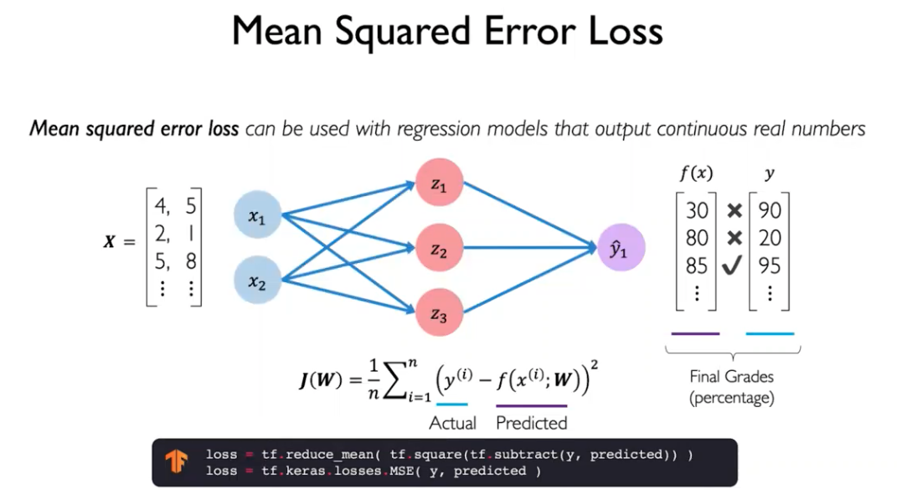

What are the final grades?

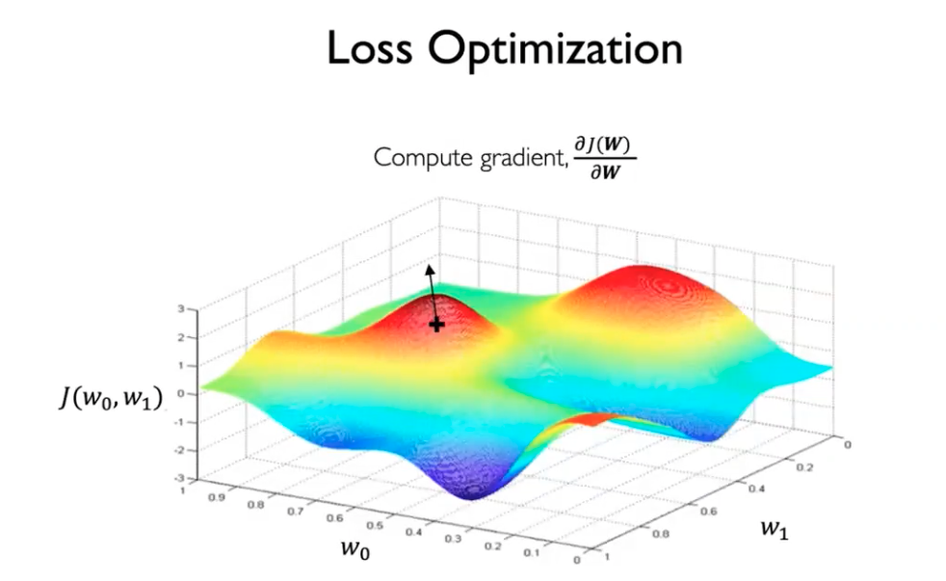

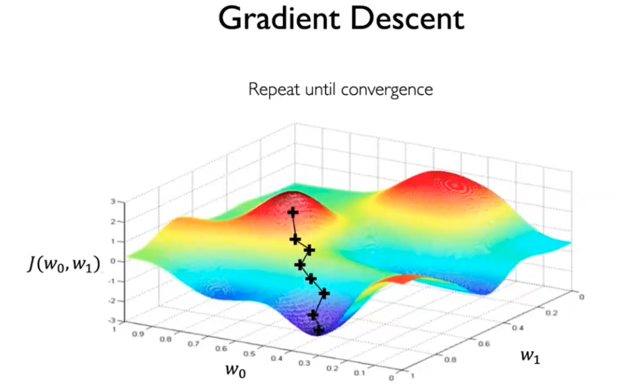

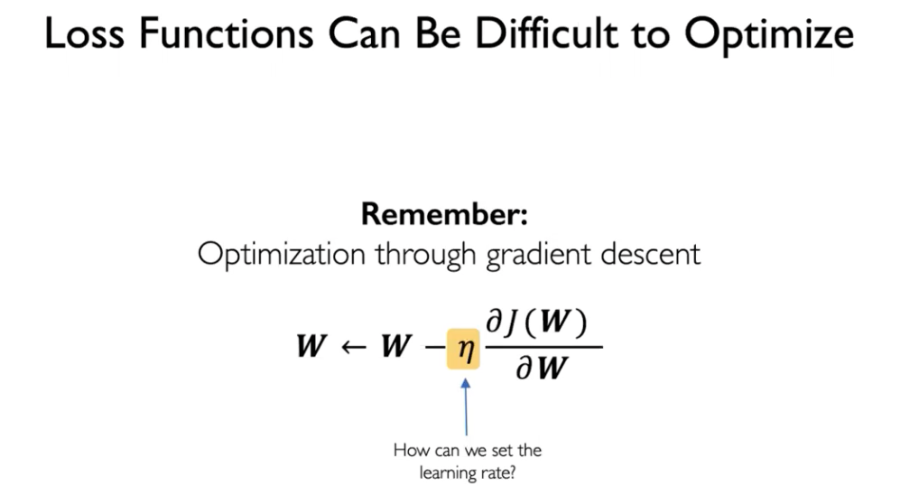

If you have very non convex loss landscape, where you have local minima. If you set the learning rate too low, then the model can get stuck in local minima. It can never escape them. It optimizes, but to a non-optimal minima

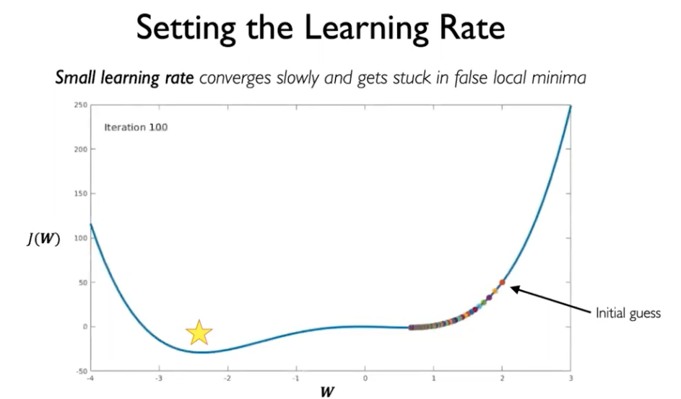

On the other hand, if our learning rate is large, then we can overshoot our local minima. We could diverge and explore the training process completely

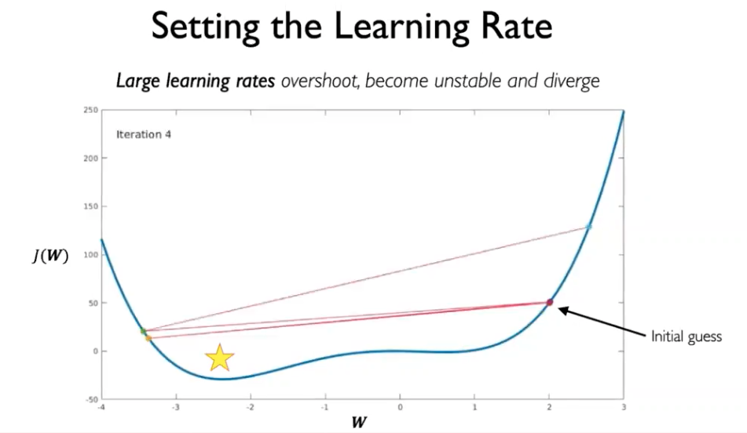

One of the challenges is how to use stable learning rate such that they avoid local minima and not diverge completely.

They are small enough to converge to the global minima

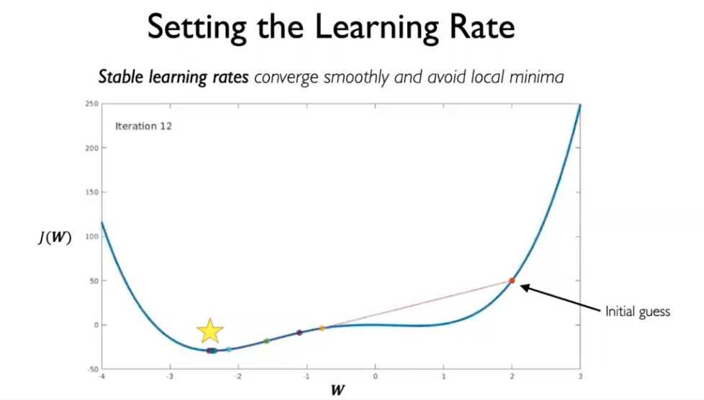

We can do by

1. Trying different learning rates
2. Build adaptive learning rate: Learning rate changes based on on the

a) gradient of that location

b) how fast learning is happening

c) size of a particular weight

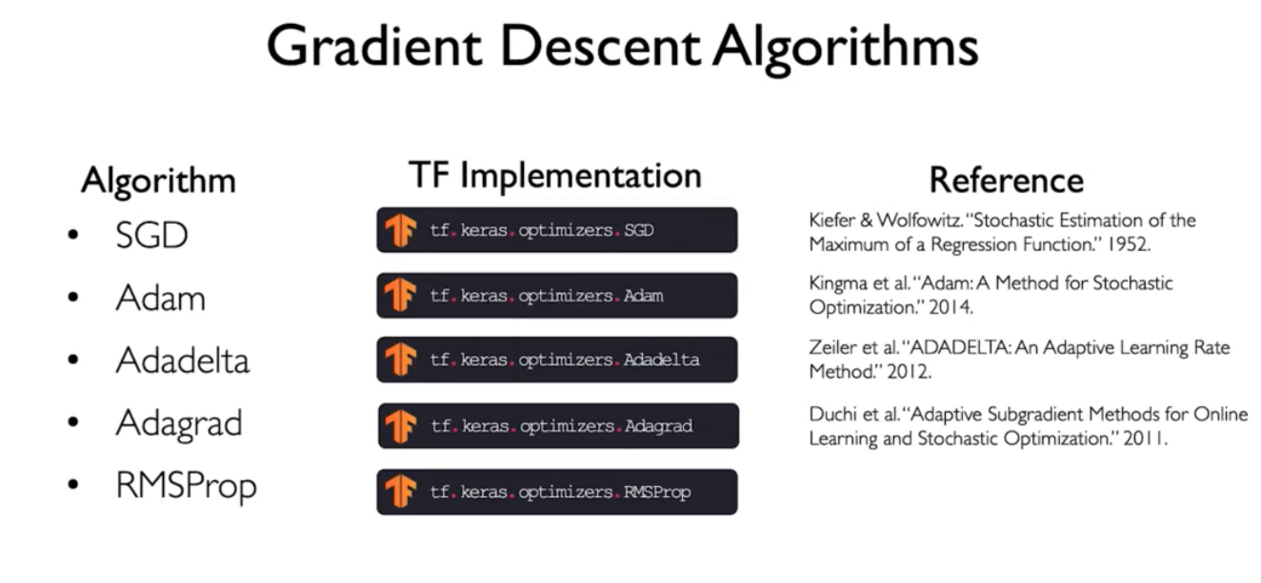

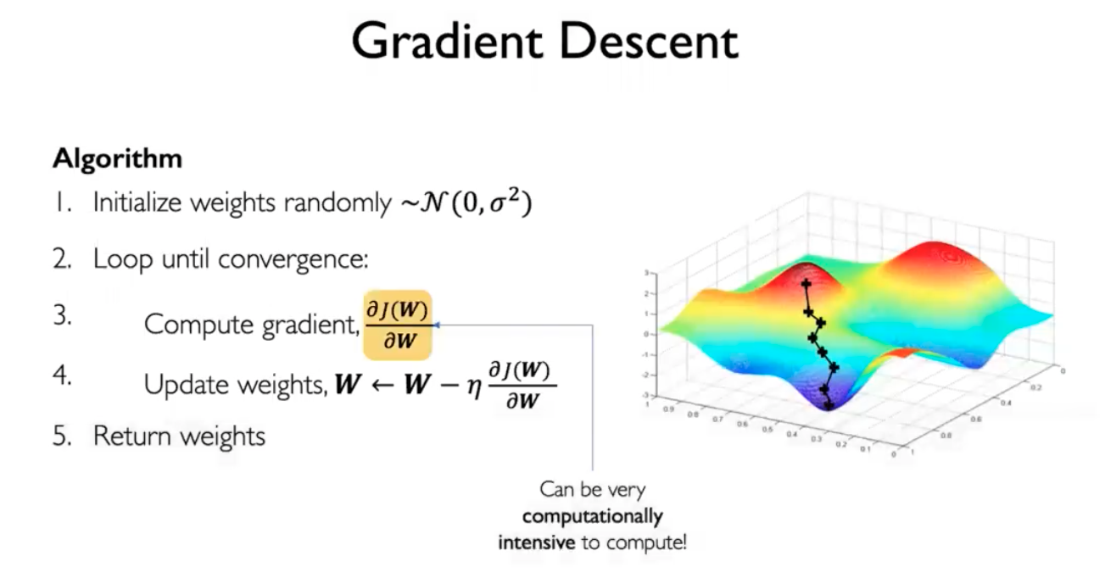

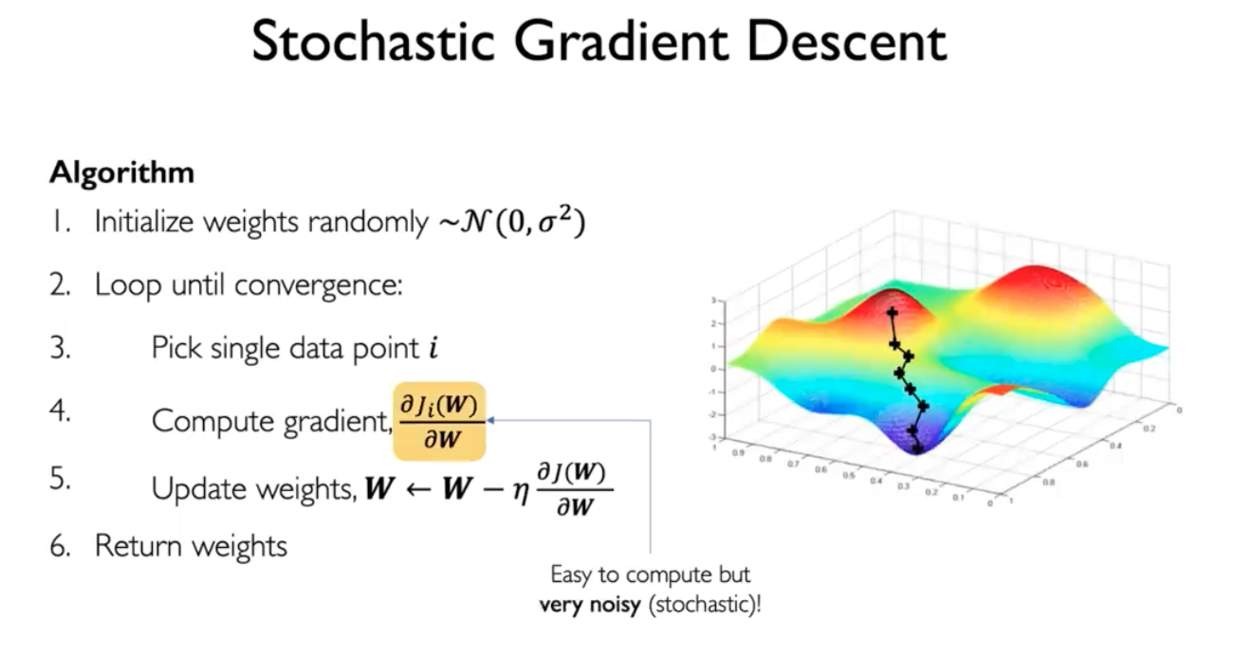

This is fast. But noisy

So there is a middle point shown below

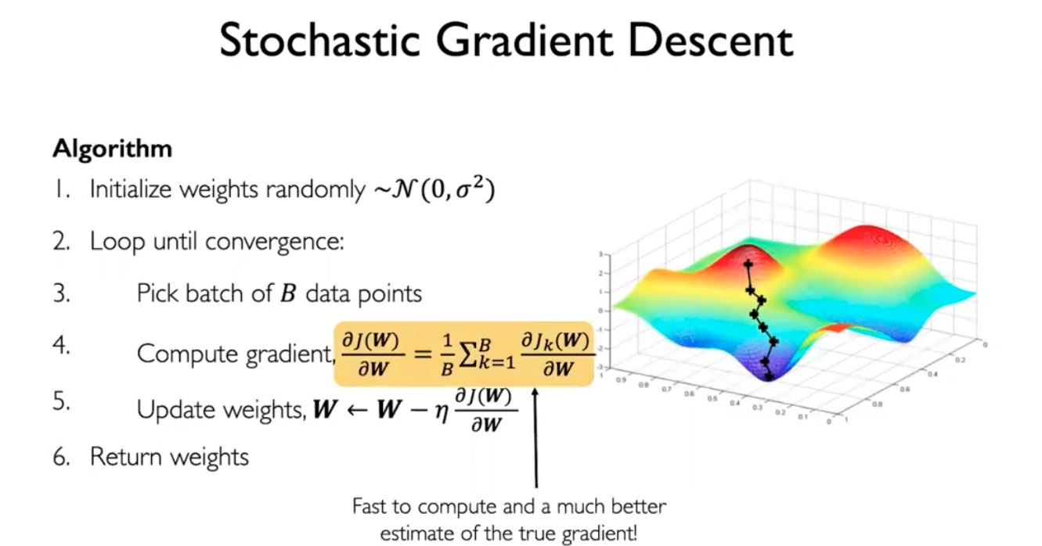

This is fast and accurate

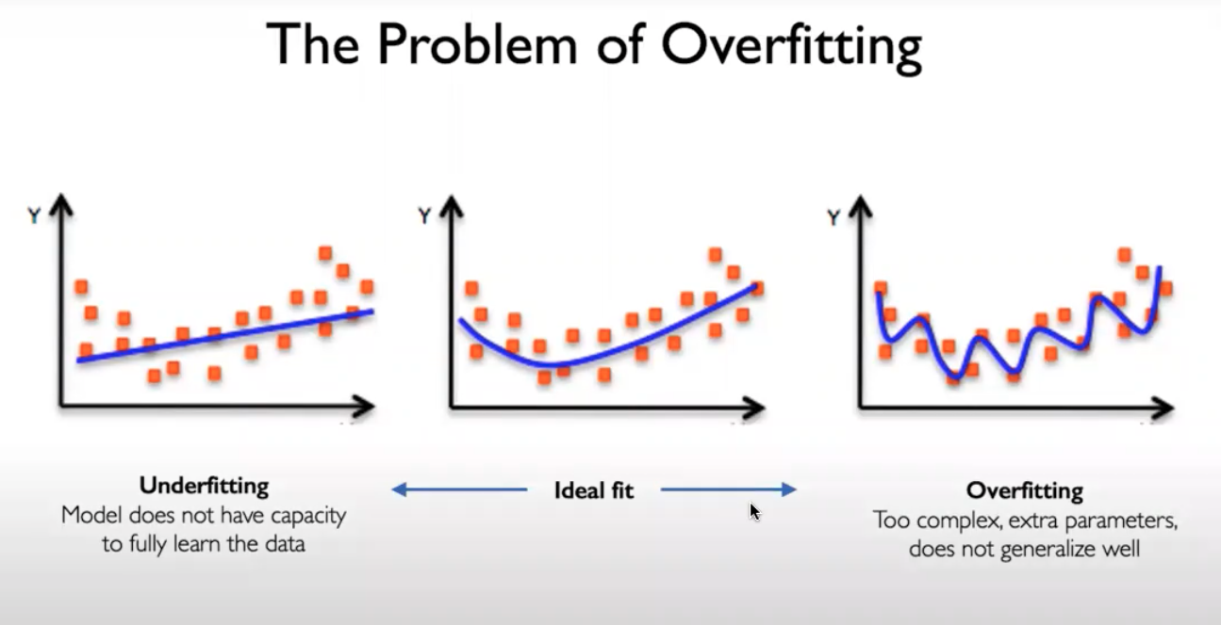

How do we prevent overfitting?

* Cross validation prevents over fitting: Using validation set/test data set, we can prevent overfitting.

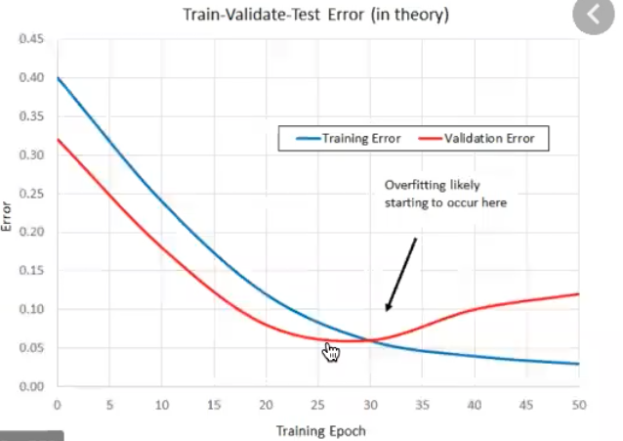

The mouse pointer shows where we have to stop. As soon as validation error starts to go up. We stop when our validation error is lowest.

In linear regression, what regularization technique exist?

-Reduce the number of feature

-lasso or ridge regression(automatically reduce those features)

In decision tree, what regularization technique exist?

* Restrict the depth of the tree

**Regularization in neural networks:**

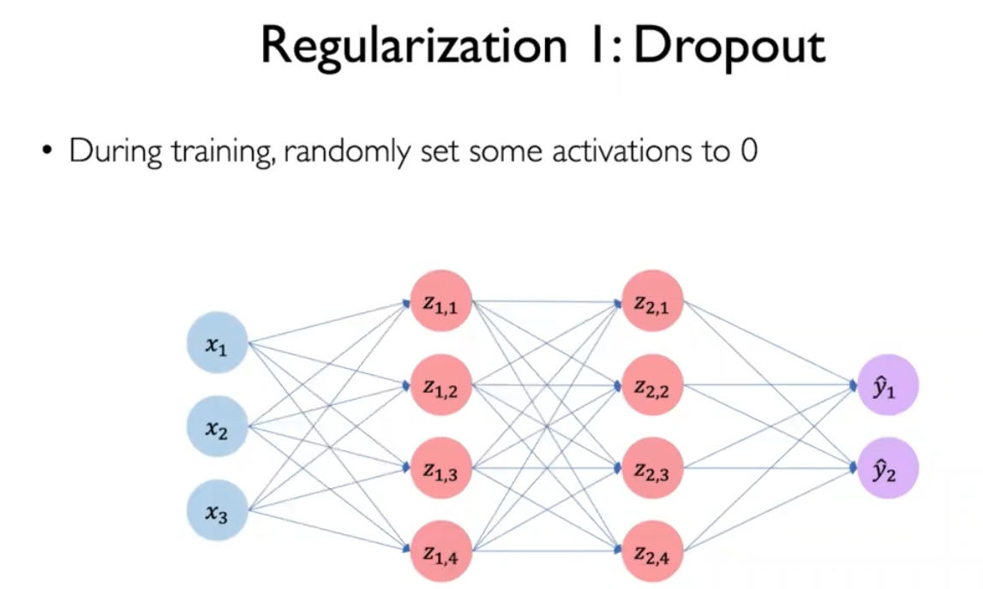

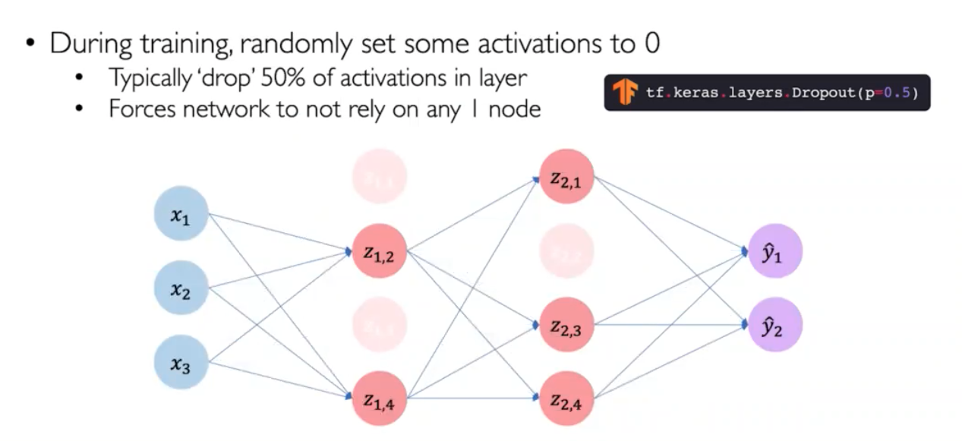

Every iteration different set of activation function is dropped out

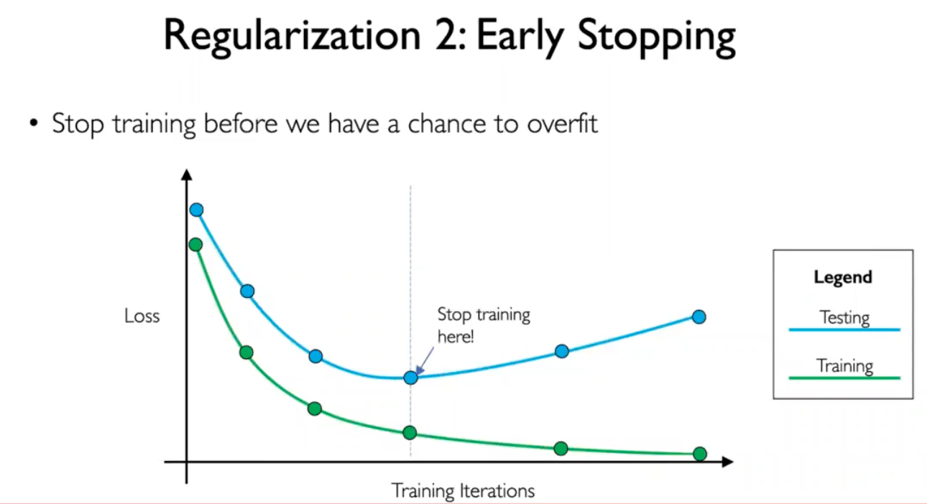

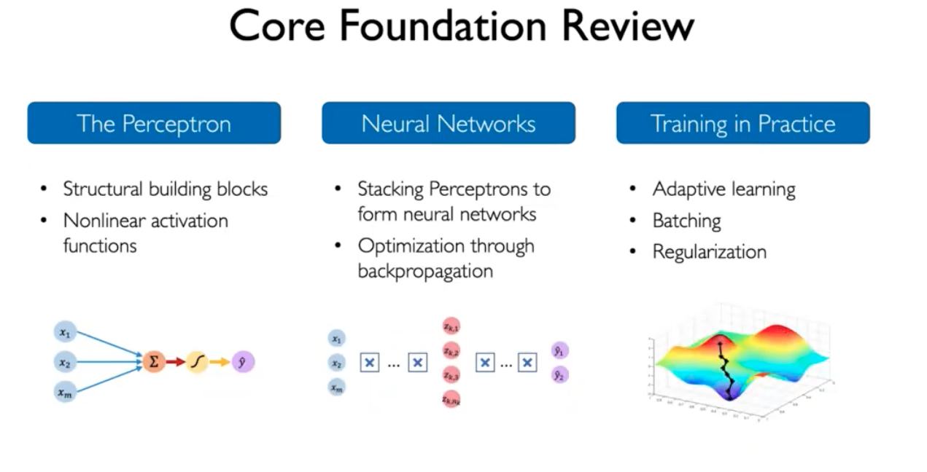

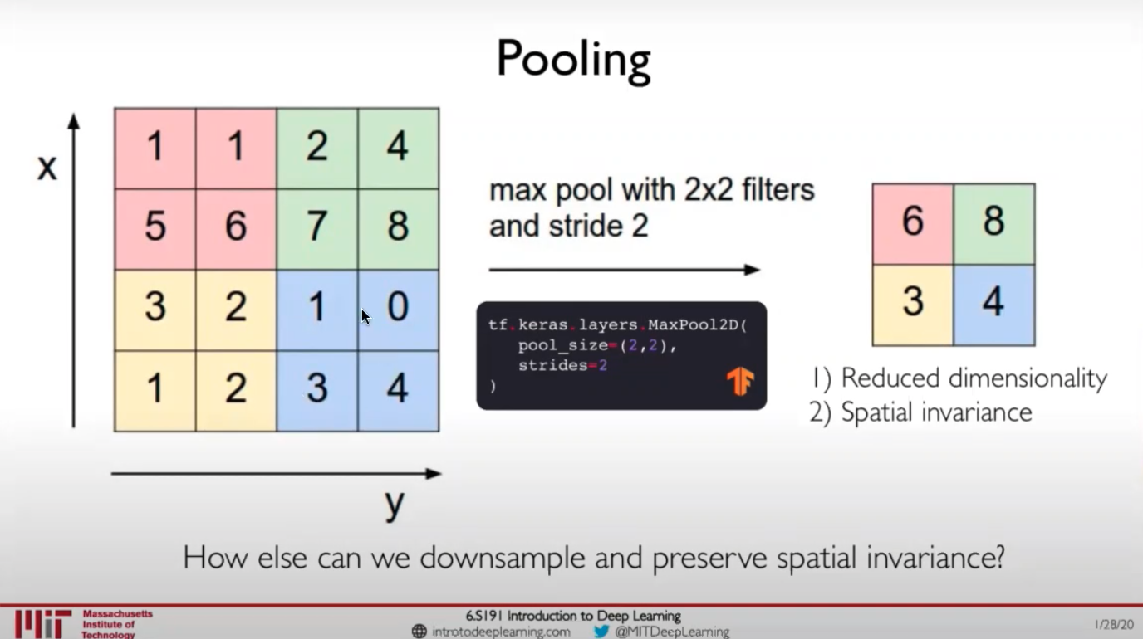

We can have max pooling, average pooling. But we don’t have min pooling, the reason is if we have large kernels, then one of those kernels is likely to be zero…and then we end up with 0 .. 0… 0.. 0

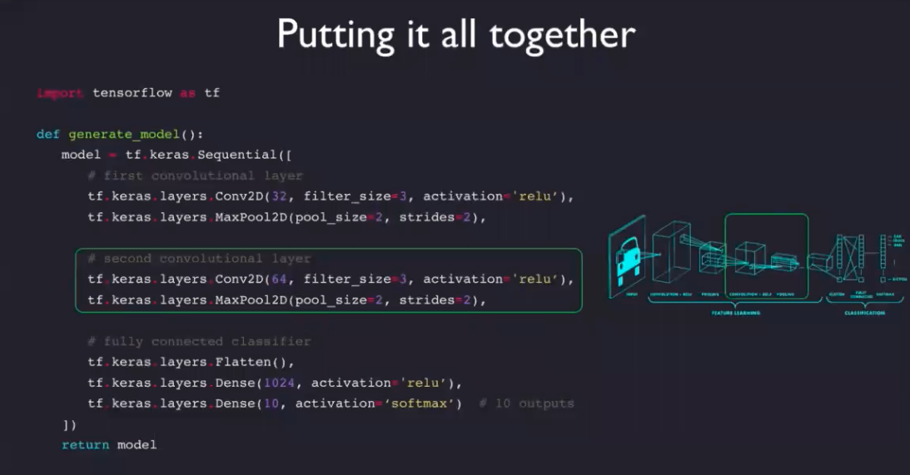

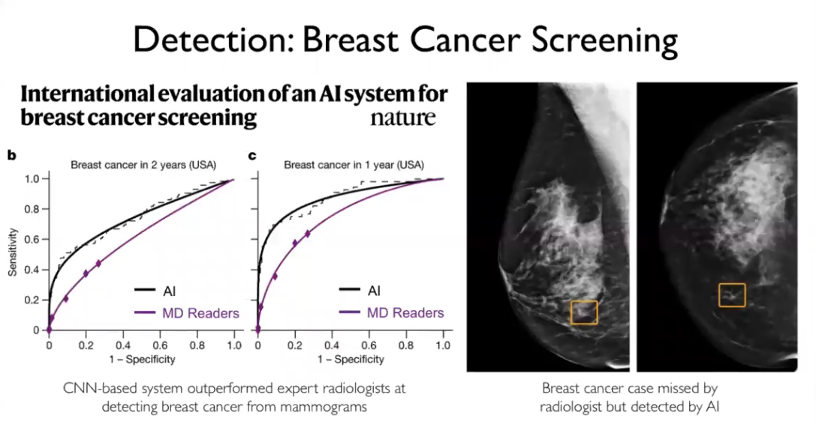

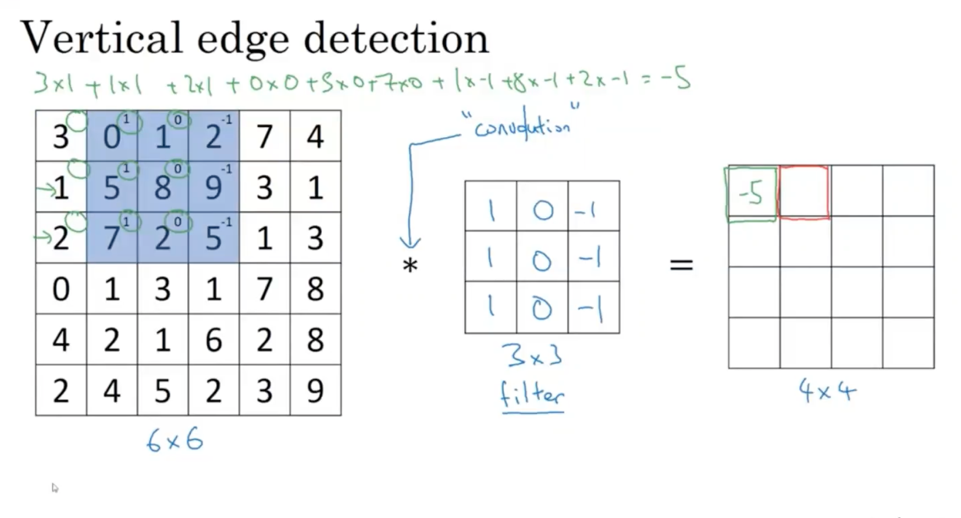

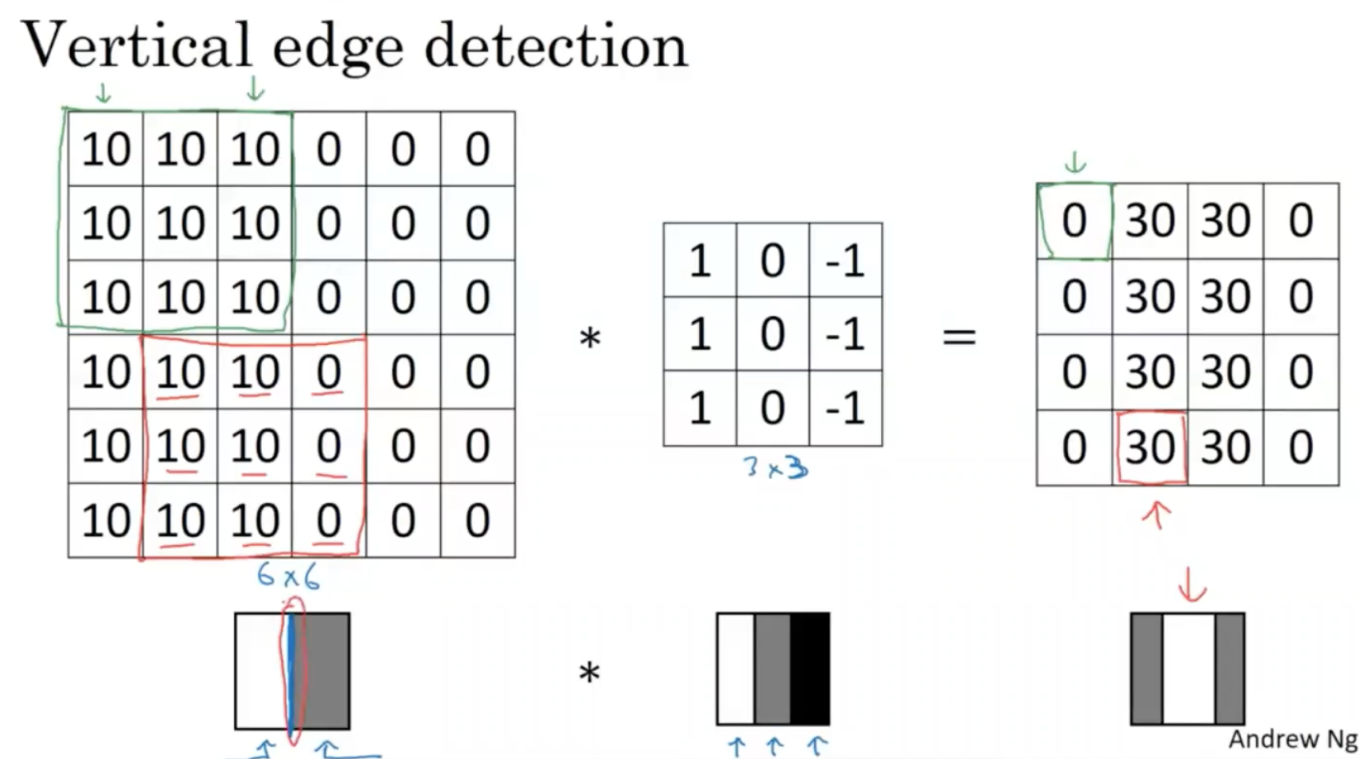

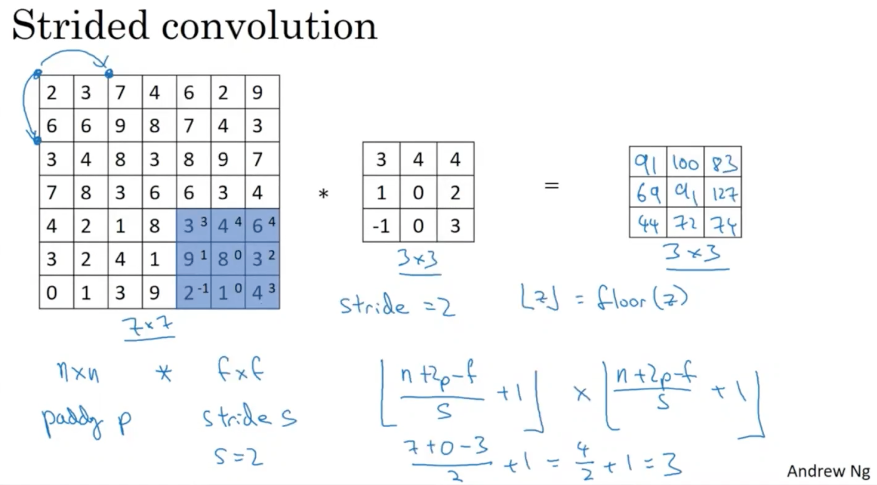

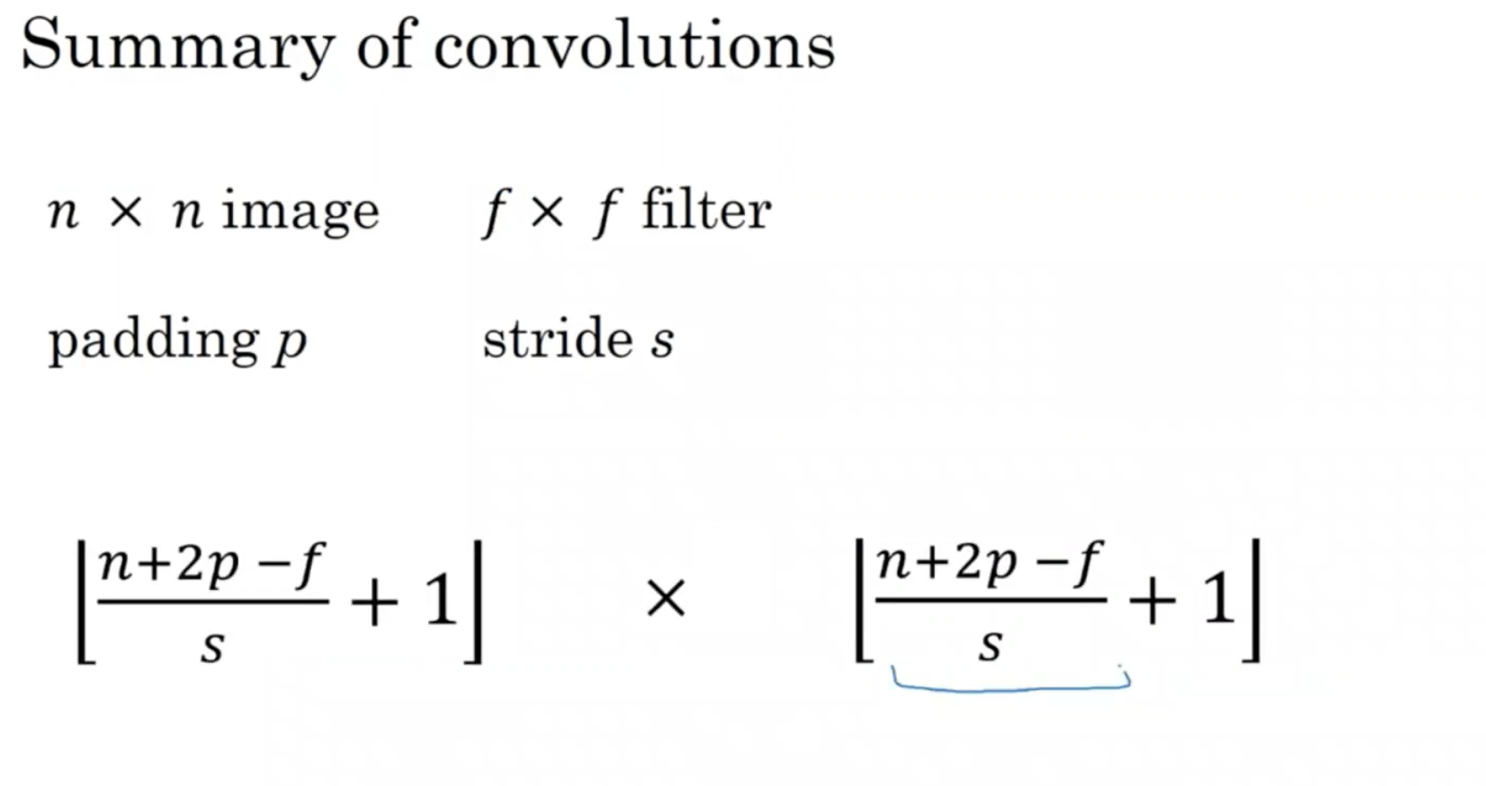

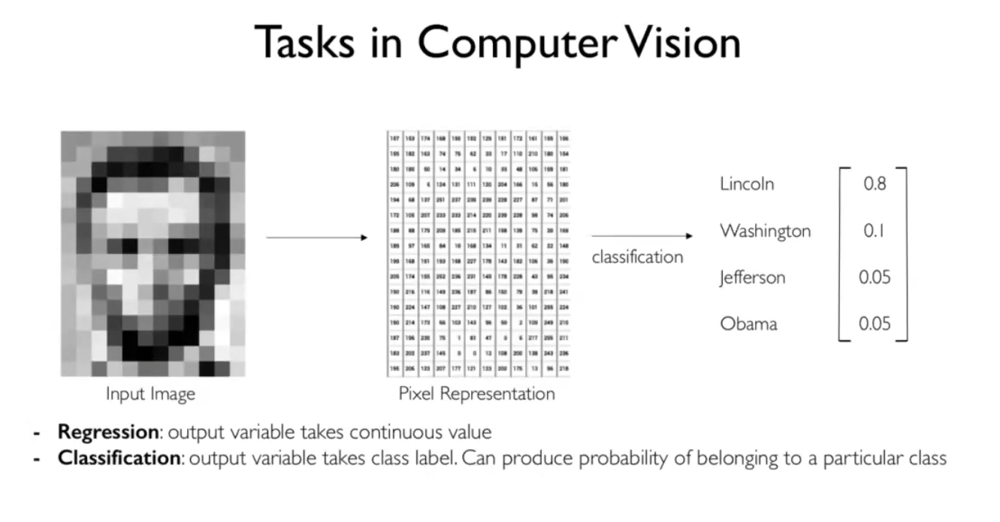

How does computer process images?

-To a computer images are just number. Each pixel is a number. If the image is greyscale, each pixel can be represented by a number. 2d matrix of numbers. Computer sees it as 2 dimensional matrix of numbers.

If we have an RGB image i.e color image instead of greyscale image. So, there will be 3 of these 2 dimensional images concatenated on top of each other. One for red, one for green, one for blue

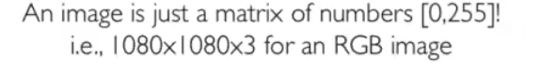

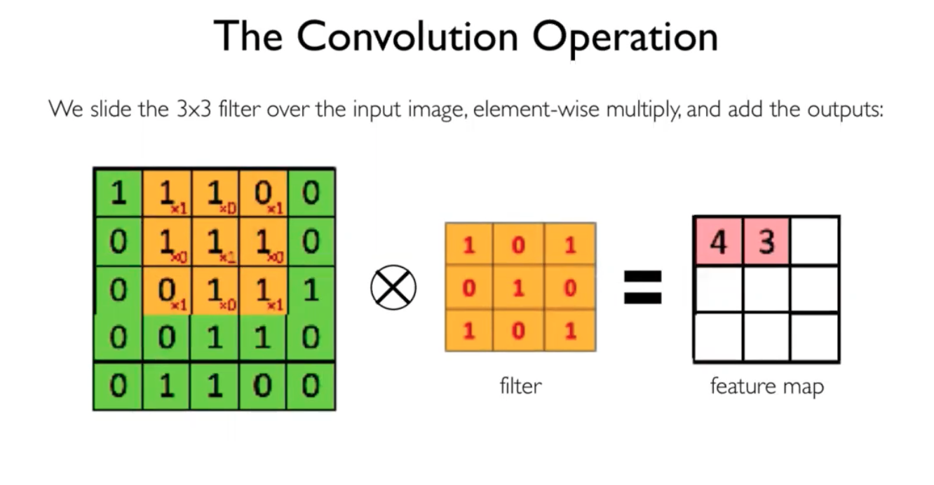

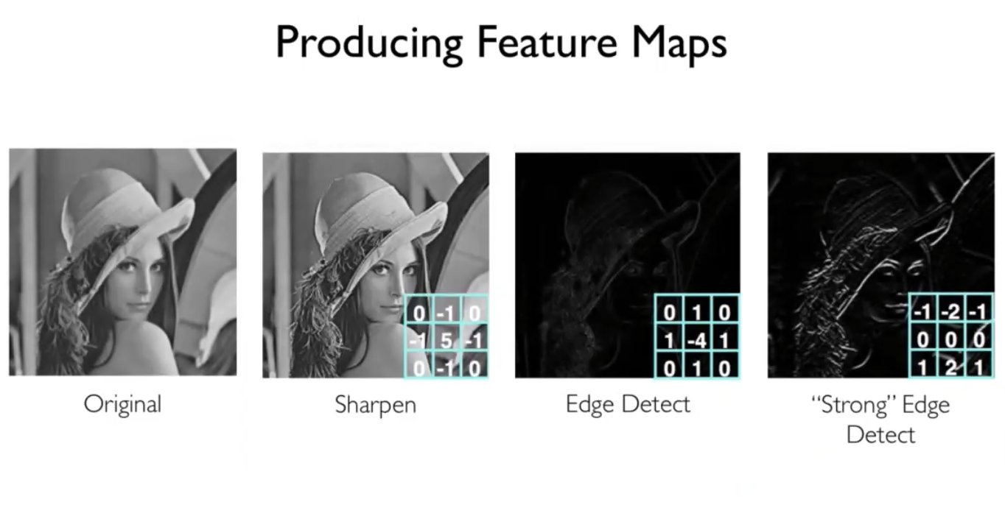

Different filters used for different purposes. We just have to change the weights to get different filters

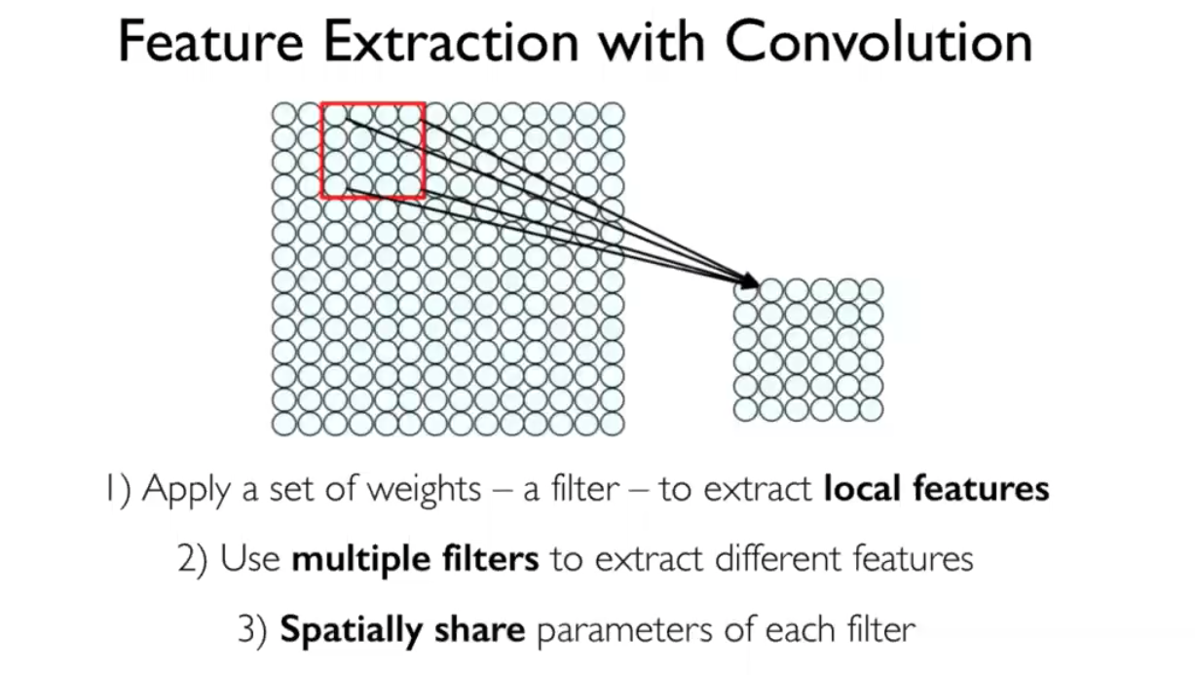

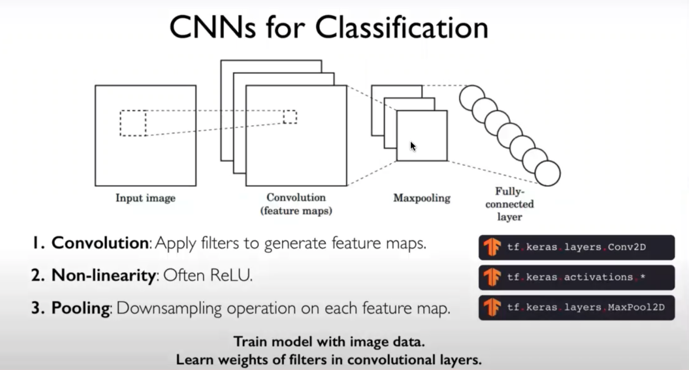

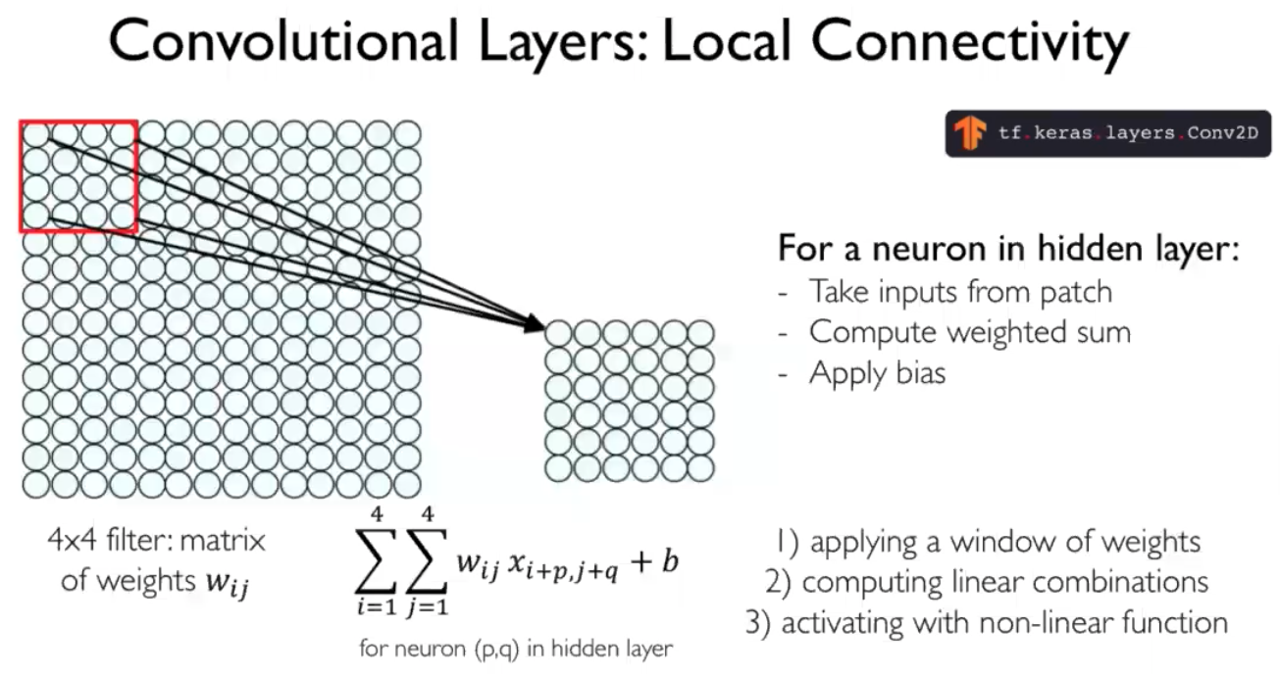

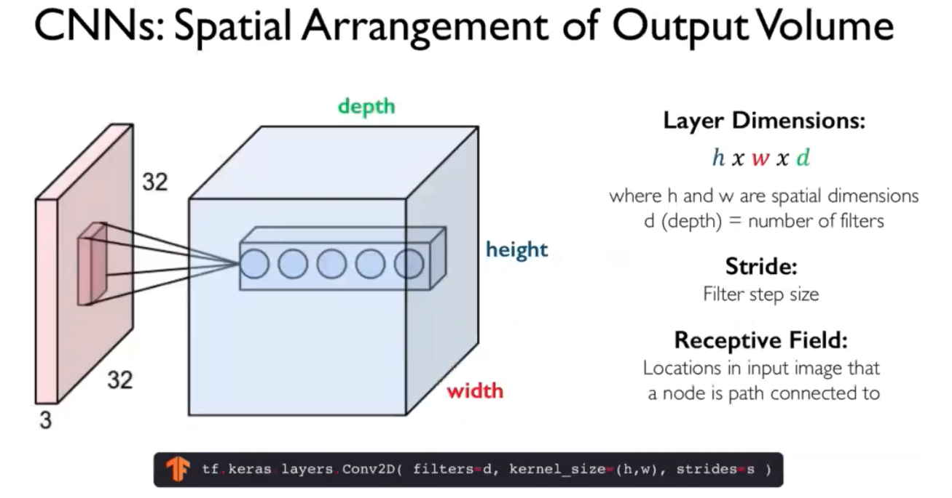

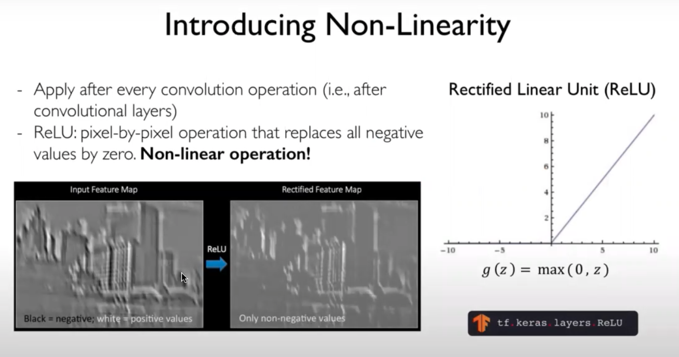

Relu function takes the real number. If it is less than zero, it converts them to zero else if number is positive, it remains as it is

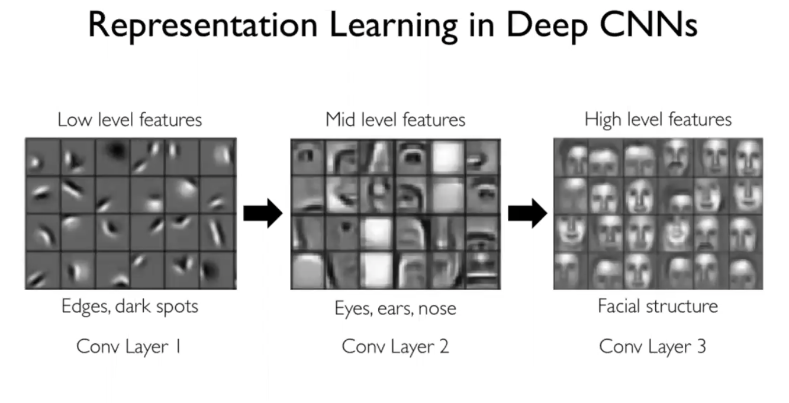

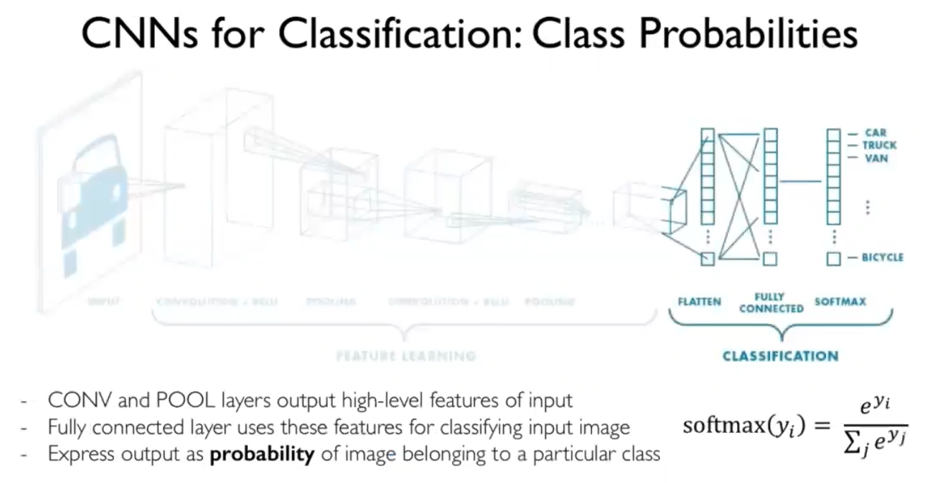

Softmax output represents categorical distributions

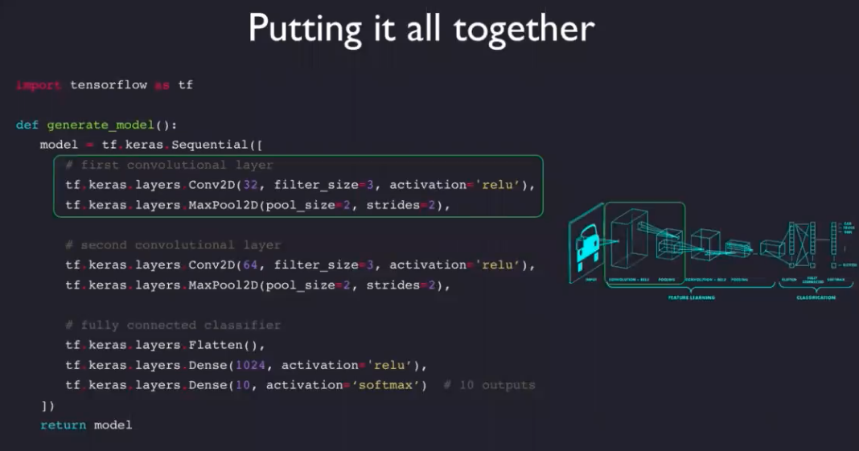

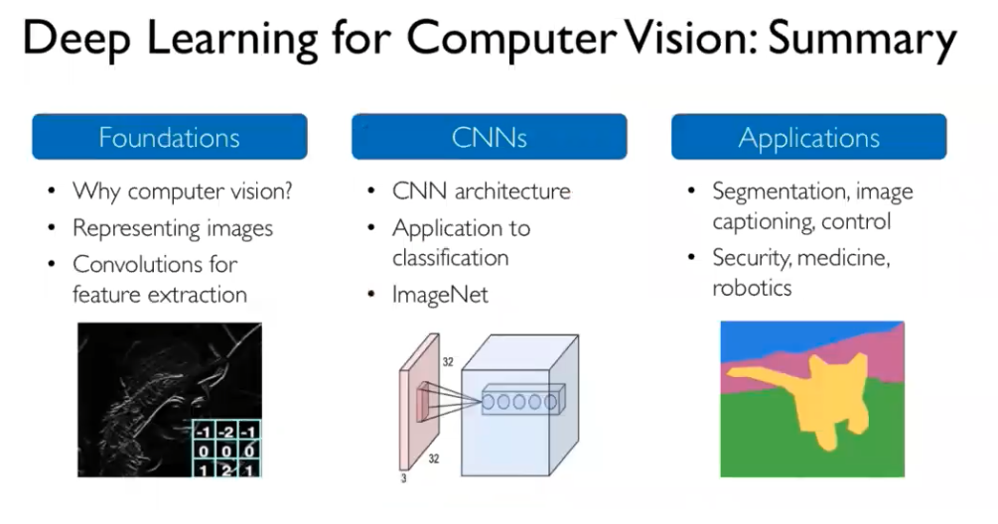

**Markov decision process:** How an agent gets an reward?

Chess is a markovian game because the next state will depend on the action that we take on the current state. It doesn’t depend on previous steps.

Predicting stock market prices is not an example of markovian process.

Policy: what actions needs to be taken by agent inorder to get the maximum cumulative reward.

Bell man practical example:

<https://www.youtube.com/watch?v=14BfO5lMiuk&ab_channel=SkowstertheGeek>

